TABLE OF CONTENTS

Unit1: Carbon and inorganic compounds Unit2: Nitrogen and inorganic compounds Unit3: Sulphur and inorganic compounds Unit4: Chlorine and inorganic compounds Unit5: Rate of reactions
Unit6: Chemical properties of acids and bases Unit7: Concentration of solutions

Unit8: Electrolysis and its applications
Unit9: Structure and properties of alkenes and alcohols Unit10: Carboxylic acids
Unit11: Petroleum products and polymerization

UNIT 1: CARBON AND ITS INORGANIC COMPOUNDS
- Carbon
Carbon is a chemical element of group IVa, its symbol is C, atomic number 6 and atomic mass is 12. It has 6 electrons and 4 valence electrons. Its electron structure is 2:4

Forms of carbon
Carbon exists in many forms. The most important forms of carbon are diamond and
graphite. These different forms of carbon are called allotropes
By definition,
- Allotropy is the existence of an element in two or more forms.
Examples of elements that exhibits allotropy are: Carbon, Sulphur and Phosphorus
- Allotropes are different forms of the same element.
The main allotropes of carbon are: Diamond, Graphite, and Amorphous carbon.
- Diamond and graphite are called crystalline allotropes (forms) of carbon because they have a regular shape as their atoms are arranged in a regular pattern.
- Amorphous carbon allotropes: Are allotropes of carbon which do not have any particular shape as the arrangement of the atoms in these forms is not orderly.
Examples of amorphous carbon allotropes are: Charcoal, Lampblack (soot) and
Coke.

a)Crystalline allotropes of carbon
Some crystalline allotropes of carbon are:

Diamond

Structure of diamond
In the Diamond structure, each carbon atom is covalently bonded (is joined) to four other carbon atoms in a tetrahedral arranged.

The following figure shows the structure of diamond
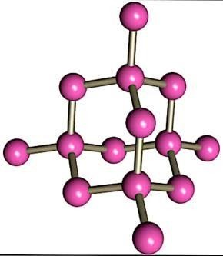

Physical properties of diamond
- Diamond is insoluble in water.
- It does not conduct electricity and heat. Because it has no free electrons which are necessary to conduct electricity.
- It is colorless, transparent and dazzling (sparkles), hence beautiful.
- It is very hard substance.
- It has high melting point of 37000 C.
- It has high density (about 3.5g/Cm3).

Uses of diamond
- Diamond is used in making jewellery because it is lustre (sparkles in light).
- It is used in the manufacture of glass cutters due to its hardness.
- It is for making drilling bits due to its hardness

Graphite

Structure of graphite
In the graphite structure, each carbon atom is covalently bonded (joined) to three other carbon atoms hexagonally arranged in flat parallel layers. The fourth electron is not attached to any particular atom and is free to move along the layer. The free electron enables graphite to conduct electricity.

The following figure shows the structure of graphite
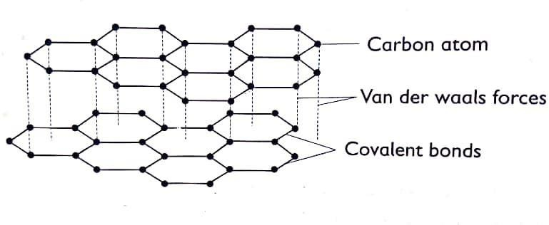

Physical properties of graphite
- Graphite is insoluble in water.
- It conducts electricity. Because it has delocalized (or free) electrons
responsible for carrying electric current.
- It is soft and slippery (greasy to touch).
- It has high melting point (3500 0c).
- It is a good conductor of heat.
- It is black in color and opaque.
- It has a low density (2.3 g/cm3).

Uses of graphite
- Graphite is used as an electrode in dry cells and during electrolysis because it is a good conductor of electricity.
- It is used as a lubricant because it is slippery.
- It is used in the manufacture of "Lead " in pencils due to its softness
NOTE:" Lead "is the black or grey part of the pencil used to write.

Difference between diamond and graphite
DIAMOND | GRAPHITE
Is very hard | Is soft and greasy to touch
Is colorless | Is Black in color
Is highly transparent | Is opaque
Carbon atoms in diamond are tetrahedrally arranged | Carbon atoms in graphite are hexagonally arranged
Has high density (about 3.5) | Has low density (about 2.3)
Does not conduct heat and electricity | Is a good conductor of electricity and heat

Similarities between diamond and graphite
  - Both are allotropes of carbon.
  - Both are covalently bonded.
  - Both have very high melting point.
  - Both are giant structures of carbon atoms.
  - Both are insoluble in water.

Amorphous carbon or non-crystalline allotropes
These allotropes do not have any particular shape as the arrangement of the atoms in these forms is not orderly. They include charcoal, coke and soot. These forms are back solids and they are formed after burning organic compounds like wood, sugar, bones and coal.
Amorphous (non-crystalline) carbon exists in many forms such as:
  - Charcoal is used as a fuel in many domestic homes.
- Animal charcoal is made by heating animal bones in a limited supply of air. it is used to remove fluoride ions from water
- Wood charcoal is made by heating wood in a limited supply of air. It is used as household fuel for cooking and as reducing agent in extraction of metals like iron and zinc from their oxides.
- Sugar charcoal is made by removing the elements of water from sugar by using concentrated sulphuric acid. It is used to decolorize colored solutions and as reducing agent in extraction of metals like iron and zinc from their oxides.
  - Lampblack(soot) is made by burning oils with a limited supply of air, and it is used for making printers ink and shoe- polish.
  - Coke is used as fuel when burnt in air and is also used as reducing agent in extraction of metal like iron and zinc.

Chemical properties of carbon

Combustion (Reaction of carbon with oxygen)
Carbon burns in air in two ways:
- In plenty of oxygen (excess oxygen), carbon burns to form carbon dioxide C(s) + O2(g) CO2(g)
- In limited supply of air (insufficient oxygen), carbon burns to produce carbon monoxide.
2C(s) + O2(g) 2CO(g)

Reducing property (carbon as a reducing agent)
- Carbon is a reducing agent; It reduces the oxide of metal forming the corresponding metal and carbon dioxide. The reducing property of carbon is used in the extraction of metals such as iron, lead, zinc and copper. Fe2O3(s) + C(s) Fe(s) + CO2(g)
ZnO(s) + C(s) Zn(s) + CO2(g)
PbO(s) + C(s) Pb(s) + CO2(g)
CuO(s) + C(s) Cu(s) + CO2(g)

Carbon reduces carbon dioxide to carbon monoxide.
C(s) + CO2(g) 2CO(g)
- White hot coke reduces water and water gas is formed (consists of two gases CO and hydrogen).
C(s) + H2O(l) CO(g) + H2(g)
Note:
- Reducing agent is a substance that remove oxygen from another substance.
- Oxidizing agent is a substance that give oxygen to another substance.

Reaction of carbon with concentrated acids
Carbon is oxidized by hot concentrated sulphuric acid and nitric acid . C(s) + 2H2SO4(l) CO2(g) + 2 H2O(l) + 2 SO2(g)
C(s) + 4HNO3(l) CO2(g) + 2 H2O(l) + 4 NO2(g)

Inorganic compounds of carbon
a)Carbon dioxide

Laboratory preparation of CO₂
Carbon dioxide is prepared in the laboratory by the action of dilute hydrochloric acid on marble chips (Calcium carbonate) to form calcium chloride, water and carbon dioxide. The carbon dioxide is collected by upward displacement of air or downward delivery because it is dense than air.

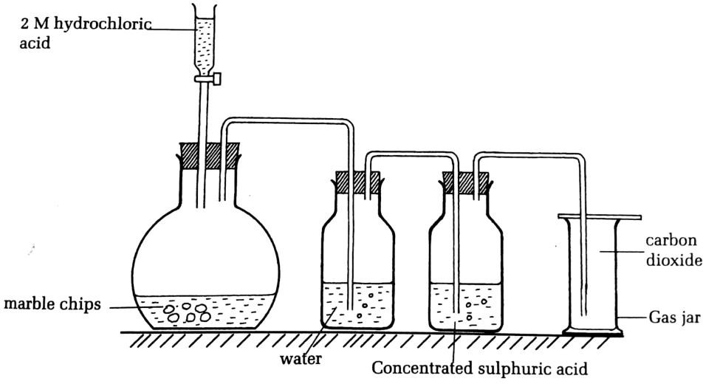

Equation for the reaction is
CaCO3(s) + 2HCl(aq) CaCl2(aq) + H2O(l) + CO2(g)
- Water is used to remove hydrogen chloride fumes). (we can use also potassium hydrogen carbonate, KHCO3, solution.
- Concentrated sulphuric acid is used to dry the gas (CO2).
The pure and dry gas is collected by downward delivery.

Physical properties of carbon dioxide
- CO2 is Colorless and odorless gas.
- CO2 does not burn, and it does not support combustion.
- It is denser than air: That is why it is collected by downward delivery. (Upward displacement of air)
- CO2 turns moist blue litmus paper red. This indicates that the gas is acidic.
- CO2 is Slightly soluble in water.

Physical properties of carbon dioxide

Reaction of CO₂ with water
Carbon dioxide slightly dissolves in water forming a weak carbonic acid CO2(g) + H2O (l) H2CO3(aq)
Carbon dioxide is acidic gas. Its aqueous solution turns blue litmus paper red.

  - Reaction of CO2 with calcium hydroxide solution (limewater)
- Carbon dioxide reacts with limewater first to form insoluble calcium carbonate, seen as a white precipitate (or milky solution is formed).
Ca (OH) 2(aq) + CO2(g) CaCO3(s) + H2O (l)
Limewater white ppt
- Then with excess carbon dioxide, the precipitate dissolves to form a colorless solution of calcium hydrogen carbonates. (i.e the milkness disappears to form colourless solution.)
CaCO3(s) + CO2(g) + H2O(l) Ca(HCO3)2(aq)

Reaction of CO₂ with magnesium metal
When a piece of burning magnesium ribbon is plunged in a gas jar of CO2, the magnesium continues to burn for short time with a splitting bright flame. black particles of carbon and white powder are left in the gas jar.
2Mg (s) + CO2(g) 2MgO(s) + C (s)
White ash Black particles

Reaction of CO₂ with sodium hydroxide solution
Carbon dioxide reacts with sodium hydroxide just like with calcium hydroxide. CO2 is quickly absorbed by aqueous sodium hydroxide forming sodium carbonate.
CO2(g) + 2 NaOH(aq) Na2CO3(aq) + H2O(l)
Then with excess CO2 gas: Na2CO3(aq) + H2O(l) + CO2(g) 2NaHCO3(s)
NOTE: With NaOH, no white precipitate of Na2CO3 is formed. When the gas is passed through NaOH for a long time a white precipitate of NaHCO3 is formed.

Test for carbon dioxide
- Carbon dioxide can be tested for by passing the gas first, in small amount, into a colorless solution of calcium hydroxide (limewater).
Observation:
  - Limewater turns milky or
  - White precipitate of calcium carbonate is formed.
Equation:
Ca (OH)2(aq) + CO2(g) CaCO3(s) + H2O(l)

- If CO2 is passed in excess, the milkness is disappeared to form a colorless (clear) again due to formation of calcium hydrogen carbonate, which is soluble. CaCO3(s) + H2O(l) +CO2(g) Ca(HCO3)2(aq)

Uses of carbon dioxide
- CO2 is used in fire extinguishers, because:
  - It does not support combustion
  - It does not burn
- CO2 is used to increase flavor to bottled drinks like soft drinks and beers.
- Solid Carbon dioxide (dry ice), is used as refrigerant (cooling).
- It is put in bread during the baking process.
- CO2 is used in photosynthesis

Environmental issues of CO and CO₂
- Carbon monoxide is poisonous and very toxic gas: This is because when inhaled, carbon monoxide reacts with haemoglobin in the blood and stops haemoglobin from carrying oxygen in the body and death occurs by suffocation (asphyxia). (CO causes suffocation (asphyxia): suffocation is lack of oxygen in the blood in the body).
- Carbon monoxide also causes air pollution.
- CO2 causes acid rain.
- CO2 also causes greenhouse effect and global warming.

Note
- The greenhouse effect is the ability of certain gases in the atmosphere to trap heat emitted from the earth’s surface thus keeping the earth warm.
- Global warming refers to the increase in the overall temperature of the earth’s atmosphere due mainly to the increasing concentrations of greenhouse gases in the atmosphere.

The phenomenon of greenhouse effect
The earth receives ultraviolet radiation from sun. This warms up the earth's surface and, in turn, the warmed earth emits infrared radiation to the atmosphere. In the atmosphere, the infrared energy is normally absorbed by carbon dioxide, methane, water vapor and other gases, thus keeping the earth warm. This warming is known as the natural greenhouse effect. However, it is anticipated that higher volumes of carbon dioxide being released into the atmosphere may increase this effect, resulting in global warming.

Carbon and carbon dioxide cycle
The carbon cycle is a series of processes whereby carbon dioxide is being constantly removed from the atmosphere and also constantly returned to it.
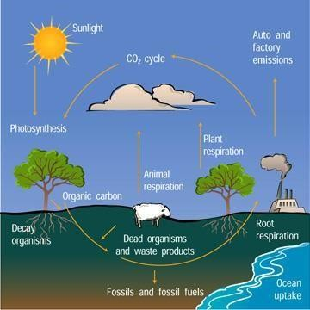
- Carbon dioxide is released into the atmosphere by:
  - Respiration of animals and plants
  - Decay of dead plants and animals
  - Burning of fossil fuels (petroleum, charcoal, wood, Coal)
- Carbon dioxide is removed from the atmosphere by the process of:
  - Photosynthesis in plants, and
  - Dissolving CO2 in the oceans, seas, and lakes.

b. Carbonates and hydrogen carbonates
Carbonates and hydrogen carbonate are salts derived from carbonic acid(H2CO3). Carbonates are normal salts while hydrogen carbonates are acid salts of carbonic acid. Insoluble carbonates are prepared by ionic precipitation while soluble carbonates are prepared by passing carbon dioxide through alkalis.
- Preparation of carbonates and hydrogen carbonates

Preparation of insoluble carbonates
- Preparation of calcium carbonate and lead(II) carbonate
- Insoluble carbonates are obtained by adding a soluble carbonate (such as sodium carbonate solution) to a solution containing Ca2+ and Pb2+ to form white

precipitate of calcium carbonate and white precipitate of lead(II) carbonate respectively
Na2CO3(aq) + Pb(NO3)2(aq) PbCO3(s) + 2NaNO3(aq) Na2CO3(aq) + Ca(NO3)2(aq) CaCO3(s) + 2NaNO3(aq)
- Calcium carbonate is a white solid, which can also be obtained by bubbling carbon dioxide through limewater (Calcium hydroxide solution)
Ca(OH)2(aq) + CO2(g) CaCO3(s) + H2O(l)

Preparation of soluble carbonates
Soluble carbonates like sodium carbonate, Na2 CO3(aq), potassium carbonate, K2CO3 and ammonium carbonate, (NH4)2CO3(aq) are prepared by bubbling carbon dioxide through their alkalis.
2NaOH(aq) + CO2(g) Na2CO3(aq) + H2O(l)
2KOH(aq) + CO2(g) K2CO3(aq) + H2O(l)
NH4OH(aq) + CO2(g) (NH4)2CO3(aq) + H2O(l)

Preparation of hydrogen carbonates

Sodium hydrogen carbonate is prepared by passing excess carbon dioxide through sodium hydroxide solution.
CO2(g) + 2 NaOH(aq) Na2CO3(aq) + H2O(l)
Then with excess CO2 gas: Na2CO3(aq) + H2O(l) + CO2(g) 2NaHCO3(s)
- Properties of carbonates and hydrogen carbonates
- Physical appearance, all carbonates appear as very fine powder and solid at room temperature. Also carbonate of group 1 and group 2 elements are colorless whereas, the carbonates of transition elements may be colored.

Solubility,
- All carbonates are insoluble in water except those of sodium, potassium and ammonium which are soluble in water.
- All hydrogen carbonates are soluble in water.
Note: Aluminium forms no carbonate

Effect of heat on carbonates and hydrogen carbonates
- All carbonates decompose on heating forming the corresponding metallic oxide and carbon dioxide gas except Na2 CO3, K2 CO3 and (NH4)2 CO3 which do not decompose on heating.
CuCO3(s) CuO (s) + CO2(g)
Green powder Black
MgCO3(s) MgO (s) + CO2(g)
White white

ZnCO3(s) ZnO (s) + CO2(g)
White powder Yellow-hot White-cold
PbCO3(s) PbO (s) + CO2(g)
White powder Orange –hot Yellow –cold
(NH4)2CO3(s) 2NH3(aq) + CO2(aq) + H2O(l)
White solid

- All hydrogen carbonates are decomposed by heat to form metal carbonate, water and carbon dioxide.
Examples:
2KHCO(3)(s) K2CO3(s)+ H2O(l) + CO2(g)
Ca(HCO3)2(s) CaCO3(s) +H2O(l) + CO2(g)

Reaction of carbonates and hydrogen carbonates with dilute acids
All carbonates react with dilute acids (HCl, H2SO4, HNO3) producing their corresponding metallic salt, carbon dioxide gas and and water.
CaCO3(s) + 2HCl(aq) CaCl2(aq) + CO2(g) + H2O(l) CuCO3(s) + 2HNO3(aq) Cu (NO3)2(aq) + CO2(g) + H2O(l) CaCO3(s) + H2SO4(aq) CaSO4(s) + CO2(g) + H2O(l)
Hydrogen carbonates reacts with dilute acid to give a salt, water and carbon dioxide.
NaHCO3(s) + HNO3(aq) NaNO3(aq) + H2O(l) +CO2(l) Ca(HCO3)2(aq) + 2HCl(aq) CaCl2(aq) +2CO2(aq) + CO2(aq)

Uses of sodium carbonate and sodium hydrogen carbonate
Sodium carbonate is used in:
- Making glass,
- Water softening,
- Paper making,
- Baking soda (sodium hydrogen carbonate) production.

Sodium hydrogen carbonate is used in:
The most commonly used hydrogen carbonate is sodium hydrogen carbonate. It is commonly used:

As antacid
- In baking powder (sodium hydrogen carbonate) production.
- As drying agent
- In toothpastes

Hard water

Definition
Hard water is water which does not allow soap to lather easily because of presence of dissolved Ca2+ and Mg2+ ions.
Note:
Water can be classified as hard or soft
  - Hard water does not allow the soap to lather easily while soft water lathers easily with soap.
  - Hard water contains calcium ions (Ca2+) or magnesium ions(Mg2+) while soft water lacks these ions

Types of hardness
There are two types of water hardness
- Temporary hardness: Is caused by dissolved calcium hydrogen carbonates or magnesium hydrogen carbonate in water.
- Permanent hardness: It is caused by dissolved sulphates or chlorides of calcium or magnesium in water.

Methods of softening water (or methods of removing hardness of water)
Hard water can be made soft by removing the dissolved calcium ions (Ca2+) or magnesium ions(Mg2+).
The following are some of the methods used to remove hardness of water.

Removing temporary water hardness
This type of hardness can be removed using the following methods:

By boiling water
Boiling decomposes calcium hydrogen carbonate or magnesium hydrogen carbonate into the insoluble calcium carbonate or magnesium carbonate.
Ca(HCO3)2(aq) Heat Ca CO3(s) + CO2(g) + H2O(l) Mg(HCO3)2(aq) Heat Mg CO3(s) + CO2(g) + H2O (l)
The insoluble calcium carbonate and magnesium carbonate can be removed from water by filtration.
Note: Boiling removes only temporary hardness.

By addition of calcium hydroxide solution in water
Calcium hydroxide precipitates all the calcium ions or magnesium ions as calcium carbonate or magnesium carbonate from the solution.
Ca(HCO3)2(aq) + Ca(OH)2(aq) 2CaCO3(s) + 2H2O(l) Mg(HCO3)2(aq) + Ca(OH)2(aq) MgCO3(s) + CaCO3(s) + 2H2O(l)
The water is then filtered to remove the insoluble calcium carbonate or magnesium carbonate.
Note: This method is only applicable to temporary hardness.

By addition of ammonia solution in water
Ammonia solution converts soluble calcium hydrogen carbonate or soluble magnesium hydrogen carbonate to insoluble carbonates.
Ca(HCO3) 2(aq ) + 2NH3(aq) CaCO3(s) + (NH4) 2CO3(aq)
Mg(HCO3) 2(aq) + 2NH3(aq) MgCO3(s) + (NH4) 2CO3(aq)
Note: This method is only used to remove temporary hardness.

Removing permanent water hardness

By distillation of water
The hard water is heated to evaporate the water. The steam is then condensed to obtain pure distilled water. The dissolved salts are left as residue in the distilling vessel.
Note: This method is used to soften both temporary and permanent hard water.

By addition sodium carbonate solution (washing soda) in water
Sodium carbonate precipitates insoluble carbonate. The insoluble carbonate is removed by filtration.
Ca(HCO3) 2(aq) + Na2CO3(aq) CaCO3(s) + 2NaHCO3(aq)
CaSO4(aq) + Na2CO3(aq) CaCO3(s) + Na2SO4(aq) MgSO4(aq) + Na2CO3(aq) MgCO3(s) + Na2SO4(aq)
Note: This method is used to soften both temporary and permanent hardness.

Use of the ions exchange
When hard water is passed through permutit (Permutit (trade name for zeolite) is sodium aluminum silicate which can be represented as Na2X), the calcium or magnesium ions of the hard water are removed and replaced with the sodium ions of the permutit.
Ca(HCO3)2(aq) + Na2X(s) CaX(s) + 2NaHCO3(aq) MgSO4(aq) + Na2X(s) MgX(s) + Na2SO4(aq)
Note: This removes both temporary and permanent hardness.

Advantages of hard water
- Hard water helps people in the formation of strong bones and teeth as it supplies Ca 2+ ions.
- Hard water is good for formation of egg shells and animal shells. e.g. Snails obtain calcium from hard water.
- Hard water has a better taste than soft water.
- Calcium and magnesium ions are important for plant growth. Hard water provides these.
- It does not dissolve lead; therefore, it can be piped through lead pipes.

Disadvantages of hard water
- Hard water wastes soap, as it does not lather easily.
- Hard water causes dirty marks on clothes, as soap and hard water form a solid called scum which makes dirty marks on clothes after washing.
- Hard water causes a layer of "fur" in kettles and scale in pipe and boilers. NOTE: When water containing calcium hydrogen carbonate is heated, say in a kettle, a white deposit called ‘fur’ is left as coating inside the kettle. This deposit is calcium carbonate.

EXERCISES
- Allotropes are usually alike in most chemical properties but there are some observable points of difference they show.
  - Define allotropy
  - State those points of difference observed in allotropes.
  - Give four examples of chemical elements that exhibit allotropy.
- a) i) What do you understand by the term allotropes?
ii) Name two crystalline allotropes of carbon.
  - Briefly describe the structure of the two allotropes
  - One of the allotropes named at a) ii) conducts electricity while the other does not. explain
- Match each of the following allotropes with its correct use.

Allotropes | Use
a) Graphite | i. Reducing agent in the extraction of metals like iron and zinc from their oxides
b) Diamond | ii. Household fuel for cooking
c) Wood charcoal | iii. Used as electrode in dry cells and during electrolysis
d) Coke | iv. Making of drilling bits and cutting glass and metals

- Suggest a reason for each of the following.
- Graphite conducts electricity while diamond does not.
- Graphite is used as a lubricant whereas diamond is not.
- Diamond is used in jewellery
- Graphite, like diamond, is insoluble in water and organic solvents.
- Diamond is used in making tips of drills while graphite is used to make pencils leads.
- (a) State two similarities and two differences between graphite and diamond
  - Suggest two mains uses of:
    - coke,
    - lampblack (soot) and
    - wood charcoal.

- Carbon seems not to react with acids. It only reacts with oxidizing acids like sulphuric acid and nitric acid. With each of these acids, three oxides are produced. Write the balanced equations showing the reaction of carbon with concentrated sulphuric acid and nitric acid.
- Study this reactions scheme of Carbon and answer the following questions
Y
+ O2(g) in excess
X +
CO2(g)
+Fe2O3(s)
C(s)
+ CO2(g)
Z
+ W
CO(g) + H2(g)
Identify compounds X, Y, Z and W.
- In laboratory, carbon dioxide is prepared by the action of dilute acids on carbonates.
- Suggest the acid and a carbonate that may be used and write the chemical equation for the reaction when they are made react.
- Suggest the role of H2O during this preparation.
- Carbon dioxide gas prepared must be dry. Suggest two substances that may be used to remove water vapours in the prepared gas.

- Study attentively the following reactions scheme of carbon dioxide (CO2).
Y
+ H2O(l)
X +
H2O(l)
+ Ca(OH)2(s)
CO2(s)
+ C(s)
Z
+ W
MgO(s) + C(s)

- Identify compounds X, Y, Z and W.
- State three physical properties and explain three uses of carbon dioxide.
- Describe a chemical test for identification of carbon dioxide. (Include the test reagent, observation and equation for the occurring reaction).
- Mention two ways in which carbon dioxide is removed from the atmosphere and two ways in which carbon dioxide is supplied to the atmosphere.
- Calcium carbonate (CaCO3) is widely known as it occurs as limestone, chalks, etc. It also finds different applications.
- Describe the preparation of calcium carbonate.
- Write balanced equations for the following reactions of calcium carbonate.
  - Reaction with dilute sulphuric acid
  - Its thermal decomposition
- Describe a chemical test to show the presence of a carbonate ion in the calcium carbonate.
- State two main uses of calcium carbonate

- The following set up was used to investigate the effect of heat on lead (II) Carbonate.
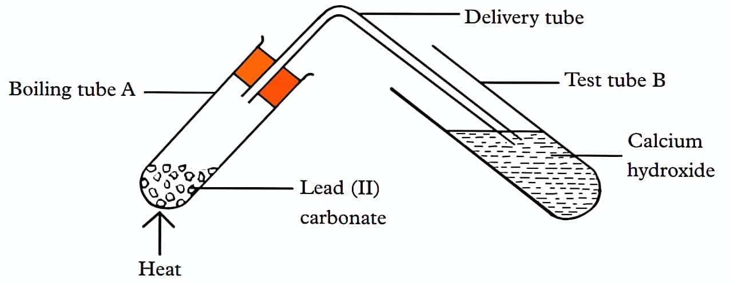
- State the observations made in boiling tube A.
- What observation is made in test tube B?
- Write an equation for the reaction that occurs in test tube A and B.
- Greenhouse effect and global warming are the main issues caused by carbon dioxide on the environment. Define the following terms:
- Global warming
- Greenhouse gases
- State two physical properties of carbon monoxide
- Including a chemical equation, describe how the carbon monoxide gas can be formed.
- It is not advisable to sleep inside a house which is not well ventilated with a burning wooden charcoal. Explain.
- (a) Define hard water in two different ways.
- Differentiate between hard water and soft water.
- State and explain the types of water hardness. For each type, describe two ways that can be used to remove this type of hardness.
- Explain two main benefits and two main disadvantages of hard water.

Study the diagram given below for the production of carbon dioxide gas and answer the questions that follow:
- Write a balanced equation of the reaction showing the physical states of the reactants and the products.

What is the role of water and concentrated sulphuric acid in the wash bottles?
- Why can’t dilute H2SO4 be used in place of dilute hydrochloric acid in this experiment.

Write balanced equations to show how CO2 react with the following:
  - Hot magnesium

Water
  - Hot carbon

Carbon dioxide was passed through a solution of calcium hydroxide (Limewater), first in small amounts and later in excess. Explain what is observed by using chemical equations.
- Mention two ways in which carbon dioxide is removed from the atmosphere and

two ways in which carbon dioxide is supplied to the atmosphere.
- State one use of carbon dioxide.

UNIT 2: NITROGEN AND ITS INRGANIC COMPOUNDS
1. Introduction
Nitrogen occurs as combined gas in air. It forms 78% by volume of air. It exists as a diatomic molecule N2. It occurs naturally in compounds such as proteins, amino acids; nitrates {ex: NaNO3, KNO3, Ca(NO3)2} and ammonium salts(NH4)2SO4. It is found in group Va in the periodic table. Its atomic number is 7 and atomic mass is
14. It has 7 electrons and 5 valence electrons. Its electron structure is 2:5 and three electrons are lacking in the outermost energy level of nitrogen to complete an octet and its valence 3.

Industrial isolation of nitrogen from the air
The isolation of nitrogen gas means separating it from the other components of air such as oxygen, carbon dioxide and the noble gases.
Industrially, Nitrogen is prepared by fractional distillation of liquid air
The following flowchart shows how nitrogen is isolated from air.
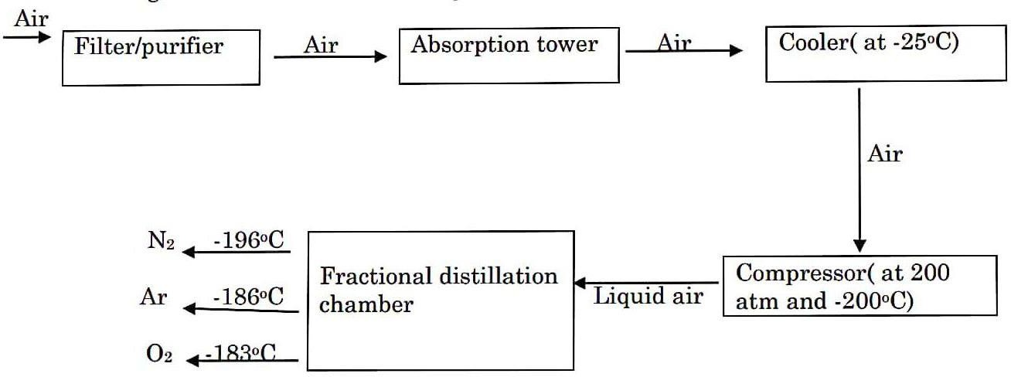
- Filter/purifier : Removes dust particles from air.
- Absorption tower : contains sodium hydroxide solution(NaOH(aq)) or potassium hydroxide solution(KOH(aq)) that removes carbon dioxide from air.
2NaOH(aq) + CO2(g) Na2CO3(aq) + H2O(l)
- Cooler : Removes water vapour from the air by condensing and freezes water vapour.
- Compressor : Turns air into liquid air. This liquid air contains oxygen, nitrogen and argon gas.

- Fractionating column: Separates nitrogen from liquid mixture of oxygen, argon and nitrogen by fractional distillation method. This allows nitrogen to separate out first at -196oc followed by argon at -186oc and lastly oxygen at -183oC.

Properties of nitrogen gas

Physical properties of nitrogen
  - Nitrogen is colorless gas and odorless gas.
  - It is almost insoluble in water.
  - It is less dense than air.
  - It does not burn or doesn’t support combustion.
  - It is neither acidic nor basic.

Chemical properties of nitrogen
- Unreactive nature of nitrogen
Nitrogen is a diatomic molecule, N2. In the molecule the atoms are joined by a strong triple bond N≡N. The three covalent bonds require a lot of energy to break up, thus rendering nitrogen unreactive. However, under forceful conditions nitrogen can be made to react.

Reaction of nitrogen with magnesium and calcium metals
Nitrogen reacts with magnesium and calcium metals at very high temperatures (above 2000oC) forming metal nitride.
3Mg(s) + N2(g) Mg3N2(s)
Magnesium nitride
3Ca(s) + N2(g) Ca3N2(s)
Calcium nitride
Then, the metal nitrides dissolve in water, forming ammonia gas and a metal hydroxide.
Mg3N2(s) + 6H2O(l) 2NH3 (g) + 3Mg(OH)2 (s)
Ca3N2(s) + 6H2O(l) 2NH3 (g) + 3Ca(OH)2 (s)

Reaction of nitrogen with hydrogen to form ammonia (Haber process)
In the presence of iron as a catalyst, nitrogen reacts with hydrogen at about 5000C to form ammonia.
N2(g) + 3H2(g) 2NH3 (g)

Uses of nitrogen gas
Nitrogen is used:
- To manufacture ammonia in Haber process
- As a refrigerant. Because it has very low boiling point of -1960C.
- To manufacture of explosives such as TNT (trinitrotoluene).
- In making chemical fertilizers. (e.g. ammonium nitrate and ammonium sulphate fertilizers)

Inorganic compounds of nitrogen
- Nitrogen dioxide

Preparation of nitrogen dioxide
- Nitrogen dioxide is prepared by reacting concentrated nitric acid with copper turnings.
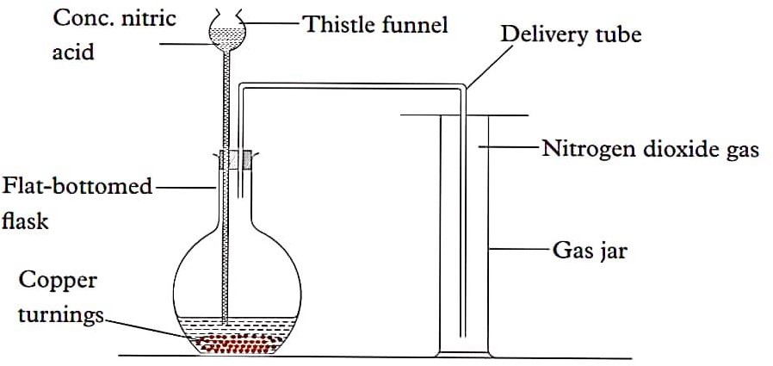

The equation for the reaction is:
Cu(s) + 4HNO3(aq) Cu(NO3)2(aq) + 2H2O(l) + 2NO2(g)
- Nitrogen dioxide is also prepared by heating metals nitrate such as lead (II) nitrate. Oxygen is also evolved as a by-product.
Pb(NO3)2(s) heat 2PbO (s) + 4NO2(g) + O2(g)

Physical properties of nitrogen dioxide
- NO2 is a red- brown gas
- It is soluble in water. Means that it dissolves in water to forms an acidic solution.

- It has a pungent, choking smell.
- It is denser than air.
- It turns blue litmus paper red. This indicates that NO2 is an acidic gas.

Chemical properties of nitrogen dioxide
- Reaction with water
NO2 is soluble in water. It dissolves in water to form a pale-yellow acidic solution consisting of nitric acid and nitrous acid.
2NO2 (g) + H2O(l) HNO3(aq + HNO2(aq)

NO₂ decomposes when heated forming nitrogen (II) oxide and oxygen.
2NO2(g) Heat 2NO(g) + O2(g)

Nitrogen dioxide oxidizes hot metals and the gas is reduced to nitrogen
4Mg (s) + 2NO2(g) 4MgO(s) + N2(g)
white ash
4Cu (s) + 2NO2(s) 4CuO (s) + N2(g)
Black

uses of nitrogen dioxide
NO2 gas is used in the:
- Manufacture of nitric acid in Ostwald process.
- Manufacture of explosives, plastics and nylon materials

b)Ammonia gas (NH₃)

Laboratory preparation of ammonia
- Ammonia is prepared in the laboratory by heating a mixture of ammonium chloride and calcium hydroxide.
- The ammonia gas is then passed through quick lime, CaO (s). This calcium oxide is used to dry ammonia gas.
- It is collected by upward delivery because it is lighter than air.

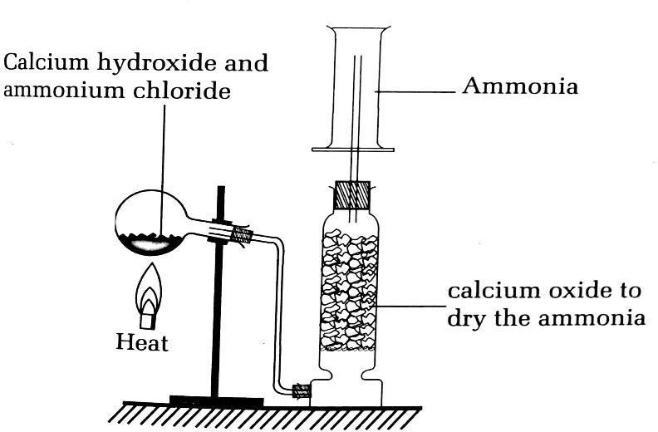
The equation for the reaction is:
2NH4Cl (s) + Ca(OH)2(s) CaCl2(s) + 2H2O(l) + 2NH3(g
Note: Concentrated sulphuric acid, H2SO4, and anhydrous calcium chloride, CaCl2, are not used to dry ammonia because they react with it.

Industrial preparation of ammonia (Haber process)
Ammonia is also obtained on an industrial scale by the Haber process, which is based on the direct combination of nitrogen and hydrogen:
The raw materials required for the manufacture of ammonia by the Haber process are:
- Nitrogen: Obtained from air by fractional distillation of liquid air.
- Hydrogen: Obtained from natural gas(methane) or by electrolysis of acidified water.
Equation: N2(g) + 3H2(g) Fe 2NH3(g)
This reaction, which is reversible, requires special conditions for an optimum yield of ammonia
- Pressure: 200 –500 atmospheres
- Temperature: 4000C- 500˚C
- Catalyst used is fine divided iron(Fe).

Physical properties of ammonia gas
Ammonia gas:
- Is a colorless gas.
- Has a pungent choking smell.
- Is less dense than air; that’s why it is collected by upward delivery method or by downward displacement of air.
- Is very soluble in water.

Chemical properties of ammonia gas

Basic nature
Ammonia is a base and its basic nature is shown by its reaction with;
- Litmus paper: Ammonia gas turns moist red litmus paper blue. This means ammonia is not an acid.
- Acids: It reacts with acids, forming the corresponding ammonium salts. H2SO4 (aq) + 2NH3 (g) (NH4)2SO4 (aq)
HNO3 (aq) + NH3 (g) NH4NO3(s)

Reaction of ammonia with hydrogen chloride
Ammonia gas reacts with hydrogen chloride gas to form dense white fumes of ammonium chloride.
HCl (g) + NH3 (g) NH4Cl(s)

Reaction of ammonia with oxygen
- Ammonia burns in a lot of air (oxygen) with yellow-brown flame.
4NH3 (g) + 3O2 (g) 6H2O (l) + 2N2(g)
- In the presence of platinum catalyst, ammonia reacts with oxygen to form nitrogen monoxide and water.
4NH3 (g) + 5 O2 (g) pt 4 NO (g) + 6 H2O (g)
This equation is the basis of the manufactured of nitric acid by Ostwald process.

Ammonia is a reducing agent
Ammonia reduces heated copper(II) oxide to copper i.e. copper turns from black to brown.
3CuO(s) + 2NH3 (g) 3Cu(s) + 3H2O(l) + N2(g)
Black Brown

Reaction of ammonia with water
Ammonia gas dissolves in water forming ammonium hydroxide solution.
NH3 (g) + H2O(l) NH4OH(aq)
The resulting solution is called ammonia solution which is a weak alkali or basic solution.

Reaction of ammonia with chlorine
Ammonia burns in chlorine forming mist of hydrogen chloride gas. In excess Ammonia, denser white fumes of ammonium chloride are formed.
2 NH3 (g) + 3Cl2 (g) N2 (g) + 6HCl (g)
HCl(g) + NH3(g) NH4 Cl (s)

Reactions of ammonia solution with metals ions (cations) in solution
This reaction of ammonia solution with metal ions is used as a test for identifying these metal ions or cations in quantitative analysis. Some metal ions react with aqueous ammonia to form insoluble metal hydroxides, which appear as colored or white precipitates.
- Metal hydroxides which are insoluble in excess ammonia solution
- Pb2+(aq) + 2OH-(aq) Pb(OH)2(s)
White ppt

- Fe3+(aq) + 3OH-(aq) Fe(OH)3(s)
Brown ppt

- Fe2+(aq) + 2OH-(aq) Fe(OH)2(s)
green ppt

- Al3+(aq) + 3OH-(aq) Al(OH)3(s)
white ppt

- Ca2+(aq) + 2OH-(aq) Ca(OH)2(s)
white ppt

- Metal hydroxides which are soluble in excess ammonia solution. The hydroxide is soluble as a result of a complex ion formation.
- Zn2+(aq) + 2OH-(aq) Zn(OH)2(s)
White ppt

- Cu2+(aq) + 2OH-(aq) Cu(OH)2(s)

pale blue ppt which dissolves to form a deep blue solution

- Test of ammonia gas
- Ammonia forms dense white fumes of ammonium chloride when brought into contact with fumes of hydrogen chloride from the concentrated hydrochloric acid.
NH3 (g) + HCl (g) NH4Cl (s)
Observation: Dense white fumes of ammonium chloride are formed
- Action with litmus paper
Ammonia turns moist red litmus paper blue and has no effect on blue litmus paper. Ammonia is the only common alkaline gas.

Uses of ammonia gas
Ammonia is used:
- In the manufacture of fertilizers e.g. Ammonium sulphate, ammonium nitrate,
- In softening hard water.
- In making nitric acid.
- In making plastics.
- In making ammonium chloride is used in dry cells.
- In making explosives.

c)Nitric acid (HNO₃)
- Preparation of nitric acid

Laboratory preparation of nitric acid
In the laboratory, nitric acid is prepared by heating a mixture of potassium nitrate or sodium nitrate with concentrated sulphuric acid. It is formed in vapour form which is condensed using cold water to obtain 99% pure nitric acid. During the preparation some of the nitric acid gas decomposes to nitrogen dioxide (the brown fumes observed, due to heat).
KNO3 (s) + H2SO4 (l) heat KHSO4 (aq) + HNO3 (g)

  - The heat is used to speed up the reaction.
  - Nitric acid formed is volatile and form vapours which are condensed to form red- brown liquid of nitric acid because it contains some dissolved nitrogen dioxide, otherwise pure nitric acid is colorless liquid.

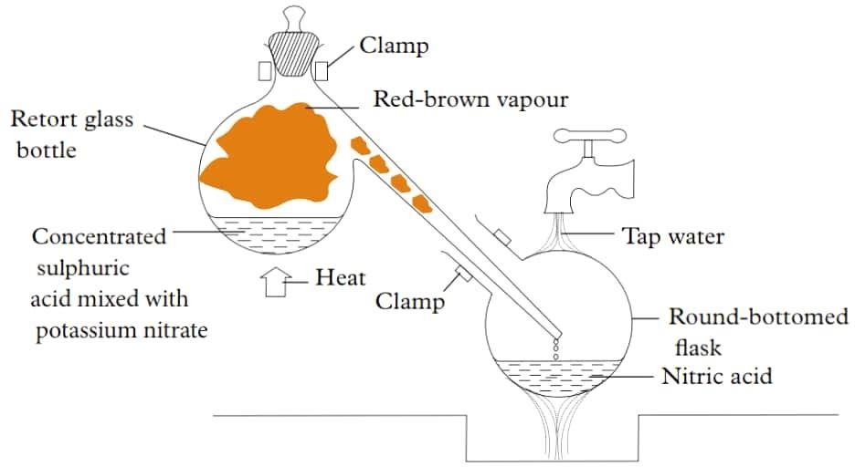

The red-brown fumes seen in the retort flask are as a result of the decomposition of some of the nitric by heat, forming red-brown nitrogen dioxide
4HNO3(aq) heat 2H2O(l) + 4NO2(g) + O2(g)

Industrial preparation of nitric acid
On industrial scale, nitric acid is manufactured by catalytic oxidation of ammonia. The steps involve are:
1st step: Catalytic oxidation of ammonia: Ammonia manufactured from the Haber process is mixed with excess oxygen from fractional distillation of air in the presence of platinum catalyst. The gases are heated to about 900oC, to form nitrogen monoxide and water. This step is strongly exothermic.
4NH3(g) + 5O2(g) 4NO (g) + 6H2O (g)
2nd step: The nitrogen monoxide so formed is rapidly cooled and combines with the oxygen from excess air to form nitrogen dioxide.
2NO (g) + O2 (g) 2NO2(g)
3rd step: The nitrogen dioxide is dissolved in water and more oxygen bubbled through the mixture to obtain nitric acid. Nitric acid obtained is 65% acid and has 35% water.
4NO2(g) + 2H2O (l) + O2 (g) 4HNO3 (aq)
The concentrated nitric acid is obtained by distillation of dilute nitric acid solution.
It is stored in dark brown glass containers, because it decomposes on exposures to light.
4HNO3(aq) 4NO2 (g) + 2H2O (l) + O2 (g)

Chemical properties of nitric acid

Reactions of dilute nitric acid, HNO_{3(aq)}
Dilute nitric acid (50% acid and 50% water) reacts with metals, Carbonates and bases.

Reaction of dilute nitric acid with metals
Only magnesium reacts with dilute HNO3 (aq) forming salt and hydrogen gas. Other metals react forming salt, water and nitrogen monoxide.
Mg(s) + 2 HNO3(aq) Mg(NO3)2(aq) + H2(g)
Metals like copper, lead, and zinc react with dilute nitric acid forming metal nitrates, water and nitrogen monoxide.
3Cu(s) + 8HNO3(aq) 3Cu(NO3)2(aq) + 4H2O(l) + 2NO(g)
3Pb(s) + 8 HNO3(aq) 3Pb(NO3)2(aq) + 4H2O(l) + 2NO(g)
3Zn(s) + 8HNO3(aq) 3Zn(NO3)2(aq) + 4H2O(l) + 2NO(g)

Reaction of dilute nitric acid with carbonates and hydrogen carbonates
Dilute nitric acid reacts with carbonates and hydrogen carbonates to produce metal nitrate, water and carbon dioxide
Examples:
Na2CO3(aq) + 2HNO3(aq) 2NaNO3(aq) + H2O(l) + CO2(g) NaHCO3(s) + 2HNO3(aq) NaNO3(aq) + H2O(l) + CO2(g)

Reaction of dilute nitric acid with bases
Dilute nitric acid reacts with bases (metal hydroxide and metal oxide) to form salts and water only. (The reactions are called neutralization reactions)
CuO(s) + 2HNO3(aq) Cu(NO3)2(aq) + H2O(l)
NaOH (aq) + HNO3(aq) 2NaNO3(aq) + H2O(l)
NH4OH(aq) + HNO3(aq) NH4NO3(aq) + H2O(aq)

Reactions of concentrated nitric acid, HNO_{3(l)} (it acts as an oxidizing agent)
Concentrated nitric acid (100% acid) has different reactions from dilute nitric acid. This is because it is a strong oxidizing agent. It oxidizes metals, non-metals and compounds.

With metals,
Concentrated nitric acid oxidizes metals like copper, lead, and zinc forming salt, water and nitrogen dioxide gas.
Cu(s) + 4HNO3(l) Cu(NO3)2(aq) + 2H2O(g) + 2NO2(g) Pb(s) + 4HNO3(l) Pb(NO3)2(aq) + 2H2O(l) + 2NO2(g) Zn(s) + 4HNO3(l) Zn(NO3)2(aq) + 2H2O(l) + 2NO2(g)

With non-metals
Sulphur is oxidized to Sulphur dioxide
S(s) + 4HNO3(l) 4NO2(g) + SO2(g) + 2H2O(l)
Carbon is oxidized to carbon dioxide
C(s) + 4HNO3(l) 4NO2(g) +2H2O(aq) + CO2(g)
Note: Dilute nitric acid does not react with non-metals.

Uses of nitric acid
Nitric acid is used to:
  - Manufacture of fertilizers e.g. ammonium nitrate
  - Manufacture explosives such as TNT and dynamite
  - Manufacture of dyes and drugs.
  - Manufacture of nylon and plastics.

Nitrates

Preparation of nitrates
Nitrates are prepared by reacting dilute nitric acid with metals, carbonates, bases (hydroxides, oxides).

Reaction with metals
Mg(s) + HNO3(aq) Mg(NO3)2(aq) + H2(g)
Cu(s) + HNO3(l) Cu(NO3)2(aq) + 2NO2(g) + H2O(l)

Reaction with carbonates and hydrogen carbonates
CaCO3(s) + HNO3(l) Ca(NO3)2(aq) + H2O(l) + CO2(g)
NaHCO3(s) + HNO3(l) NaNO3(aq) + H2O(l) + CO2(g)

Reaction with metal hydroxides and metal oxides (bases)
KOH(aq) + HNO3(aq) KNO3(aq) + H2O(l) NaOH(aq) + HNO3(aq) NaNO3(aq) + H2O(l)
ZnO(s) + 2HNO3(aq) Zn(NO3)2(aq) + H2O(l)

Properties of nitrates
- All nitrates are soluble in water.
- All nitrates are solid and ionic compounds.
- Action of heat on nitrates
When heated, nitrates decompose to form various products:
- Group I metal nitrates produce metal nitrite and oxygen.
2NaNO3(s) Heat 2NaNO2(s) + O2 (g)
2KNO3(s) Heat KNO2(s) +O2(g)

- The nitrates like copper(II)nitrate, lead(II)nitrate, zinc nitrate, magnesium nitrate and calcium nitrate decompose by heat to form metal oxide, nitrogen dioxide and oxygen gas.
2Cu (NO3)2(s) heat 2CuO(s) + 4 NO2 (g) + O2 (g)
Green Black brown fumes

2Zn (NO3)2(s) heat 2ZnO(s) + 4 NO2(g) + O2(g)
colourless yellow-hot brown fumes white-cold
- The nitrate of heavy metals like silver and mercury decompose by heat to form a metal, nitrogen dioxide and oxygen gas.
Hg (NO3)2 Heat Hg (l) + 2NO2 (g) + O2(g)

2AgNO3(s) Heat 2Ag(s) + 2NO2 (g) + O2 (g)
- Ammonium nitrate decomposes explosively. NH4NO3(s) N2O(g) + H2O(l)

Test for nitrates
To detect the presence of nitrate you can carry out:

Brown ring test
To a solution of a nitrate (e.g. sodium nitrate solution) in the test tube, add freshly prepared iron (II) sulfate solution and shake. then add a few drops of concentrated sulfuric acid slowly along the walls of the test tube and observe.

Observation: A brown ring is formed between sulphuric acid and the rest of the solution due to formation of iron (III) complex, FeSO4.NO (called nitroso iron(II) suphate).
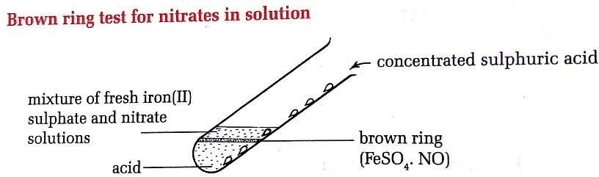

Heat the solid
To the solid (e.g. put half-spatula of lead(II)nitrate in a test tube) heat gently and then strongly.
Observation: Brown fumes produced confirm a nitrate.

Environment issues with nitrogen dioxide and nitrates fertilizers
Nitrogen dioxide
- Nitrogen dioxide contributes to the formation of acid rain which damage vegetation, buildings and water bodies.
- Elevated level of nitrogen dioxide in the atmosphere can cause respiratory diseases
(e.g. Asthma).
Nitrate fertilizers
- Excess use of nitrate fertilizers, lead to water pollution.
- Nitrate fertilizers can also cause soil acidity

EXERCISES
- Air contains mainly …………………….gas with about %. the main components
of air are mainly separated by process.
- What is the importance of the following during isolation of nitrogen from air:
  - Passing air through filters and concentrated sodium hydroxide solution.
  - Compression and expansion of air.
  - Fraction distillation of liquid air?
- Liquid air has three components X, Y and Z whose boiling points are ─186 0C, ─183 0C and ─196 0C respectively. When the liquid air is fed into a tall fractional distillation column and near its bottom warmed up slowly.
  - Which components will be collected from near the bottom of the fractional distillation column? why?
  - Which component will be collected from the top of the fractional distillation column? Why?
  - Which component will be collected from the middle part of the fractional distillation column? Why?
  - What could the components X, Y and Z be in real situation?
- Nitrogen gas does not support combustion but a magnesium ribbon continues to burn in presence of nitrogen. Discuss.
- Metals burn in oxygen to form oxides. Likewise, metals burn in nitrogen at high temperatures, forming solid compounds called nitrides.
  - Give equations to show how nitrides formed when calcium and magnesium are burnt in nitrogen.
  - The nitrides formed react with water giving ammonia as one of the products. Using the nitride of magnesium, give the equation for the reaction.
  - It is found that the combustion of magnesium in nitrogen takes place at a higher temperature than the combustion of magnesium in oxygen. What does this indicate about the nature of nitrogen?
- a) State three physical properties of nitrogen.
b) State two uses of nitrogen.

- Nitrogen dioxide dissolves in water to form two acids. Write the chemical equation for the reaction that takes place.
- a) Give three physical properties of nitrogen dioxide
b) State two uses of nitrogen dioxide.
- Nitrogen dioxide neither burns nor supports combustion. However, burning magnesium continues to burn in the presence of the gas. Explain.
- Mutesi dissolved nitrogen dioxide gas in water. She later put blue and red litmus papers in the solution formed. The blue litmus paper turned red while there was no effect on the red litmus paper.
  - Explain the observations made above.
  - Write a chemical equation for the reaction that took place.
- The diagram below shows the apparatus used to prepare and collect ammonia in the laboratory.
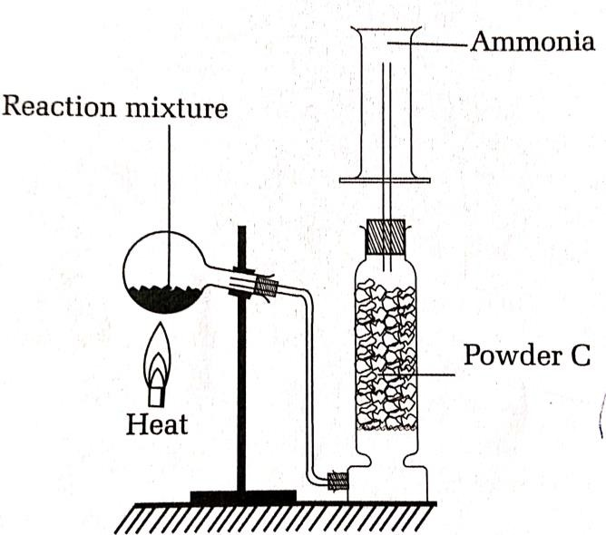
  - Identify
    - The reacting mixtures
    - The powder C.
  - i) what is the role of powder C?
ii) What property of the gas is shown by the method of collection?
  - A glass rod containing drop of concentrated hydrochloric acid was inserted into a gas jar of ammonia.
    - State what was observed.

    - Write the equation for the reaction.
  - What is the action of heat on a sample of what was produced in (C ).
- In the Habber process, hydrogen is made to react with nitrogen directly over a catalyst.
  - Give the equation for the reaction.
  - Name the catalyst used.
  - What other two conditions favour this reaction?
  - Give two sources of:
    - Nitrogen and
    - Hydrogen
  - Give two commercial uses of ammonia.
- When ammonia chloride (NH4Cl) is heated with calcium hydroxide, Ca(OH)2, a salt, water and ammonia gas are produced.
  - Write a balanced equation for the reaction between ammonium chloride and calcium hydroxide.
  - Ammonium salts often sublime when heated. What is meant by the term sublimation?
  - Calculate the percentage by mass of nitrogen in NH4Cl. (N=14, H=1, Cl= 35,5)
  - Ammonia gas is manufactured on a large scale by the Haber process according to the equation.
NH3(g) + 3H2(g) 2NH3(g)
    - What does the sign mean in the equation?
    - How is nitrogen obtained for use in the Haber process?
    - What would be the effect on the amount of ammonia produced if the pressure was increased beyond 600 atm?
    - What would be the effect on the amount of ammonia produced if the temperature was increased beyond 6000C?
  - State the temperature ranges and the catalyst used in the above process.
  - Write balanced equations to show how ammonia reacts with:
    - HCl
    - CuO
    - H2O
  - State two large scale use of ammonia.

- Ammonia gas is used to manufacture nitric as shown below in the flowchart below:
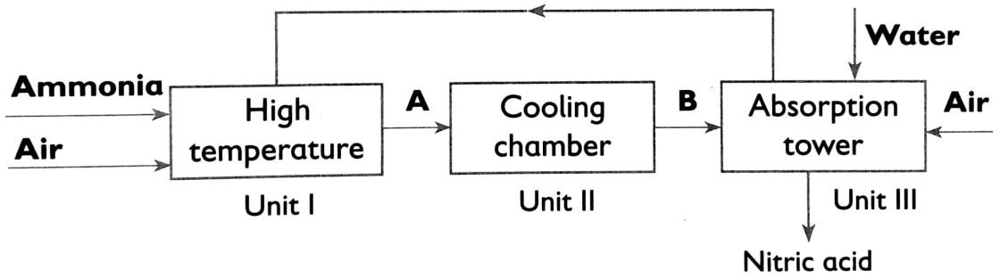
  - The process shown above requires the use of a catalyst. In which unit is the catalyst used?
  - Identify compounds A and B.
  - Use chemical equations to explain conversion of ammonia to nitric acid.
  - Concentrated nitric acid was added to iron (II) sulphate acidified with sulphuric acid and the mixture heated. The solution turned from pale green to yellow with evolution of brown gas. Explain the observations.
- a) Give equations for the reactions taking place between dilute nitric acid and:
- Potassium hydroxide solution
- Lead (II) oxide
- Copper (II) carbonate
- Copper metal
  - State what is observed when concentrated nitric acid is added to:
    - Copper
    - Sulphur
    - Carbon
- Describe the industrial preparation of nitric acid from ammonia (diagram is not required). Your description should include equation for reactions that occur.

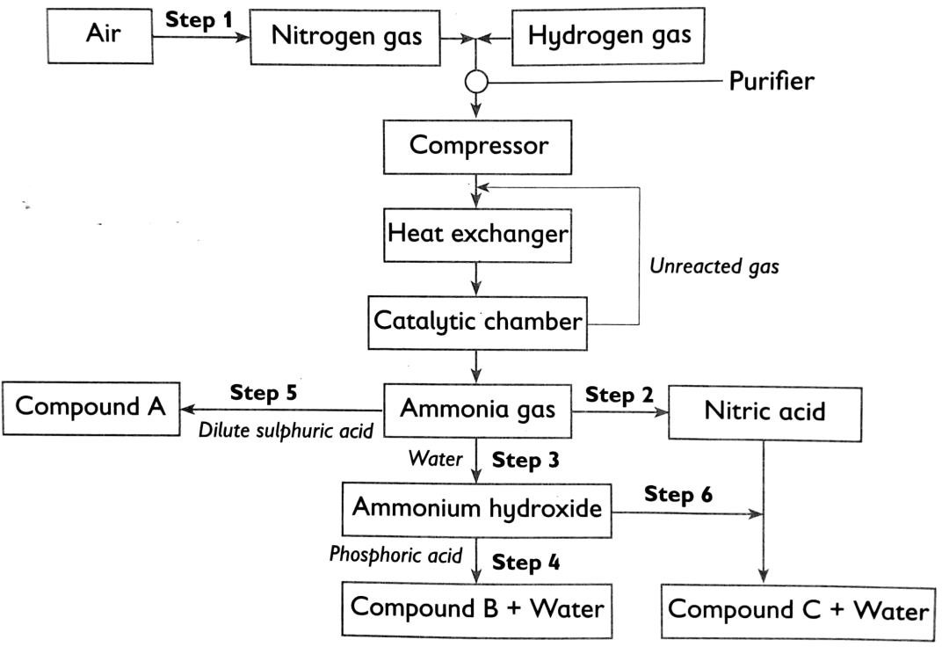
- The flowchart below shows the industrial preparation of ammonia and the processes used in the manufacture of some ammonium compounds. Study it and answer the questions that follows.
  - i) Give name of step 1.
- State one possible source of hydrogen gas.
- Explain why it is necessary to compress nitrogen and hydrogen in this process.
  - Name the catalyst and reagents used in step 2.
  - Give the names of:
    - Compound A.
    - Compound B.
    - Compound C.
  - Write chemical equations for reactions in:
    - Step 3
    - Step 6
  - Give one commercial use of compounds A and C.

UNIT 3: SULPHUR AND ITS INRGANIC COMPOUNDS
- Sulphur
Sulfur is the second member of group VIa, and comes just below oxygen. The atomic number is 16 and the electronic configuration is 2:8:6, so the 16 electrons are arranged in three main energy levels (shells), with the outer shell containing six electrons

Occurrence of sulphur
Sulphur occurs:
- As a pure element in underground Sulphur deposits.
- In the combined state with other elements such as,
- metal sulphides, like: iron pyrites: FeS2, zinc blende: ZnS, galena: PbS, and copper pyrite CuFeS2.
- sulfates like gypsum, CaSO4•2H2O, and baryte, BaSO4, Hydrogen sulphide (H2S) gas found in petroleum, As a product of volcano lava.

Allotropes of sulphur
Sulphur is one of the few non-metal elements which exist as allotropes. The two crystalline forms of Sulphur are rhombic Sulphur and monoclinic Sulphur. Both of these solid forms of Sulphur made up of S8 molecules structure at room temperature.
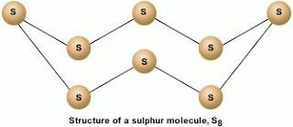

The table below summarizes the differences between the two allotropes of Sulphur (properties)
Rhombic Sulphur | Monoclinic Sulphur
Octahedral shaped | Prism shaped
Stable at temperatures below 96˚C | Unstable at temperatures below 96˚C
Melting point 113 ˚C | Melting point 119˚C
Density 2.08 g/cm3 | Density 1.98 g/cm3

Extraction and production of sulphur
Sulphur is extracted from its underground deposits by using Frasch process by using three pipes. The outermost pipe contains superheated water, which melts the sulfur. The innermost pipe is filled with hot compressed air, which serves to create foam. The central pipe forced up the molten sulfur to the surface.
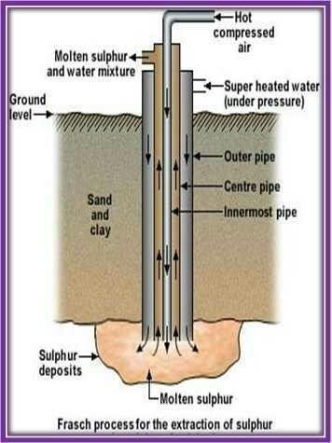

Properties of sulphur
- Physical properties of sulphur
- Sulphur is a yellow non-metallic solid
- It has boiling point of 4440C
- It is insoluble in water but soluble in organic solvent
- Sulphur does not conduct heat and electricity
- It burns in oxygen with a blue flame.

Chemical properties of sulphur

Reaction of Sulphur with oxygen
Sulphur burns in oxygen (air) with a blue flame to form Sulphur dioxide gas
S(s) + O2(g) SO2(g)

Reaction of Sulphur with hydrogen
The reaction between hydrogen and sulfur produces hydrogen sulphide. H2 (g) + S(s) H2S(g)

Reaction of Sulphur with metals
Sulfur can react with metals like iron, copper and zinc by heating the mixtures Fe (s) + S (s) Heat FeS (s)
Zn (s) + S (s) Heat ZnS (s)
2Cu(s) + S(s) Heat Cu2S(s)

Reaction of Sulphur with acids
Concentrated sulphuric acid oxidizes Sulphur to Sulphur dioxide gas. S(s) + 2H2SO4 (l) 3SO2 (g) + 2H2O(l)
Concentrated nitric acid also oxidizes Sulphur to sulphuric acid, H2SO4 S(s) + 6HNO3(l) H2SO4(aq) + 6NO2(g) + 2H2O(l)

Uses of sulphur
Sulphur is used:
- To manufacture sulphuric acid and Sulphur dioxide.
- For vulcanization of rubber
- To manufacture of matches
- To manufacture medicines. (e.g. sulphonamides such as sulphadimidine, sulphadiazine, sulphafurazole)
- For making gun powder.

Inorganic compounds of Sulphur
- Sulphur dioxide, SO₂

Laboratory preparation of Sulphur dioxide
- From sodium suphite
- Sulphuric acid, H2SO4 or concentrated HCl is added to crystals of Na2SO3 in round bottomed flask. The gas is dried by H2SO4 acid and collected by downward or upward displacement of air.

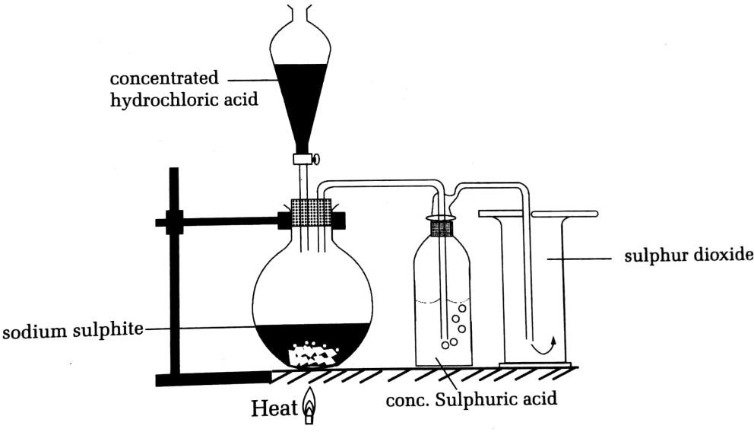

Equation of reaction:
Na2SO3(s) + 2HCl(aq) 2NaCl(aq) + H2O(l) + SO2(g)

From copper turnings
By reacting copper with concentrated sulphuric acid. The gas can be dried by concentrated H2SO4 and collected by downward delivery or upward displacement of air.
Cu(s) + 2H2SO4(l) CuSO4(aq) + 2H2O(l) + SO2(g)

physical properties of Sulphur dioxide
Sulphur dioxide
- is colourless gas
- has an irritating chocking smell
- is very soluble in water
- is denser than air. That why it is collected by downward delivery.

Chemical properties of Sulphur dioxide
- Reaction with water
SO2 is very soluble in water; it dissolves in water and forms a weak sulphurous acid, H2SO3.
SO2(g) + H2O(l) H2SO3(aq)

This acid is responsible for the formation of acid rain. Hence sulphur dioxide is an atmospheric pollutant.

- Bleaching action of Sulphur dioxide
- The word bleach is used to show that the color is being lost.
- The coloring matter of a dye turns to white (if in solid form) or turns to colorless (if in liquid form)
- When moist blue or red flowers are added to a gas jar full of Sulphur dioxide, the blue or red color on the flowers are turned colorless (i.e. the flowers are bleached).
Note: SO2 is a bleaching agent when wet. The gas first reacts with water to give sulphurous (H2SO3). this acid contains sulphite ions (SO32-) which accept oxygen in the dye. The dye (colored substance) is then beached.
1st stage: SO2 (g) + H2O(l) H2SO3(aq)
The acid contains the sulphite ion, SO32-(aq)
This ion removes oxygen from the coloured dye , leaving it colouless.
2nd stage: H2SO3 (aq) + Dye H2SO4(aq) + [Dye-O]
Coloured Colourless

Or

Note:

+ Dye + [Dye−O]
Coloured Colourless

- SO2 bleaches by reduction because it removes oxygen from the coloured substance and making it colouless.
- Bleaching by SO2 is temporary because the bleached material may regain its colour by absorbing atmospheric oxygen.

- Combustion reaction
SO2 combines with oxygen in the presence of vanadium (V) oxide, V2O5, as catalyst to form Sulphur trioxide SO3.
SO2 (g) + O2(g) 2SO3(g)

- Reaction of Sulphur dioxide with alkalis
When sulphur dioxide is passed through sodium hydroxide solution, neutralization reaction occurs.
SO2(g) + NaOH(aq) Na2SO3(aq) + H3O(l)

Test for SO₂
SO2 is tested by using:
- An acidified solution of potassium dichromate, K2Cr2O7 (orange). Observation: SO2 changes the color of potassium dichromate from orange to green.
- An acidified solution of potassium manganate(VII), KMnO4(purple)
Observation: SO2 changes the color of potassium manganate(VII) from purple to
colorless

Uses of Sulphur dioxide, SO₂
SO2 is used:
  - In the manufacture of sulfuric acid in contact process.
  - As bleaching agent.
  - It is used to bleach paper, wool or straw
  - Liquid Sulphur dioxide is used as refrigerant.
  - As a fumigant. Since the gas is poisonous, it can be used to kill germs in houses, clothing and grain.

Environment issues related to Sulphur oxides
- Sulphur dioxide causes acid rain. Some effects of acid rain are: Corrosion of building, makes water acidic.
- Sulphur dioxide causes greenhouse effect and global warming
- Sulfur dioxide causes respiratory diseases, particularly lung function, and can irritate the eyes.

Sulphuric acid, H₂SO₄

Industrial preparation of sulphuric acid (contact process)
Sulphuric acid is not prepared in the laboratory. We use the industrial method to prepare H2SO4. one of method used is the contact process.
The raw materials in this process are:
- Sulphur or metal sulphide (FeS2, ZnS, and PbS)
- Oxygen, O2
- Distilled water (H2O)

The process takes place in the following stages

Making the Sulphur dioxide
Sulphur dioxide is obtained by either burning Sulphur in an excess of air or roasting(heating) metal sulphides like pyrite (FeS2) in an excess of air in combustion chamber.
S(s) + O2 (g) SO2 (g) or
4FeS 2(s) + 11O2 (g) 2Fe2O3 (s) + 8 SO2 (g)

Converting the Sulphur dioxide (SO₂) into Sulphur trioxide, SO₃
Here the Sulphur dioxide combine with oxygen to form Sulphur trioxide, SO3. The reaction is a reversible reaction, and the formation of the Sulphur trioxide is exothermic.
SO2(g) + O2(g) SO3(g)
Conditions required are:
- Catalyst called vanadium pentoxide: V2O5
- Temperature: 400 0C - 450 oC
- Pressure: 1-2atm

Converting the Sulphur trioxide (SO₃) into Sulphur acid, H₂SO₄
This cannot be done by simply adding water to the sulphur trioxide. It is because Sulphur trioxide dissolves in water, producing a large amount of heat which changes sulphuric acid to sulphuric acid mist.
The sulphur trioxide is first dissolved in concentrated sulphuric acid to form oleum
or fuming sulphuric acid.
SO3 (g) + H2SO4 (aq) H2S2O7 (l)
Oleum
This can then be reacted safely with water to produce concentrated sulphuric acid, twice as much as you originally used to make the fuming sulphuric acid.
H2S2O7 (l) + H2O (l) 2H2SO4 (l)

Properties of sulphuric acid

Properties of concentrated sulphuric acid
- Physical properties of sulphuric acid
  - Concentrated sulphuric acid is 98 % acid and 2 % water
  - It is colorless, odorless oily liquid
  - It has a density of 1.84 g/cm3

  - It is a liquid at room temperature and boils at 3380C
Note: When diluting the acid, always add the acid into water and never water into the acid.

Chemical properties of sulphuric acid
- Chemical properties of concentrated H₂SO₄
  - Concentrated H2SO4 acid is a dehydrating agent: Dehydration means removal of water molecules or the elements of water (hydrogen and oxygen) form a chemical substance. This means that the acid removes the elements of water from the substance.
- When concentrated sulfuric acid is added to sugar, the elements of water (hydrogen and oxygen) are removed from the sugar, leaving behind a black solid carbon.
C12H22O11 (s) concH2SO4(l) 12C (s) + 11H2O (l)
Black
- Concentrated sulphuric acid will remove the water of crystallisation from copper (ll) sulphate crystals. The blue hydrated copper (II) sulfate turns white.
CuSO4 • 5H2O(s) concH2SO4(l) CuSO4(s) + 5H2O(g)
Blue White steam

- Concentrated sulphuric acid is a powerful oxidizing agent
- The reaction of copper with concentrated sulphuric acid produces sulphur dioxide.
Cu(s) + 2 H2SO4 (l) CuSO4 (aq) + 2H2O(l) + SO2(g)
- Non-metals such as carbon and sulphur are also oxidized by the hot concentrated acid to give carbon dioxide or sulphur dioxide
S(s) + 2H2SO4 (l) 3SO2 (g) + 2H2O(l
C(s) + 2H2SO4(l) CO2(g) + 2SO2(g) + 2H2O(l)

Chemical properties of dilute H₂SO₄
Dilute sulphuric acid like all mineral acids reacts with metal, metal oxides, metal hydroxide (alkalis) and metal carbonates.
- Reaction with metals
Dilute sulphuric acid reacts with metals to form salt and hydrogen gas: Zn + H2SO4(aq) ZnSO4(aq) + H2(g)
Mg(s) + H2SO4(aq) MgSO4(aq) + H2(g)
- Reaction with metal oxide to form salt and water
ZnO (s) + H2SO4(aq) ZnSO4(aq) + H2O (l)

CuO(s) + H2SO4(aq) CuSO4(aq) + H2O(l)
- Reaction with alkali to form salt and water
2NaOH(aq) + H2SO4(aq) Na2SO4(aq) + 2H2O(l)

- Reaction with carbonates to form salt, carbon dioxide and water
ZnCO3(aq) + H2SO4(aq) ZnSO4(aq) + CO2(g) + H2O(l)

Uses of sulphuric acid
Sulphuric acid is used:
- To manufacture fertilizers, Such as ammonium sulphate.
- To manufacture paints and pigments.
- As a drying agent for gases which do not react with water (e.g. SO2, Cl2, HCl, and H2)
- In the manufacture of detergents.
- As an electrolyte in lead accumulators.
- In the production of metallic sulphates, hydrochloric acid and plastics.
- In cleaning of metal surfaces.

iii. Sulphates
Sulphates are normal salts derived from sulphuric acid and contain the sulphate ion, SO42-

Preparation of Soluble sulphates
Soluble sulphates are prepared by the action of dilute sulphuric acid on the
metals, oxides, hydroxides, or carbonates of the metal.
- Reaction of sulphuric acid with metals
Dilute sulphuric acid reacts with metals to form salt and hydrogen gas: Zn + H2SO4(aq) ZnSO4(aq) + H2(g)
Mg(s) + H2SO4(aq) MgSO4(aq) + H2(g)
- Reaction of sulphuric acid with metal oxides
ZnO (s) + H2SO4(aq) ZnSO4(aq) + H2O (l)
CuO(s) + H2SO4(aq) CuSO4(aq) + H2O(l)
- Reaction of sulphuric acid with alkalis
2NaOH(aq) + H2SO4(aq) Na2SO4(aq) + 2H2O(l)
- Insoluble sulphates such as (BaSO4 and PbSO4 and CaSO4) are prepared by precipitation method.
Ba(NO3)2(aq) + MgSO4(aq) BaSO4(s) + Mg(NO3)2(aq)
Ca(NO3)2(aq) + Na2SO4(aq) CaSO4(s) + 2NaNO3(aq)
Pb(NO3)2(aq) + Na2SO4(aq) PbSO4(s) + 2NaNO3(aq)

Test for sulphate and sulphite ions
Reagent: To an aqueous solution of any sulphate, add barium nitrate solution solution followed by dilute nitric acid

Observation:
- with , a white precipitate of barium sulphate forms which does not dissolve in nitric acid.
- With , a white precipitate of barium sulphite is formed. The
precipitate dissolves in nitric acid.

Equation: + BaSO4(s)
White precipitate, not dissolve in nitric acid
+ BaSO3(s)
White precipitate, dissolves in nitric acid

Uses of some sulphates
- Calcium sulphate is used to make plaster casts used on patients with broken bones.
- Ammonium sulphate is used in water treatment and purification.

EXERCISES
- Name two allotropes of Sulphur.
- a) Write a balanced chemical equation to show the reaction between Sulphur and
  - Oxygen gas
  - Concentrated nitric acid.
b) Outline 3 physical properties of Sulphur dioxide.
- Study the diagram below representing the preparation and collection of Sulphur dioxide in the laboratory.
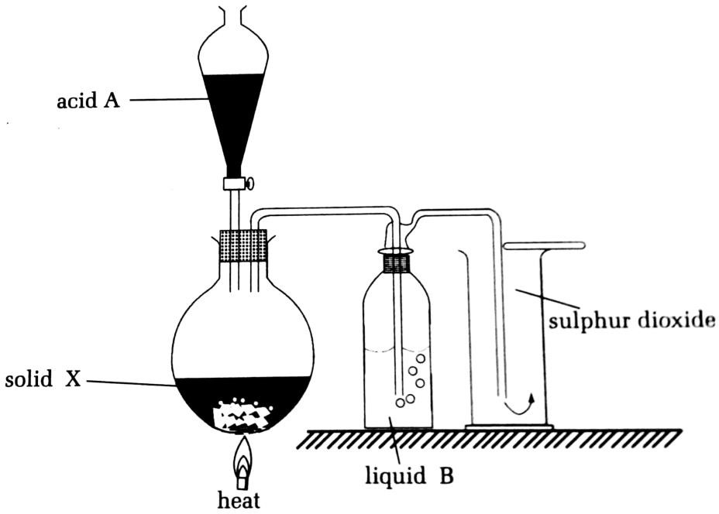
- Identify X, A and B
- i) write the equation for the reaction in the flask.
ii) What is the purpose of liquid B?
- Describe what is observed when sulphuric dioxide is passed into an acidified aqueous solution of:
  - Potassium manganite (VII)
  - Potassium dichromate
- State a physical property of Sulphur dioxide that is related to its method of collection.
- i) Name two ways in which Sulphur Sulphur dioxide is produced on an industrial scale.
- Write the equations for the reactions in (d) (i).
- Name three commercial uses of the gas.
- Describe ant two dangers associated with industrial production of Sulphur dioxide.

- During industrial manufacture of sulphuric acid, Sulphur trioxide is dissolved in concentrated sulphuric acid to form oleum.
- i) Why is the gas not dissolved directly in water to form sulphuric acid?
ii) Write a word equation to show how the gas dissolves in concentrated sulphuric acid to form oleum.
- Outline 3 uses of the following:
  - Sulphuric acid
  - Sulphur dioxide gas.
- a) Show by means of equations how dilute sulphuric acid reacts with the following:
- Zinc metal
- Copper (II) carbonate
- Sodium hydroxide solution.
- How would concentrated sulphuric acid react with the following:
  - Hydrated copper (II) Sulphate, CuSO4●H2O
  - Sugar, C6H12O6
  - Copper metal.
  - Crabon
- Amina added barium chloride solution to sodium sulphite solution and sodium sulphate solution. She then added drops of dilute hydrochloric acid in the two samples.
- What observations did she make in:
  - A test tube containing sodium sulphite?
  - A test tube containing sodium sulphate?
- Write a balanced chemical equation for the reaction between sodium sulphate and barium chloride.
- Sulphuric acid is manufactured in the contact process according to the steps shown below:
I: Sulphur is buned in air (oxygen).
II: The product is reacted with more air (oxygen) in the presence of a catalyst to form Sulphur dioxide.
III: Sulphur trioxide is absorbed in concentrated acid and then diluted with water.
- Give a balanced equation for the reaction in step I.
- Give a balanced equation for the reaction in step II.
- Name the catalyst used in step II.
- Briefly, explain why Sulphur trioxide is not directly reacted with water.
- Some Sulphur dioxide may escape into the atmosphere. Explain an environmental problem this may cause.
- Give two large scale uses of sulphuric acid.

UNIT 4: CHLORINE AND ITS INRGANIC COMPOUNDS
- Chlorine
Chlorine is an element found in group VIIa and period 3 of the periodic table. Its atomic number is 17 and it has electronic structure 2,8,7. Just like other elements, chlorine gains one extra electrons to fill its outer most electron shell. Chlorine comes from the Greek word chloros means green.

Laboratory preparation of chlorine
- Chlorine is prepared by the reaction between potassium permanganate (KMnO4) with concentrated hydrochloric acid(HCl). There is no heating during the reaction since potassium permanganate is a stronger oxidizing agent.
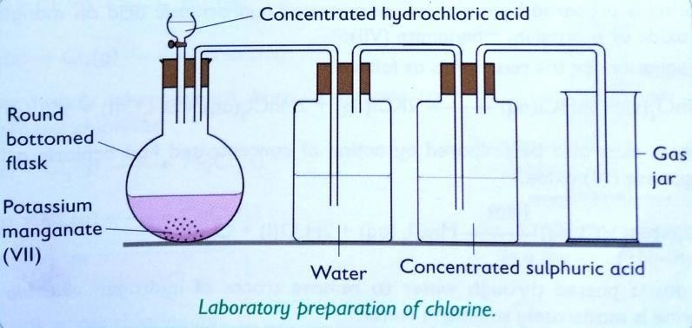

Equation for the reaction is:
2KMnO4(s) + 16HCl(l) 2KCl(aq) + 2MnCl2(aq) + 8H2O(l) + 5Cl2(g)
- It can also be prepared by reacting manganese (IV) oxide(MnO2) with concentrated hydrochloric acid(HCl). The mixture requires heating.
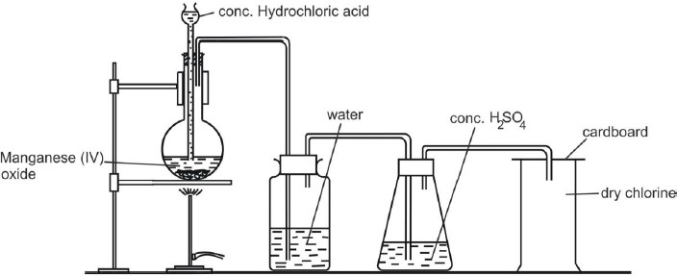

Equation for the reaction is:
MnO(2) + 4HCl(g) MnCl2(aq) + 2H2O(l) + Cl2(g)
Note:
The water is used for removing unreacted Hydrogen Chloride fumes and the concentrated H2SO4 is for drying chlorine gas, and then it is collected by downward delivery since it is denser than air.

Physical properties of chlorine
Chlorine gas:
    - Is a gree-yellow in colour
    - Has an irritating chocking smell
    - Is denser than air, that is why it is collected by downward delivery.
    - Is a poisonous gas
    - Is slightly soluble in water.

  - Chemical properties of chlorine

Reaction of chlorine with water
Chlorine dissolves slightly in water, forming a pale yellow solution known as chlorine water. Chlorine water is a mixture of hydrochloric acid and hypochlorous acid. The solution turns blue litmus paper red, which means the solution is acidic.
Cl2(g) + H2O(l) HCl(aq) + HOCl(aq)
Hydrochloric acid hypochlorous acid
When chlorine water is exposed to the sunlight, the pale yellow color of the chlorine water fades and a colorless, odorless gas of oxygen is given off, as chloric (I) acid is reduced to hydrochloric acid.
2HOCl(aq) UV sunlight 2HCl(aq) + O2(g) Or
HCl(aq) + 2HOCl(aq) UV sunlight 3HCl(aq) + O2(g)

Bleaching action of chlorine
  - Chlorine water contains hypochlorous acid HOCl.
  - Household bleach contain sodium hypochlorite NaOCl.
  - Both solutions contain the hypochlorite ion, OCl−
  - The hypochlorite ion gives up its oxygen to the coloured dye, thus making it colourless as follows:

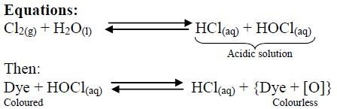

- The coloring matter of a dye is bleached to white (if in solid form) or colorless (if in liquid form)
- In the absence of water, bleaching does not occur as hypochlorous acid responsible for bleaching action is not formed.
Note:
  - Chlorine bleaches by oxidation because it gives oxygen to the coloured substance and making it colouless.
  - Bleaching by Chlorine is permanent because the bleached material may not regain its colour by absorbing atmospheric oxygen.

Difference between bleaching done by Sulphur dioxide and bleaching done chlorine
- Sulphur dioxide bleaches by reduction while chlorine bleaches by
oxidation.
- Bleaching by Sulphur dioxide is temporary while bleaching by chlorine is
permanent

Reaction of chlorine with metals
Chlorine reacts with magnesium and iron, forming white magnesium chloride and black iron (III) chloride.
Mg(s) + Cl2(g) MgCl2(s)
white
2Fe(s) + 3Cl2(g) 2FeCl3(s)
black

Reaction of chlorine with non-metals
Chlorine reacts with non-metals, forming the corresponding chlorides.
- Chlorine reacts with hydrogen to form hydrogen chloride.
H2(g) + Cl2(g) 2HCl(g)
- Chlorine combines directly with phosphorous in the presence of heat. It forms phosphorous trichloride or phosphorous pentachloride if chlorine is in excess.
2P(s) + 3Cl2(g) 2PCl3(s)
2P(s) + 5Cl2(g) 2PCl5(s)

Reaction of chlorine with cold and dilute alkalis
- Chlorine reacts with cold and dilute solution of either NaOH or KOH to form a pale yellow solution of sodium hypochlorite or potassium hypochlorite, sodium chloride or potassium chloride and water.
Cl2 (g) + 2NaOH (aq) NaOCl (aq) + NaCl (aq) + H2O (l)
Cl2(g) + 2KOH (aq) KOCl (aq) + KCl (aq) + H2O (l)
- Chlorine reacts with a hot solution of sodium hydroxide or potassium hydroxide to give a mixture of sodium chlorate, NaClO3 or potassium chlorate KClO3, sodium chloride, NaCl or potassium chloride KCl and water.
3Cl2 (g) + 6NaOH (aq) NaClO3(aq) + 5NaCl (aq) + 3H2O (l)
3Cl2(g) + 6KOH (aq) KClO3(aq) + 5KCl (aq) + 3H2O (l)

Oxidizing action of chlorine
Chlorine oxidizes green aqueous iron (II) chloride to brown iron (III) chloride.
2FeCl2(aq) + Cl2(g) 2FeCl3(aq)
Green Brown

Displacement reaction by chlorine
- Chlorine removes hydrogen from hydrides of non-metals, forming hydrogen chloride and leaving the non-metal element.
Cl2(g) + H2S(aq) S(s) + 2HCl(aq)
- Reaction with a solution of potassium bromide
When chlorine gas is bubbled through a solution of potassium bromide, the solution turns from colourless to red. Means that chlorine oxidizes KBr into Br2.
KBr (aq) + Cl2 (g) 2KCl (aq) + Br2(aq)
Colourless Red

- Reaction with a solution of potassium iodide
Bubbling chlorine gas through a solution of potassium iodide, the chlorine turns the solution from colourless to brown. Means that chlorine oxidizes KI into I2
2KI (aq) + Cl2 (g) 2KCl (aq) + I2 (aq)
Colourless Brown

  - Test for chlorine
1st way
Reagent: Add damp blue litmus paper to chlorine gas.
Observation: Chlorine will first turn damp blue litmus paper red and then quickly bleach it to white

2nd way
Reagent: Use potassium bromide solution (Colourless)
Observation: When chlorine is bubbling through the solution, it turns from
colourless to red. or
3nd way
Reagent: Use potassium iodide solution (Colourless)
Observation: When chlorine is bubbling through the solution, it turns from
colourless to brown.

Uses of chlorine
Chlorine is used:
- In the manufacture of plastics (e.g. PVC used in making plastic water pipes, chairs and tables.
- As a bleaching agent. It bleaches coloured flower, leaves, wood pulp, etc.
- To manufacture hydrochloric acid.
- In the treatment of water and sewage.
- To kill bacteria in swimming pool (Means that it acts as disinfectant).
- Used in manufacture of insecticides e.g. DDT (Dichlorodiphenyl trichloroethane).
- To manufacture of dyes
- In manufacture of anesthetics. E.g. chloroform (CHCl3).

Inorganic compounds of chlorine
- Hydrogen chloride

Laboratory preparation of hydrogen chloride
Hydrogen chloride gas is prepared by the action of concentrated sulphuric acid on common salt (sodium chloride). The gas is dried by passing it through a wash bottle of concentrated sulphuric acid. Heat gently if necessary and the gas is collected by downward delivery

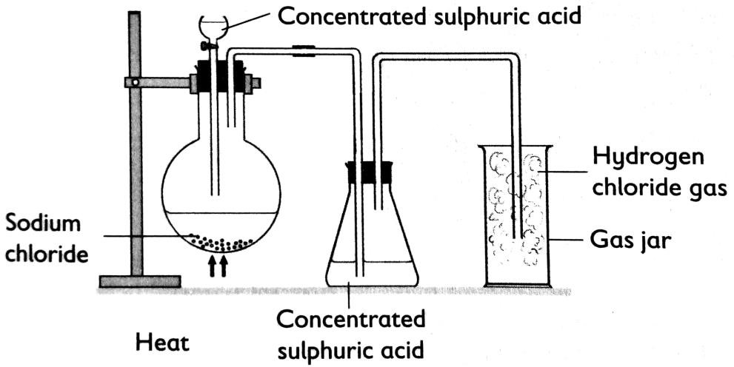

Physical properties of hydrogen chloride
Hydrogen Chloride:
- Is a colorless gas with a choking, irritating smell.
- Is denser than air, that is why it is collected by downward delivery.
- Forms white fumes in air.
- Is very soluble in water, forming hydrochloric acid, HCl(g) + H2O(l) HCl(aq)
- Turns moist blue litmus paper red, showing that it is an acidic gas

Chemical properties of hydrogen chloride

Reaction with water
Hydrogen chloride is very soluble in water, forming hydrochloric acid. The solution turns blue litmus paper red.
HCl(g) + H2O(l) H3O+(aq) + Cl─(aq)

Reaction with ammonia
Hydrogen chloride reacts with ammonia to form dense white fumes of ammonium chloride.
NH3(g) + HCl(g) NH4Cl(s)

Reaction with metals
When heated with iron metal, hydrogen chloride forms iron (ll)chloride.
Fe(s) + 2HCl(g) FeCl2(s) + H2(g)
When hydrogen chloride gas is passed over heated metals such as sodium, magnesium and zinc, the metals combine with the gas to form their respective metal chlorides. Hydrogen gas is liberated in the process.
Zn(s) + 2HCl(g) ZnCl2(s) + H2(g)

2Na(s) + 2HCl(g) 2NaCl(s) + H2(g)

Reaction with acidified silver nitrate solution
In this reaction, hydrogen chloride gas first dissolves in water contained in silver nitrate solution to yield hydrogen ions and chloride ions (Hydrochloric acid). The hydrochloric acid then reacts with silver nitrate to form white insoluble silver chloride.
HCl(aq) + AgNO3(aq ) AgCl(s) + HNO3(aq)
White precipitate
Ionic equation is: Ag+(aq) + Cl─(aq) AgCl(s)
White precipitate

Test for hydrogen chloride
When a moist blue litmus paper is placed at the mouth of the test tube containing the gas, it turns red.
When the mouth of test tube containing HCl gas is brought near the mouth of a bottle containing ammonia gas, white fumes of ammonium chloride are formed.
NH3(g) + HCl(g) NH4Cl(s)

When silver nitrate solution acidified with nitric acid is added to the test tube containing the gas white precipitate of silver chloride is formed. This is because of the chloride ions formed in the aqueous solution.
AgNO3(aq) + HCl(aq) HNO3(aq) + AgCl(s)
White precipitate
The ionic equation is : Ag+(aq) + Cl─(aq) AgCl(s)
White precipitate

Uses of hydrogen chloride
Hydrogen chloride is used:
- In the production of hydrochloric acid.
- In the preparation of chlorine.
- In the production of vinyl and alkyl chlorides.
- In the hydrochlorination of rubber.

Hydrochloric acid, HCl_{(aq)}

Industrial preparation of hydrochloric acid
Hydrochloric acid is manufactured by dissolving hydrogen chloride gas in water. This has the same formula but you can tell the difference because of the state symbol (aq) , which stands for "aqueous". The formula is written as HCl(aq). In water hydrogen chloride produces hydroxonium and chloride ions and the hydroxonium is responsible for the acidic properties.
HCl(g) + H2O(l) H3O+(aq) + Cl─(aq)
All this takes place in water in an absorption tower. The absorption tower yields an acid solution which is 35%.

Chemical properties of hydrochloric acid
A solution of hydrogen chloride is called hydrochloric acid. Dilute hydrochloric acid reacts with some metals, metal oxides, metal hydroxides, metal carbonates and metal hydrogen carbonates.

Examples:

Reaction with metals
Hydrochloric acid reacts with metals to give metal chloride and hydrogen gas. Mg(s) + 2HCl(aq) MgCl2(aq) + H2(g)
Zn(s) + 2HCl(aq) ZnCl2(aq) + H2(g)

Reaction with bases
Dilute hydrochloric acid reacts with basic oxides and alkalis to give salt and water.
MgO(s) + 2HCl(aq) MgCl2(aq) + H2O(g)
NaOH(aq) + HCl(aq) NaCl(aq) + H2O(l)

Reaction with carbonates and hydrogen carbonates
Dilute hydrochloric acid reacts with carbonates and hydrogen carbonates to give metal carbonate, water and carbon dioxide.
Na2CO3(s) + 2HCl(aq) 2NaCl(aq) + H2O(l) + CO2(g)
NaHCO3(s) + HCl(aq) NaCl(aq) + H2O(l) + CO2(g)

Uses of hydrochloric acid
Hydrochloric acid is used:
- In the production of drugs, paints, fertilizes and dyes.
- In cleaning metals surface before they are electroplated
- In the manufacture of plastics such as polyvinylchloride (e.g. PVC).
- In the photographic, textile, and rubber industries.
- In the removal of rust from iron before it is galvanized.

Sodium chloride, NaCl

Laboratory preparation of sodium chloride
Sodium chloride can be prepared by the action of hydrochloric acid on sodium hydroxide, sodium carbonate, and sodium hydrogen carbonate.
NaOH(aq) + HCl(aq) NaCl(aq) + H2O(l)
Na2CO3(aq) + 2HCl(aq) 2NaCl(aq) + H2O(aq) + CO2(g) NaHCO3(aq) + HCl(aq) NaCl(aq) + H2O(aq) + CO2(g) Sodium reacts with chlorine to form a white solids of sodium chloride. 2Na(s) + Cl2(g) 2NaCl(s)

Physical properties of sodium chloride
- It is white solid at room temperature.
- It is soluble in water.
- It does not conduct electricity in solid state. However, it conducts electricity in molten and in aqueous states.
- It has high melting and boiling points.

Chemical properties of sodium chloride

Reaction with concentrated sulphuric acid
Concentrated sulphuric acid reacts with sodium chloride to produce hydrogen chloride gas. NaCl(s) + H2SO4(l) NaHSO4(s) + HCl(g)

Reaction with silver nitrate solution
It reacts with silver nitrate solution to form silver chloride.
NaCl(aq) + AgNO3(aq) NaNO3(aq) + AgCl(s)
White precipitate

Uses of sodium chloride
- NaCl is used as a food flavour and food preservative.
- It is used in the manufacture of sodium, Chlorine, Sodium hydroxide
through electrolysis of concentrated aqueous solution (brine).
- It used in manufacture of soap during “salting out”.

Test for chlorides

Solid chloride
To any chloride, add concentrated sulphuric acid, hydrogen chloride gas is evolved. The gas turns moist blue litmus paper red, forms white fumes with ammonia and a white precipitate with acidified silver nitrate solution.
Example: NaCl(s) + H2SO4(l) HCl(g) + NaHSO4(s)
White fumes

Chloride solution
Reagent: Add silver nitrate solution followed by dilute nitric acid. Observation: a white precipitate is formed if chloride ions are present Equation: Ag+(aq) + Cl─ (aq) AgCl(s)
Dilute nitric acid prevents precipitation of other silver salts e.g. silver (I) carbonate Ag2CO3

Environmental issues of chlorine and its compounds (CFCs and toxicity of chlorine gas)
- Chlorine irritates the skin, the eye, and the respiratory system.
- Chlorine gas released into the atmosphere dissolves in rain leading to the formation of acid rain. Acid rain affects plants, animals and building.
- CFCs (Chlorofluorocarbons) destroy the ozone layer.
- CFCs (Chlorofluorocarbons) causes greenhouse effect and global warming.

EXERCISES
- a) When concentrated hydrochloric acid was added to manganese(IV) oxide and heated, the gas thus evolved, bleached litmus paper. Write the equation to show what happened.
  - Chlorine dissolves in water to give chlorine water.
    - Write the equation for the reaction that occurs.
    - When the chlorine water is exposed to sunlight a colourless gas,which gives a positive test with a glowing splint, is given off. Explain.
  - Materials bleached with chlorine do not gain colour with time as opposed to those bleached using Sulphur dioxide. Explain.
  - Chlorine can react with a cold dilute solution of potassium hydroxide, to form water and two other products.
    - Write the equation for the reaction.
    - Name the other two products.
    - Give the uses of the solution obtained above.

- a) With the aid of a well labeled diagram, describe an experiment to prepare chlorine gas from manganese (IV) oxide (MnO2)
- Write equations to show how Cl2 reacts with:
  - Iron (Fe)
  - Iron (II) chloride (FeCl2)
  - Water (H2O) Sodium hydroxide solution, NaOH.
- Chlorine gas is prepared by heating manganese (IV) oxide with concentrated hydrochloric acid. The gas is collected by downward delivery. It is highly reactive and strong oxidizing agent.
  - Describe a chemical test for chlorine gas.
  - Chlorine is a member of halogens of group 7 in the periodic table. how does the reactivity of halogens change down the group and why?
  - Using balanced equations, show the products formed when chlorine reacts with:
    - Sodium iodide
    - Sodium hydroxide at room temperature. iii Iron (II) chloride.
  - Aluminium chloride is prepared from chlorine by passing dry chlorine over hot aluminium. Aluminium chloride sublimes and is collected in the cooler part of the apparatus.
- What is sublimation?
- Write a balanced equation for the reaction of chlorine with aluminium. iii What mass of aluminium chloride is produced from 0.54g of aluminium?
(Cl =35.5 , Al = 27)

- During preparation of hydrochloric acid, hydrogen chloride gas is dissolved in water.
- Write a balanced chemical equation the shows how hydrogen chloride gas can be prepared from potassium chloride.
- Hydrogen chloride gas is highly soluble in water.
  - Draw a well labelled diagram to show the arrangement used for the safe absorption of hydrogen chloride gas in water.
  - Give two reasons why such an arrangement is necessary.
  - Hydrochloric acid is an important reagent. Give four uses of the acid in industries.
- Use the flow chart below to answer the questions that follow:

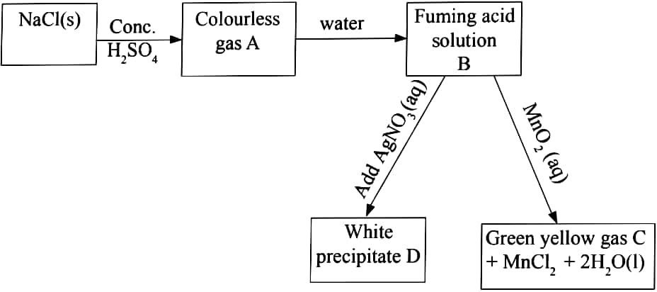
- Name gas A and C.
- Name precipitate D.
- Name the solid which can be heated with solution B to produce gas C.
- a) Silver nitrate can be used to distinguish between sodium chloride solution and sodium bromide solution. State the observations made when the solution is added to:
- Sodium chloride
- Sodium bromide
b. i) Describe how the presence of CFCs in the upper atmosphere increases the amount of ultra-violet rays reaching the earth’s surface.
    - Outline three environmental problem caused by CFCs.

- Dry chlorine can be prepared by the reaction between manganite (IV) oxide with concentrated sulphuric acid. Below is a diagram of this preparation:
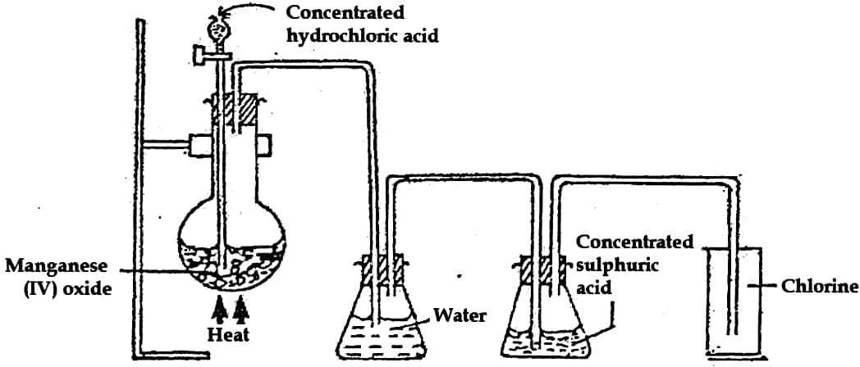
- Write the chemical equation of the reaction between manganese (IV) oxide and concentrated hydrochloric acid.
- What are the roles of water and concentrated sulphuric acid in this experiment?
- When chlorine reacts with iron:
    - Iron (II) chloride not formed.
    - State the compound that is instead of iron (II) chloride.
- With the aid of ionic equation, state what would be observed if chlorine was bubbled through the solution of:
  - Iron (II) sulphate
  - Potassium iodide
- Chlorine is a bleaching agent when in the presence of cold water. Write an equation for the reaction between chlorine and cold water.

UNIT 5: RATE OF REACTIONS
A chemical reaction only occurs when:
- Two particles (atoms or molecules) collide into each other and bond together by chemical forces to produce product. In order for the particles to be bonded together, the force of collision must be great enough to overcome the initial repulsive forces (the activation energy of the reaction).
- The reacting particles must collide with a certain minimum energy known as the
activation energy.
- A collision that results in a reaction is called effective collision.
- If the frequency of effective collision is high, the rate of reaction is also high.
- The rate of reaction depends on how many successful collisions there are in a given unit time.

Definition of rate of reaction
Rate of a chemical reaction /speed of reaction is the change of amount/or concentration of reactant(s) consumed or product(s) formed per unit time.
Chemical reactions proceed at different rates. e.g. Rusting of iron is a very slow process, but burning of sodium in air occurs rapidly while burning of charcoal is much slow.

The factors that affecting rate of chemical reaction are:
- Particle size of a solid reactant
- Concentration of a reactant (s) (In a solution form)
- Pressure of a reactant (s)
- Temperature of the reactants
- Catalyst
- light
A change in one or more of these factors may alter the rate of a reaction. In this unit, you will define these factors and describe their effects on reaction rates.

Effect of particle size on rate of chemical reaction
A decrease in the particle size of a solid reactant will increase the rate of reaction
while increase in particle size reduces the rate of reaction. Why?
Reducing the size of solid reactant, increases surface area, hence increases the frequency of effective collisions between the particles.

or
An increase in surface area of solids increases the area of contact with a liquid solution, hence increasing the chances of successful/ effective collision to form products.
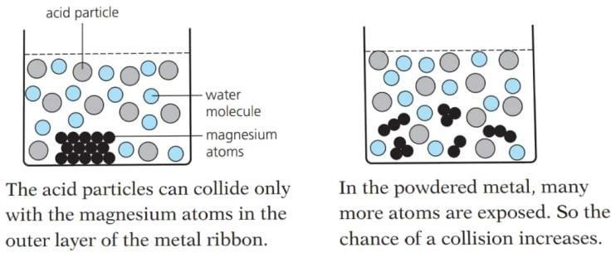

  - More surfaces mean more collision sites for particles as shown below:
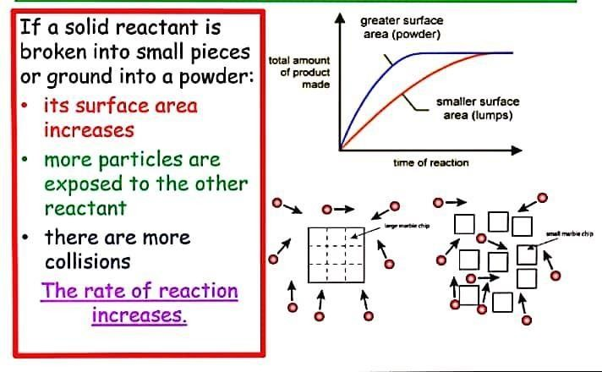

Surface area is the area of contact. An increase in surface area is a decrease in particle size. When a solid is in powder form it has a larger surface area than a solid lump. The larger the surface area, the more contact there is between the reacting particles, hence the number of effective collisions increases and the rate of reaction increases. That is why many solids are powdered using a mortar and pestle before being used in a reaction. Example of reaction where surface area is important is:
Mg(s) + 2HCl(aq) MgCl2(aq) + H2(g)
The reaction is fast when magnesium is in powder and slow when magnesium solid is lumps. Magnesium powder has largest surface area, while magnesium lumps has smallest surface area.

Effect of concentration on rate of chemical reaction
An increase in the concentration of one or more of the reactants will increase the rate of reaction.
Why?
- Increasing the concentration of solution increases the number of particles per unit volume, this increases the number of effective collisions between reacting particles. Thus, rate of reaction increases with increasing concentration.
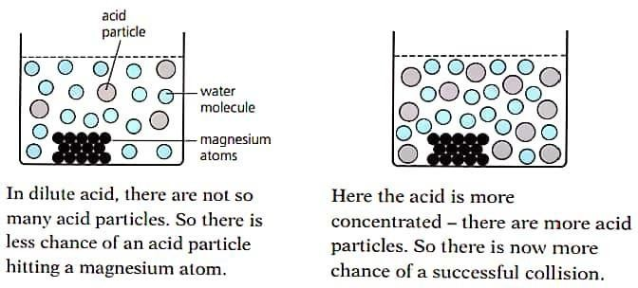

or
- Increase in concentration of the reactant(s) reduces the distance between the reacting particles hence increasing their collision frequency to form products. Example:
Reacting a known mass of magnesium ribbons with 1 M HCl and 2 M HCl, the rate of reaction is faster with 2 M HCl.

Effect of pressure on rate of chemical reaction
A change in the pressure will only affect the rate of reaction for chemical reactions involving gaseous reactants.
Why does increasing the pressure of gaseous reactants increase the rate of reaction?
The increase in pressure brings gas reactant particles closer together making them collide more often hence increasing the number of fruitful collisions. This leads to increases in rate of reaction and vice versa.
As the pressure increases, the space in which the gas particles are moving becomes smaller. The gas particles become closer together, increasing the frequency of collisions. This means that the particles are more likely to react.
Squeezes particles together allowing more collision as shown below:

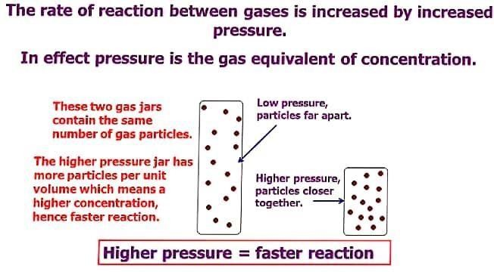

Pressure of gases can be increased by decreasing the volume of gas which brings the reacting particles closer together. Under higher pressure or at a higher concentration, gas molecules collide more frequently and react at a faster rate.
Conversely, increasing the volume of a gas decreases pressure which in turn decreases the collision frequency and thus reduces the reaction rate. Concentration of a gas is a function of the pressure on the gas. Increasing the pressure of a gas is exactly the same as increasing its concentration. If you have a certain number of gas molecules, you can increase the pressure by forcing them into a smaller volume.

Note: Solids and liquids are not affected by pressure changes.

Effect of temperature on rate of chemical reaction
An increase in the temperature will increase the rate of reaction for most chemical reactions. Why?
- Increasing the temperature increases the rate of reaction because the reacting particles move more quickly (faster) and collide more often with greater energy. This increases the number of effective collisions. Thus, rate of reaction increases when the temperature is increased.
Or
- Increase in temperature of solution, increases the kinetic energy of reacting particles, this makes the particles to collide more often hence increasing the number of successful collisions.

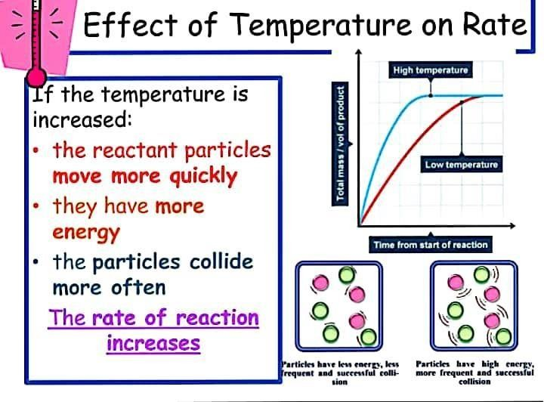

With the exception of some precipitation reactions involving ionic compounds in solution, just about all chemical reactions take place at a faster rate at higher temperatures. The question is why? Increasing the temperature, increases the kinetic energy and the speed of the reacting particles. This enables more reacting particles to have energy equal to or greater than the activation energy. Hence the number of effective collisions increases. This results in an increase in the rate of reaction. At higher temperatures, particles collide more frequently and with greater intensity.
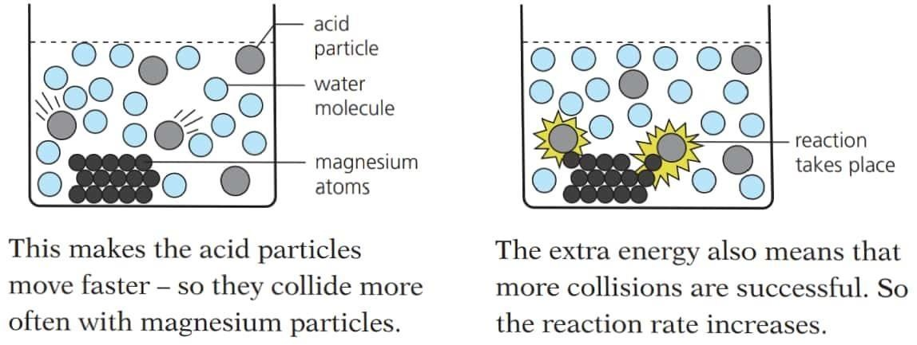

Note:
  - Increase in temperature increases the rate of a reaction which is endothermic
and it decreases the rate of an exothermic reaction.
  - Higher temperature means greater kinetic energy, more collisions between solute and solvent.

Effect of catalyst on rate of chemical reaction
A catalyst is a substance that increases the rate of a chemical reaction but remains chemically unchanged at the end of a reaction. This means that the mass of a catalyst is the same before and after a reaction occurs.
- A catalyst increases the rate of a reaction because it lowers the activation energy of the reactants, this increases the number of successful / effective collisions with enough activation energy to react hence increasing the rate of reaction.
- Activation energy is the minimum amount of energy reactants must overcome to proceed to form products.
How does a catalyst work?
A catalyst lowers the activation energy. This means that the particles can react with less energy than they needed before the catalyst was added. (Think about it: if the government lowered the legal age to buy cigarettes, then more people could legally buy cigarettes. Similarly, if we lower the amount of energy needed for particles to react, then more particles can react).
Example: 2H2O2(aq) MnO2 2H2O(l) + O2(g)
Production of oxygen is very slow. On addition of Manganese(IV) oxide (MnO2) the rate of reaction increases and oxygen gas is collected faster in the measuring cylinder.
Other examples of reactions require catalysts include:
- Fe catalyst is used in the manufacture of NH3
- Pt catalyst is used in the conversion of NH3 to NO in the production of nitric acid.
- Effect of light on rate of chemical reaction
Some chemical reactions require light energy to break bonds and initiate the reaction. These are referred to as photochemical reactions. The higher the intensity of light, the higher the reaction rate.
Examples:
- Photosynthesis: Plants traps energy when sunlight falls on leaves containing the green pigments, chlorophyll, and convert carbon dioxide gas from the atmosphere and water from the soil to glucose and oxygen.
6CO2(g) + 6H2O(l) UV light C6H12O6(g) + O2(g)

- Silver bromide decomposes in presence of sunlight while in darkness it does not.

2AgBr(s) Sunlight 2Ag(s) + Br2(g)

- Substitution reactions: A mixture of a halogen and an alkane undergo substitution reactions when placed in bright sunlight to form halogenoalkanes
CH4(g) + Cl2(g) UV light CH3Cl(g) + HCl(g)

EXERCISES
- a) What is meant by the term rate of chemical reaction?

  - State 4 factors that affect the rate of chemical reaction.
  - Which factor affects the rate of reaction by increasing kinetic energy of reacting particles.
- Explain briefly how the following factors affect rate of reaction. Use suitable examples in each case.
  - Temperature
  - Pressure
  - Size of particles
  - Concentration
  - Light
- Explain why increasing the concentration of reacting particles increases the rate of reaction.
- Explain why decreasing the particle size of the reactants increases the rate of reaction.
- Explain why increasing the temperature of reacting particles increases the rate of reaction.
- Explain why using a catalyst increases the rate of reaction.
- a) State whether additional of catalyst increases the amount of energy release during a chemical reaction.
b)Give two examples of catalysts and their uses in industry.
- Copper (II) oxide catalyses the decomposition of hydrogen peroxide. 0.5 g of the oxide was added to a flask containing 100cm3 of hydrogen peroxide solution. A gas was released. It was collected, and its volume noted every 10seconds. This table shows the results.
Time/s | 0 | 10 | 20 | 30 | 40 | 50 | 60 | 70 | 80 | 90
Volume/cm3 | 0 | 18 | 30 | 40 | 48 | 53 | 57 | 58 | 58 | 58
- What is a catalyst?
- Draw a diagram of suitable apparatus for this experiment.
- Name the gas that is formed.
- Write a balanced equation for the decomposition of hydrogen peroxide.
- Plot a graph of the volume of gas (vertical axis) against time (horizontal axis).

- Describe how rate changes during the reaction.
- What happens to the concentration of hydrogen peroxide as the reaction proceeds?
- What chemicals are present in the flask after 90 seconds?
- What mass of copper(II) oxide would be left in the flask at the end of the reaction?
- Name one other substance that catalyses this decomposition.
- In a class experiment to study the rate of reaction, 2 g of manganese(IV) oxide was added to a 50cm3 of diluted hydrogen peroxide solution at 250C. The volume of gas produced was measured at 10 seconds intervals and results are as follows.
Time/s | 0 | 10 | 20 | 30 | 40 | 50 | 60 | 70 | 80
Volume of gas/ cm3 | 0 | 60 | 90 | 105 | 112 | 116 | 118 | 120 | 120
  - Name the gas produced.
  - Write the equation for the for the reaction that took place.
  - Plot a graph of volume of gas produced against time. label this graph Z.
  - Use the graph to find:
    - Volume of gas produced after 35 seconds.
    - Time to produce 100 cm3 of the gas.
  - Explain why the volume of gas does not exceed 120cm3 ?
  - The mass of manganese(IV) oxide after the experiment was found to be 2g when dried. Explain.
- In an experiment to determine how hydrogen is produced when magnesium powder reacts with dilute hydrochloric acid, the volume of hydrogen produced was measured at different intervals. The following results were obtained.

Time/ minutes | 0 |  | 1 |  | 2 |  | 3 |  | 4 |  | 5 |  | 6
Volume of hydrogen  /cm3 | 0 | 8 | 14 | 20 | 25 | 29 | 33 | 36 | 38 | 39 | 40 | 40 | 40 | 40

  - Plot a graph of volume of H2 produced (on the Y-axis) versus time (X- axis).
  - Why is the volume of H2 constant in the last three results?
  - Suggest a suitable instrument or piece of apparatus that can be used to measure the volume of H2.
  - Why is the volume of H2 = 0 cm3 when the time= 0 seconds?
  - How would you prove that hydrogen gas is evolved in each experiment?
  - Suggest three ways of speeding up this reaction.
  - State two industrial uses of hydrogen gas.

UNIT 6: CHEMICAL PROPERTIES OF ACIDS AND BASES
- Preparation of acids
An acid is a substance which dissolves in water to produce hydrogen ions (H+) as the only positive ions.
When concentrated sulphuric acid reacts with solid sodium chloride, hydrogen chloride gas is produced. The gas (HCl) is the dissolved in water. A solution of hydrogen chloride gas in water is called hydrochloric acid.
The gas is highly soluble in water therefore an inverted glass funnel is used to increase the surface area for absorption.
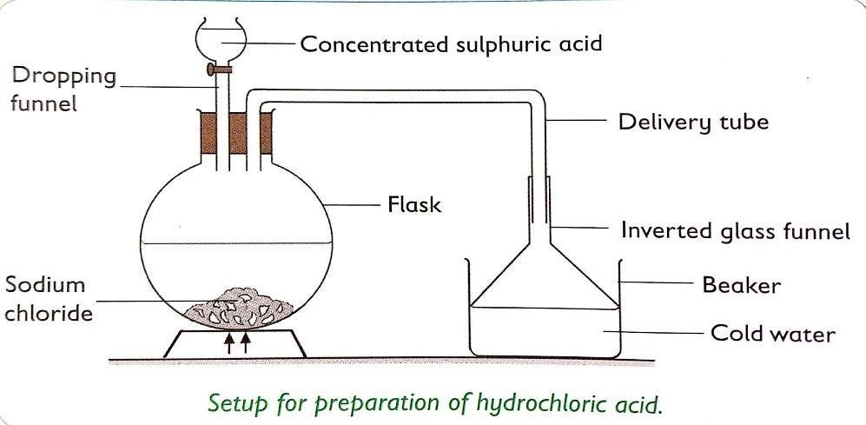

Equation:
NaCl(s) + H2SO4(l) NaHSO4(s) + HCl(g)
Then HCl(g) water HCl(aq)

Preparation of bases
A base is a substance that reacts with an acid to form salt and water only. Alkalis are bases that produce hydroxide ions(OH-) as the only negative ions when dissolved in water.
Bases (Alkalis) can be prepared in two ways:

Addition of water to soluble metal oxides
Metal oxide + water Metal hydroxide

Na2O(s) + H2O(l) 2NaOH(aq)
K2O(s) + H2O(l) 2KOH(aq)

Addition of water and a metal
Metal + water Metal hydroxide + hydrogen gas
2Na(s) + 2H2O(l) 2NaOH(aq) + H2(aq)
When sodium metal is dropped in water, the following observations are made:
- Sodium floats on water (because it is less dens than water)
- A colorless gas is given off (hydrogen)
- Universal indicator turns purple.

Reactions of dilute acids

Reaction of dilute acids with metals
- Dilute HCl and H2SO4 acids react with more reactive metals such as Mg, Zn, Fe and Al to liberate hydrogen gas.
Metal + dilute acid salt + hydrogen gas
2Zn(s) + 2H2SO4(aq) 2ZnSO4(aq) + H2(aq)
- When a piece of magnesium ribbon is dropped in dilute hydrochloric acid, effervescence occurs and a colorless gas that burns with a “pop” sound is evolved. The is hydrogen
Mg(s) + HCl(aq) MgCl2(aq) + H2(g)

Note:
  - Metals below hydrogen in the reactivity series like copper do not react with dilute acids because they cannot displace hydrogen from the acids.
  - Potassium and sodium react explosively with acids hence the reaction should not be attempted in the laboratory.

Reaction of dilute acids with carbonates and hydrogen carbonates
- Dilute acids react with carbonates to give a salt, carbon dioxide and water. Na2CO3(s) + 2HCl(aq) 2NaCl(aq) + H2O(l) + CO2(g)
CaCO3(s) + 2HCl(aq) CaCl2(aq) + H2O(l) + CO2(g)

- With hydrogen carbonates
KHCO3(s) + HNO3(aq) KNO3 (aq) + CO2(g) + H2O(l)

Reaction of dilute acids with metal oxides (Neutralization)
Acids react with metal oxides to form salt and water only. This reaction is known as
neutralization.
Acid + base Salt + water
H2SO4(aq) + CuO(s) CuSO4(aq) + H2O(l)
Black powder blue solution
Ionically, 2H+(aq) + CuO(s) Cu2+(aq) + H2O(l)
2HCl(aq) + CuO(s) CuCl2(aq) + H2O(l)
Black powder green solution
MgO(s) + 2HCl(aq) MgCl2(aq) + H2O(l)
White colorless solution

MgO(s) + 2H2SO4(aq) MgSO4(aq) + H2O(l)
White colorless solution

Reaction of dilute acids with metal hydroxides
The reaction between an acid and base to form salt and water only is called neutralization reaction.
NaOH(aq) + HCl(aq) NaCl(aq) + H2O(l)
2NaOH(aq) + H2SO4(aq) Na2SO4(aq) + H2O(l)

Reactions of bases
Bases react with dilute acid to form salt and water only. NaOH(aq) + HCl(aq) NaCl(aq) + H2O(l)
Some bases such as zinc oxide, lead(II)oxide and aluminium oxide react with basesto form complex salts.
ZnO(s) + 2NaOH(aq) + H2O(l) Na2Zn(OH)4(aq)
PbO(S) + 2NaOH(aq) + H2O(l) Na2Pb(OH)4(aq) Al2O3(aq) + 2NaOH(aq) + 3H2O(l) 2NaAl(OH)4(aq)
The above oxides react with both acids and alkalis and are known as amphoteric oxides.

Uses of some acids

Hydrochloric acid:
- Is used in digestion in human stomarch
- Cleaning metal surfaces.
- Manufacture of polyvinylchloride (PVC)

Sulphuric acid:
- Is used as an electrolyte in lead acid batteries
- Is used for making detergents, dyes and explosive.
- Making fertilisers, paints and drugs.

Carbonic acid:
- Making fizzy drinks

Uses of some bases

Sodium hydroxide
Is used in making detergents, paper and household bleaches

Ammonium hydroxide
Is used in making fertilizers like ammonium sulphate

Calcium hydroxide (slaked lime) and calcium oxide (quicklime)
Is added in soil to reduce acidity in a process called liming

Magnesium hydroxide (milk of magnesia)
Neutralize excess acid in human stomarch.

Dangers of some acids and bases
- Concentrated acids and bases are corrosive and cause chemical burns if they come into contact with the skin, eyes or internal organs.
- Acids and bases can cause undesirable effect on the environment such as acid rain, tooth decay, soil PH change and stomarch indigestion.

EXERCISES
- Acids and alkalis are two important, but opposite classes of compounds.
- What is meant by:
  - An acid
  - An alkali
  - A base
- Give the names and formulas of:
  - Three examples of acids and
  - Three examples of alkalis.
  - What is the relationship between bases and alkalis?
- Complete the following chemical equations for the reactions between acids and metals.
  - Mg(s) + H2SO4(aq)
  - Zn(s) + HCl(aq)
  - Zn(s) + H2SO4(aq)
  - Ca(s) + HCl(aq)
- a) Define the following term “neutralization”.
  - Write a word equation and its balanced formula equation for the reaction between potassium hydroxide and nitric acid.
  - Complete the following reaction equation
    - ZnCO3(s) + H2SO4(aq)
    - Na2CO3(s) + HCl(aq)
    - Ca(HCO3)(aq) + HCl(aq)
- a) What are the products formed when hydrochloric acid reacts with magnesium?
b) Complete the following reaction equations and balance them. CaO(s) + HCl(aq)
ZnO(s) + H2SO4(aq) CuO(s) + H2SO4(aq)
Na2O(s) + HCl(aq)
- Give three differences between acids and bases.
- a) Differentiate between a strong acid and a weak acid.
b) Give two examples of strong acids and two examples of weak acids.
- a) Differentiate between a strong base and a weak base.
b) Give two examples of strong base and one example of weak base.

- Potassium oxide was added to water and the mixture stirred, a colourless solution Q was formed. The colourless solution Q was then react with dilute nitric acid to form salt and water only.
  - Name the colourless solution Q.
  - State the colour of solution Q when phenolphthalein indicator is added.
  - Write balanced chemical equation for:
    - The formation of solution Q.
    - Reaction between solution Q and nitric acid.
- a) i) Outline any 3 uses of acids.
ii) Give any two uses of bases.
b) Describe briefly any 3 dangers of acids and bases.
- a) You are provided with zinc oxide, sodium oxide, copper(II) oxide and potassium oxide. Complete the table below by classifying the oxides given as soluble and insoluble.

Soluble oxide | Insoluble oxide
- Calcium oxide dissolves partially in water.
  - Give the name of the solution formed.
  - What is the major use of the resultant solution in the laboratory?
- Bases can be prepared by adding water to metals or soluble metal oxides. Write balanced chemical equation between:
  - Sodium oxide and water.
  - Sodium and water.
  - Potassium and water
  - Potassium oxide and water.

UNIT 7: CONCENTRATION OF SOLUTIONS
- Introduction
Sugar mixes with water uniformly to form a homogeneous mixture; in this sense, sugar is soluble in water and dissolves in it. The sugar is a solute, the water is a solvent and the mixture is a solution.
- A Solute: is a substance that is dissolved in a solvent.
- A Solvent: is a liquid that dissolves the solute (say distilled water).
- A Solution: is a uniform mixture of solute and solvent.
Note: A Solution in water is called aqueous solution

Concept of concentration

Activity
- Materials: sugar, teaspoons, 3 cups and water.
- Procedure:
- Put equal amounts of water in each of the three cups and label them A, B and C.
- Add sugar as follows:
  - In cup A, Add half teaspoonful of sugar.
  - In cup B, Add one spoonful of sugar
  - In cup C, Add two spoonfuls of sugar
- Stir and taste each sugar solution prepared in step 2 above.

Study questions
- In which cup was the solution sweetest?
- How can we tell the cup with a lot of sugar?
- How can we decrease the taste of sugar in each cup?
- What would happen when the water used was warmed first before step 2 in the procedure above was carried out?
- How can concentrations of solutions be measured?

Conclusion
Cup c had the sweetest taste because it contained most sugar particles. By adding more water that is diluting the solution, we reduce the taste of sugar.
- The solution is highly concentrated if it has large amounts of solutes.
- The solution is lowly concentrated if it has small amounts of solutes per volume. This solution is said to be dilute. Therefore, C is more concentrated than B and B is more concentrated than A.
The term concentration refers to the amount of solute dissolved in a given volume of solvent.
In a given amount of water, the more solute dissolved, the more concentrated the solution. If the solution contains a little solute, it is described as a dilute solution.

Thus, concentration of a solution can be expressed as:

Mass of solute per given volume of solution: g/ litre or g/dm3 (mass concentration)
- Moles of solute per litre of solution: mol/l (molarity)

Mass concentration
Mass concentration is the mass of solute (in grams) dissolved in one litre of solution. So it is expressed in grams per dm3(g/dm3) and It is calculated using the following formula:

Mass concentration of solution = 
Examples
- 500 cm3 of a solution of sodium hydroxide contains a mass of 5 g of solid NaOH. Calculate the concentration of the solution in g/dm3.

Answer:
Given: volume of solution = 500 cm3 = 500 × 10-3 dm3= 0.5 dm3 Mass of NaOH = 5g
Mass concentration= 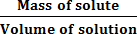 = 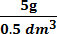 = 10 g/dm3
- 0.95 g of solid aluminium sulphate, Al2 (SO4)3 was dissolved in 250 cm3 of water. What is the mass concentration of the solution in g/dm3?

Answer
Data: volume = 250 cm3 = 250 × 10-3 dm3= 0.25dm3 Mass of Al2 (SO4)3 = 0.95 g

Mass concentration = 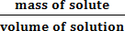 = 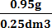 = 3.8g/dm3
A solution of known concentration is called a standard solution.

Molar concentration or molarity
Molarity is the number of moles of a solute dissolved in one liter (1dm3) of solution.
It is denoted by M.

The molar concentration can be calculated using the following formula:
M =
Where, n = number of moles of solute (expressed in mol)
V = volume of the solution (in dm3 or l)
M = molar concentration or molarity (expressed in mol/l).
Since n= then M=
where m is the mass of solute (expressed in g)
Mm is the molar mass of the solute (expressed in g/mol). V is volume of the solution (in dm3 or l)

Example1
Calculate the molarities of the following solutions:
- 5.85g of NaCl in 100 cm3 of solution
- 7.9 g of KMnO4 in 1 dm3 of solution

Answers
- Given: mass of NaCl = 5.85 g
molar mass of NaCl = 23 + 35.5= 58.5 g/mol
Volume of solution = 100 cm3 = 100 × 10-3dm3 =0.1dm3

Molarity of NaCl= = 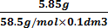 = 1mol/dm3
- Given: Mass of KMnO4 =7.9 g
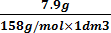
Molar mass of KMnO4 = 39 + 55 +(16×4) = 39 + 55 + 64=158 g/mol Volume of solution: 1dm3

Molarity of KMnO4 = = =0.05mol/dm3

Example 2
- Calculate the amount of solute present in 250 cm3 of a solution of hydrochloric acid which has a concentration of 2.0 mol dm-3.

Answer
Amount (mol) = Volume (dm3) × Concentration (mol dm–3)
Amount of solute, HCl = (250 × 10–3) dm3 × 2.0 mol dm–3 = 0.50mol

- What mass of sodium carbonate must be dissolved in 1dm3 of solution to give a solution of concentration 1.5 M?

Answer
Amount (n) = M × V = 1.5 mol dm–3 ×1.00 dm3 = 1.5mol Molar mass of Na2CO3 = (2 × 23) + 12 + (3 × 16) = 106 g mol–1 Mass of Na2CO3 = n × Mm= 1.5mol ×106 g mol–1 = 159 g

3. Preparation of solutions

If the solute is a solid, such as NaCl, NaOH or Na₂CO₃
The steps below are followed during the preparation of a solution of known molarity from a solid.
- Calculate the mass of the solid required.
- Weigh out the solid.
- Place the solid in an appropriate volumetric flask.
- Fill the flask half full with distilled water and stir to dissolve the solid. The volume of water must be less than the required volume.
- Adjust the volume of your solution by adding more water to the mark.
- Label your flask containing the solution (indicating the formula, concentration, date of preparation and name of the formula)

Example: To prepare 1 litre of solution of 1M sodium hydroxide
Requirements:
- Weighing balance
- Distilled water
- Sodium hydroxide pellets
- Labels
- 1litre volumetric flask
Procedure:
- Calculate the mass of NaCl required.

M=
m of NaOH= M × Mm× V= 1M×40g/mol × dm3 =40 g
- Weigh exactly 40g of NaOH
- Transfer the solid into a 1 litre volumetric flask.

- Half fill the flask with distilled water. Shake/stir the mixture to dissolve all the solute.
- Add more water up to 1liter mark of the volumetric flask
- Label this solution as 1M sodium hydroxide (indicating the concentration and the name of the solute)

Preparation of solutions of known concentrations from more concentrated liquids such as 36%concHCl or 98%conc H₂SO₄ (Dilution)

Solutions can also be prepared by diluting more concentrated solutions to the desired concentration. Many solutions are often sold in concentrated forms. The may need to be diluted to the desired concentration in the laboratory. Such solutions include acids (hydrochloric acid, sulphuric acid, nitric acid) ammonium hydroxide and hydrogen peroxide.

Procedures:
- Pour the required volume of concentrated solution slowly into some water, less than the final volume required with constant stirring.
- Mix the water and the amount of the solute thoroughly, then make up the volume with more water to the required volume of solution.
- Label and stopper the solution. When a solution is prepared through dilution, the following equation can be used. Mi × Vi= Mf × Vf
Where: Mi: Molar concentrated of the concentrated solution
Vi: Volume of the concentrated solution
Mf: Molar concentration of the dilute solution.
Vf: Volume of the dilute solution
The number of moles of the solute in the concentrated solution (given by Mi×Vi) = the number of moles of the solute in the diluted solution (given by Mf×Vf)

Example: Preparation of 2litres of 0.5 M CuSO₄ from a 2M CuSO₄ solution

Answer:

Requirements:
- Measuring cylinder or Burette
- Distilled water
- 2litres volumetric flask
- 2MCuSO4 solution
- Label

Procedure:
- Use the formula: Mi×Vi= Mf× Vf to calculate the volume of concentrated solution Vi = ? Vf = 2 L
Mi = 2M Mf = 0.5 M

Then Vi= = = 0.5 litres or 500cm3
- Use a measuring cylinder or a 500ml volumetric flask to accurately measure 500 cm3 of 2 M CuSO4.
- Transfer all the solution into a 2 litres volumetric flask using a filter funnel. Top up to the mark with distilled water. Stopper
- Label the solution as 0.5 M CuSO4

Note: when preparing dilute solution from concentrated solution, you put in mind this rule: “Never pour water into pure concentrated sulphuric acid (98%) or into concentrated hydrochloric acid (36%) or onto pellets of solid NaOH because a great deal of heat is evolved” pour the acid into water.

Simple acid– base titration
Titration is a method of reacting a solution of unknown concentration with another of
known concentration, in order to determine the unknown concentration.

The acid-base titration is the determination of the unknown concentration of an acid by making it react with a known volume of a base with known concentration and vice-versa.

In an acid-base titration, a solution of an acid of a known concentration is added gradually from a burette to a measured volume of solution of the base (alkali) of unknown concentration in a conical flask or vice versa until a complete reaction occurs.

Example:
The known volume of the alkali is usually measured using a pipette. The alkali is carefully transferred to a clean conical flask.
A suitable acid-base indicator is then added to the alkali in the conical flask. The acid is added to the alkali little at a time until a color change of the acid- base indicator occurs.
This shows that the alkali is completely neutralized by the acid.

- The point at which the color of the indicator changes is called the end point.

Role of indicator

The indicator is used to show the end point of the reaction by a rapid color change.

The following table shows common indicators and the color changes in acidic, basic and end point situation.
ACID-BASE INDICATOR | COLOR
 | In alkalis | At the end point | In acids
phenolphthalein | Pink | Colorless | Colorless
Methyl orange | yellow | orange | Red
Litmus solution | Blue | Purple | Red

- Equivalent point is when the number of moles of hydrogen ions (H+) of an acid is equal to the number of moles of hydroxide ions(OH–) of an alkali.

The apparatus often used in acid- base titration are:
  - Burette
  - Conical flask
  - Pipette
  - Dropper
  - Retort stand.

Procedures for an acid-base titration
- Put a volume x cm3 of standard solution in a conical flask.
Standard solution: is a solution whose concentration is known.
- Add to it a few drops of an indicator
Example: Phenolphthalein in NaOH, the solution in the conical flask will become pink.
- Fill the burette with the other reagent solution to be titrated (a solution whose concentration is unknown)
Example: Aqueous solution of HCl
- Clamp the burette on the stand.
- Open the tap of the burette and allow the flow of the reagent drop by drop until a rapid color change of the indicator happens. That is the end point, so close the tap immediately.
- Read the volume that has been run in from the burette.
- Calculate the concentration of the solution in the burette.

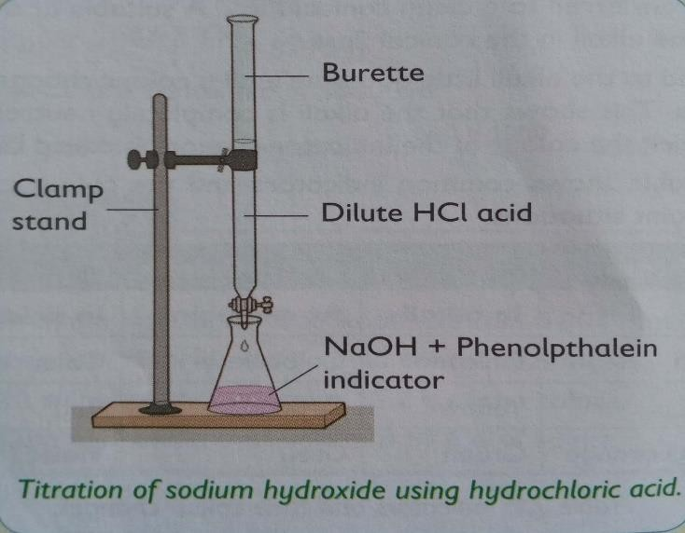

Calculation involving titration:
We should assume that at the end-point: Ma × Va × na = Mb × Vb × nb
where,
Ma = molarity of acid Mb = molarity of the base being neutralised
Va = volume of the acid Vb = volume of the base
na = number of H+ ions in the acid formula nb = number of OH- ions in the alkali formula

Or you can also use the following expression. = 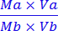
Where, Ma: Molarity of acid Va: volume of acid
na: number of mole of acid in a balanced chemical equation Mb: molarity of base
Vb: Volume of base
na: number of mole of base in a balanced chemical equation.

Worked example1
Given the equation: NaOH(aq) + HCl(aq) NaCl(aq) + H2O(l)
25.0 cm3 of a sodium hydroxide solution was pipetted into a conical flask and titrated with a standard solution of 0.2M hydrochloric acid. Using phenolphthalein indicator for the titration, it was found that 15.0 cm3 of the acid was required to neutralize the alkali. Calculate the molarity of the sodium hydroxide and its concentration in g/dm3

Answer
Given: NaOH(aq) + HCl(aq) NaCl(aq) + H2O(l) is well balanced

Ma = 0.2 M Mb = ?
Va= 15.0 cm3 =0.015 dm3 Vb = 25.0 cm3 = 0.025 dm3
na= 1 nb = 1
1st way
Use the formula: Ma×Va×na=Mb×Vb×nb Mb= = 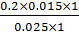 =0.12M
2nd way
Or we can use the following expression. = 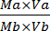
= 0.025 × Mb × 1 = 0.2 × 0.015 × 1
Mb= = 0.12M = 0.12mol/dm3
Concentration in g/dm3
Concentration in g/dm3 = molarity × molar mass
Molarity = 0.12 M
Mm of NaOH = 23 + 16 +1 = 40 g/mol
Concentration in g / dm3 = 0.12 mol/dm3 × 40 g/mol = 4.8 g/dm3

Worked example 2
Given the equation
2KOH(aq) +H2SO4(aq) K2SO4(aq) + 2H2O(l)
20.0cm3 of a sulphuric acid solution was titrated with a standardized solution of 0.0500mol/dm3 potassium hydroxide. Using phenolphthalein indicator for the titration, the acid required 36.0cm3 of the alkali(KOH) for complete neutralization. What was the concentration of the acid in mol/dm3 and in g/dm3.

Answer
Given: 2KOH(aq) + H2SO4(aq) K2SO4(aq) + 2H2O(l)

Ma = ? Mb = 0.0500 mol/dm3
Va= 20.0cm3 =0.020dm3 Vb = 36.0 cm3 =0.036 dm3
na= 2 nb = 1

1st way
Use the formula: Ma×Va×na = Mb×Vb×nb

Ma= = = 0.045M or 0.045mol/dm3
2nd way

Or we can also use the following expression = 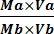
= 0.020 × Ma × 2 = 0.0500 × 0.036 × 1 Ma= = 0.045M= 0.045mol/l
Concentration in g/dm3
Concentration in g/dm3 = molarity × molar mass
Molarity = 0.045 M
Mm of H2SO4= (2×1) + 32 + (4×16) = 98g/mol
Mass concentration = 0.045 mol/dm3 × 98 g/mol = 4.41g/dm3

EXERCISES
- Determine the number of moles of solute present in:
  - 25 cm3 of 0.1 M NH4OH
  - 100 cm3 of 18 M HCl
  - 250 cm3 of 2.5 M sulphuric acid
  - 12 cm3 of 1.8 M potassium iodate.
- Calculate the mass of solute present in the following solution:
  - 300 cm3 of 2M NaCl .
  - 1.5 liters of 0.1 M KMnO4 .
  - 500 cm3 of 0.01 M potassium iodide.
  - 750 cm3 of 0.4M potassium carbonate
- Calculate the molarity (concentration in moles/litre) of the following solutions.
  - 4 g of sodium hydroxide dissolved in 100 cm3 solution. (Na = 23, H = 1, O=16)
  - 3.31 g of lead (II) nitrate dissolved in 250 cm3 solution. (Pb = 207, N = 14, O = 16)
  - 57.2 g of sodium carbonate decahydrate crystals (NaCO3. 10H2O) dissolved in 400 cm3 solution. (Na =23, C = 12, O =16, H =1)
- Calculate the concentration of the following solutions in mass/litre.
a) 2 M C6H12O6 (C =12, H = 1, O =16)
b) 18 M H2SO4 (H = 1, S =32, O =16)
- 2.5 M Potassium hydroxide (K = 39, H = 1, O =16)
- 0.5 M Barium nitrate (Ba = 137, N = 14, O= 16)
- 0.2 moles of hydrochloric acid are needed to completely neutralize 0.2 moles potassium hydroxide. If the concentration of the hydrochloric acid is 1.2 moles/litre, calculate the volume of the acid used.
- a) During acid –base titration procedure,
- end point and equivalence points are reached. Explain the difference between the two.
- an acid– base indicator is usually used. State the reason why it is used.
- List the apparatus needed during a titration procedure.
- Name two commonly used acid– base indicators during acid base titration.
- In a titration involving 24 cm3 KOH solution against a solution containing 1mol/dm3 of H2SO4, 28 cm3 of the acid was found to neutralize the alkali completely.
  - Write a word and chemical balanced equation for the reaction.
  - Name a suitable indicator for the titration and state the colour change you would observe at the end point.
  - Calculate the concentration of the alkali in mol/dm3.

  - Describe a chemical test which you would use to identify the type of salt produced during the reaction.
- What mass in (g) of hydrogen chloride (HCl) is needed to make up 1000 cm3 of a solution of concentration 1mol/dm−3. (H=1 , Cl = 35.5)
- 4.9 g of sulphuric acid is dissolved in water and the final solution has a volume of 220 cm3. Using titration, it was found that 20 cm3 of this solution was able to completely neutralize 10 cm3 of a sodium hydroxide solution. Calculate the concentration of the sodium hydroxide in mol/ dm−3
- 100 g of sodium chloride (NaCl) is dissolved in 450 cm3 of water.
  - How many moles of NaCl are present in the solution?
  - What is the volume of water (in dm3)?
  - Calculate the concentration of the solution.
  - What mass of sodium chloride would need to be added for the concentration to become 5.7mol dm−3? (Na = 23, Cl = 35.5)
- Given the equation: NH3(aq) + HCl(aq) NH4Cl(aq)
5.00 cm3 portions of household ammonia were titrated with a standard hydrochloric acid solution of 1.00 mol/dm3 (1M). If the average titration using methyl orange indicator was 22.5 cm3 of hydrochloric acid. Calculate the molarity of the ammonia solution, and its concentration in g/dm3 and g/cm3.
- During titration, 25 ml of a 0.2 mole/litre NaOH solution was poured in a beaker. An appropriate indicator (phenolphthalein) was added to the NaOH base. Titration of H2SO4(aq) from a burette was done. Neutralization of the base was reached on addition of 23.50 ml of H2SO4(aq).
Equation: H2SO4(aq) + 2NaOH(aq) 2H2O(l) + Na2SO4(aq)
  - State the name of another acid-base indicator that can be used to detect NaOH solution and the colour of this indicator in the base.
  - Calculate the number of moles of NaOH present in 25 ml of solution.
  - Determine the number of moles of H+ ions(aq) in 23.50 ml of H2SO4 solution.
  - Calculate the number of moles of H2SO4(aq) in 23.50 ml of its solution.
  - Calculate the molarity (moles / litre) of H2SO4(aq).

- During titration, 25 ml of a 0.1 mole/litre Na2CO3 solution was poured in a beaker. An appropriate indicator (3 drops of phenolphthalein) was added to the Na2CO3 alkaline solution. Titration of HCl(aq) from a burette was done. Neutralization of the base was reached on addition of 27.50 ml of HCl(aq).
Equation: 2HCl(aq) + Na2CO3(aq) 2NaCl(aq) + CO2(g) + 2H2O(l)
  - State the name of another acid-base indicator that can be used to detect Na2CO3 solution and the colour of this indicator in the base.
  - Calculate the number of moles of Na2CO3 present in 25ml of solution.
  - Calculate the number of moles of HCl (aq) in 27.50ml of the solution.
  - Calculate the molarity (moles / litre) of HCl(aq).
  - Calculate the mass of anhydrous Na2CO3 that was used to prepare 25ml of the solution. (Atomic mass : Na = 23, C =12, O =16)

UNIT 8: ELECTROLYSIS AND ITS APPLICATIONS
- Introduction to oxidation and reduction reactions (redox reactions)
Oxidation and reduction (redox) reactions can be described in terms:
  - Loss and gain of electrons
  - Addition or removal of oxygen or hydrogen
  - Increase and decrease of oxidation number.

Oxidation and reduction in terms of electron transfer (Loss and gain of electrons)

Oxidation is loss of electrons.
During chemical reactions, atoms of metals lose electrons in their outermost energy levels to become stable. Metals undergo oxidation

Examples:
Ca Ca2+ + 2e- or Ca – 2e- Ca2+ Mg Mg2+ + 2e
Al Al3+ + 3e

Reduction is gain of electrons.
During chemical reactions, non-metal may gain electrons to become stable.

Examples:
Cl + e- Cl-
O + 2e O2-
N + 3e N3-
Non-metals react by undergoing reduction reactions.

Note: the acronym OIL RIG can be used to remember the meaning of oxidation and reduction in terms of loss and gain of electrons.
OIL: Oxidation is loss of electrons
RIG: Reduction is gain of electrons

Oxidation and reduction in terms of oxygen transfers

- Oxidation is the gain of oxygen (or is the addition of oxygen to a substance).

Example:
2Cu(s) + O2(g) 2CuO(s)
- Reduction is the loss of oxygen.
reduction
Example: Fe2O3 + 3CO 2Fe + 3CO2

oxidation

NOTE:

An oxidizing agent is a substance that undergoes reduction reaction
- A reducing agent is a substance that undergoes oxidation reaction

Oxidizing agents:

Give oxygen to another substance
  - Accepts electrons or gain electrons.

Reducing agents:

Remove oxygen from another substance
  - Donate or lose their electrons.

Example: oxidation (oxygen added) CuO(aq) + H2(aq) Cu(aq) + H2O(l)
Reduction (oxygen removed)

- Oxidizing agent is CuO
- Reducing agent is H2

Oxidation and reduction in terms of hydrogen transfer

Oxidation is the loss of hydrogen.
Example: CH3CH2OH CH3CHO

Oxidation by loss of hydrogen

Reduction is the gain of hydrogen.
Reduction by gain of hydrogen

Example: CH3CHO CH3CH2OH

Note:

An oxidizing agent is required to remove hydrogen from the ethanol (say potassium dichromate(VI) solution K2Cr2O7)
- A reducing agent is used to reduce ethanal to ethanol by adding hydrogen (e.g. sodium tetrahydridoborate, NaBH4)
Now
  - Oxidizing agent removes hydrogen from a substance.
  - reducing agent adds hydrogen to a substance.

    - Oxidation and reduction in terms of increasing or decreasing in oxidation numbers
Oxidation number of an element is the apparent charge of an atom of an element in a compound or in an ion. It is positive or negative numbers to elements in chemical formulae according to a set rules.

Below are some simple rules for calculating oxidation numbers

- The oxidation number of a free (uncombined) element is zero.

Examples: Na, Mg, Cl2, H2, K, Zn, etc. have zero as their oxidation numbers.

- The oxidation number of any simple one ion is equal to its charge.

Example:
: its oxidation number is +1
: its oxidation number is +2
: its oxidation number is –1
: its oxidation number is –3

- Hydrogen has an oxidation number of in non-ionic compounds such as HCl, CH4, H2O etc. Except for metal hydrides where it has oxidation number (example are NaH and LiH
- Oxygen has oxidation number of in all compounds such as H2O, SO2, CO2, CO, H2SO4, NO except for peroxide where it has (examples are H2O, Na2O2)
- The alkali (group I) metals in a compound are always assigned oxidation number of
- The alkaline earth metals (group II) in a compound are always assigned an oxidation number of .
- The algebraic sum of oxidation numbers of all atoms in a neutral molecule must be
zero Examples:
  - CO2 is neutral molecule.so we can calculate the oxidation state of carbon in a molecule as follow:

,
so oxidation number of carbon in CO2 is .
  - KMnO4 (neutral molecule)

Then oxidation number of Mn in KMnO4 is

- In ion, the algebraic sum of the oxidation numbers of the constituent atoms must be equal to the charge on the ion.
Examples:
a)
Then, Oxidation number of sulphur in is
b)
Then, Oxidation number of phosphorus in is

- Oxidation involves increase in oxidation number of an element. It is accompanied by loss of electrons.

Examples:
Mg Mg2+ + 2e
0 increase in O.N +2
Na Na+ + e
0 increase in O.N +1
Cl– Cl2 + e
-1 increase in O.N 0

- Reduction involves decrease in oxidation number of an element. It is accompanied by gain of electrons.

Examples:
Cl2 + 2e- 2Cl-
0 decrease in O.N -1 Na+ + e Na
+1 decrease in O.N 0

An oxidizing agent is a substance (atom or a molecule or an ion) which accepts electron(s) from another substance.

Examples:
Mg0 + S0 Mg2+S2-
Oxidation reaction: Mg Mg2+ + 2e- so, Mg is the reducing agent Reduction reaction: S + 2e- S2- so, S is the oxidizing agent

A reducing agent is a substance (an atom, molecule or ion) which releases electrons to another substance.

Examples:

oxidation

Zn(s) + CuSO4(aq) ZnSO4(aq) + Cu(s)

0 +2 +2 0

reduction

Then, Zn(s) is a reducing agent and Cu2+(aq) is an oxidizing agent

ELECTROLYSIS

Definition of some terms
- Electrolyte is an ionic compound which conducts electric current in molten or aqueous state and decomposed by it.

Example: H2SO4, HCl, NaCl, KNO3, KOH, etc.
Any liquid that contains ions will conduct electricity. This is because the ions are free to move. But at the same time decomposition takes place.

Types of electrolytes

Strong electrolytes: are electrolytes that dissociate (or separate) completely into ions when dissolved in water or when in molten state.

Examples:
- Strong acids: H2SO4, HNO3, HCl,

Strong bases: NaOH, KOH and Ca(OH)2
- Salts: NaCl, KNO3, MgCl2, etc
They above electrolytes have high electrical conductivity.

Weak electrolytes: are electrolytes that dissociate (or separate) partially into ions when dissolved in water or when in molten state.

Examples:
- Ammonia solution {NH3(aq) } also called ammonium hydroxide (NH4OH).
- Methanoic acid (HCOOH)
- Ethanoic acid (CH3COOH)
The above electrolytes have low electrical conductivity.

- Non-electrolytes are covalent compounds (or liquids) that do not conduct an electric current because they do not contain ions. This means that they do not dissociate (or separate) into ions when dissolved in water or when in molten state.

Examples:
- Sugar
- Ethanol
- Urea.

Electrolysis process
Electrolysis is the decomposition of a compound (known as an electrolyte) by using electricity.
This means that electrolysis breaks the molten ionic compound down to its elements, giving the metal at the cathode and non-metal at the anode.

An electrolyte contains mobile positive and negative ions.
Electrolytic cell is the apparatus in which electrolysis is carried out. And It has two electrodes called anode and cathode.
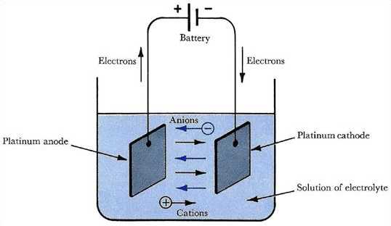
- In electrolysis, they are solid conductors connected to the source of current called
electrodes.

  - So, Electrode are piece of metal (rod or plate) used to carry an electric current into or out of electrolyte.
- There two types of electrodes namely:
  - Anode (Positive electrode): is an electrode connected to the positive terminal (pole) of the cell.
  - Cathode (Negative electrode): is an electrode connected to the negative terminal (pole) of the cell.

During electrolysis,
- Positive ions (cations) move towards the negative electrode (cathode) where they are discharged by gaining electrons hence the reaction is called reduction.
- Negative ions (anions) move towards the positive electrode (anode) where they are discharged by losing electrons hence reaction is called oxidation.
NOTE: Discharge is the removal of electrons from negative ions to form atoms or the gain of electrons of positive ions to become atoms.
Then a chemical reaction takes place at each electrode with ions changing from
positive or negative to neutral atoms or molecules.

Reactions occur at electrodes
- During electrolysis, electrons leave the electrolyte at the anode and enter the electrolyte at the cathode.

At the anode
X― X + e ( Anode reaction)
The negative charged ions give up their electrons to the electrode and become neutral atoms. The atoms the quickly form the respective element.

At the cathode
M+ + e M (Cathode reaction)
The positively charged ions gain electrons from the cathode, thus becoming neutral atoms.

Electrolysis of some compounds
- Electrolysis of molten substances
- Electrolysis of molten lead (II) bromide
Lead(II)bromide is made up of lead(II) ions, Pb2+, and bromide ions, Br−.

In the solid state, the ions are in fixed positions and cannot move. Therefore, the solids do not conduct electric current. When the solid is heated to melt, the ions become free and mobile to conduct electric current.

- Electrodes used: Carbon (graphite) (inert)
- Electrolyte: Molten lead(II) bromide (PbBr2(l))
- Ions present: Pb2+ and Br−
During electrolysis, the negative bromide ions move to the anode and turn into bromine gas while positive lead(II) ions move towards the cathode and turn into lead atom.
- Reaction at cathode: Pb2+(l) + 2e Pb(l)
molten lead
Product at cathode: molten lead will collect at the bottom near cathode
- Reaction at anode: 2Br−(l) Br2(g) + 2e
Red-brown fumes
Product at anode: red-brown bromine vapour bubbles off.
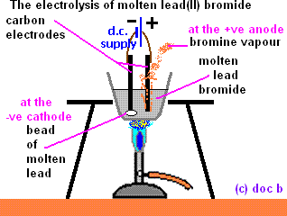

Electrolysis of molten sodium chloride (NaCl_{(l)})
Solid NaCl melts to form a liquid at about 8000C. The ions become free to move, so the liquid contains sodium ions(Na+) and chloride ions(Cl−).
  - Electrodes used: Carbon (graphite) (inert)
  - Electrolyte: Molten sodium chloride NaCl(l)

  - Ions present: Na+ and Cl−
Na+ ions undergo cathode reduction and form molten sodium. which sticks on the cathode.
  - Cathode reaction: 2Na+(l) + 2e 2Na(l)
molten sodium
Cl− ions undergo anode oxidation and form chlorine gas, Cl2, which can be collected above the anode.
  - Anode reaction: 2Cl−(l) Cl2(g) + 2e
Green-yellow gas

QUESTIONS
- What are inert electrodes? Give one example.
Answer: Inert electrodes are electrodes that do not react during electrolysis process.
Examples: Graphite and Platinum

- What are active electrodes? Give one example.
Answer: Active electrodes are electrodes that react during electrolysis process.
Example: Copper electrode.
- Electrolysis of aqueous solutions
Electrolyzing an ionic compound in its solution is very different to electrolyzing it when it is molten. This is because in a solution we have 4 ions.
  - H+ and OH– from water and
  - Positive and negative ions from the compound. But only one type of ion gets discharged at each electrode.

The rules for the electrolysis of a solution are:
- For the positive ions, the one that gets discharged at the cathode is the least reactive one.
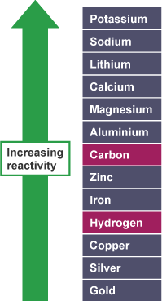
- If the ion from the ionic compound is above hydrogen in the reactivity series (more reaactive), H+ gets discharged at the cathode.
- If the ion from the ionic compound is below hydrogen in the reactivity series (less reaactive), the ion from the compound gets discharged at the cathode in place of hydrogen.
NOTE:
  - The metal will be produced if the metal is less reactive than hydrogen.
  - Hydrogen will be produced if the metal is more reactive than hydrogen.
Examples:

Ionic compound | Product at the negative electrode (cathode)
Potassium chloride | Hydrogen
Copper solphate | Copper
Sodium bromide | Hydrogen
Siler nitrate | Silver
Zinc chloride | Hydrogen

- For the negative ions however it is different.
- If the electrolyte is a concentrated solution, then there are many of the halide ions, more than OH– . So the halide ions gets discharged at the anode. This happens when a solution is a concentrated solution of a halide (a compound containing I–, Br– and Cl– ions), then iodide, bromine or chlorine forms at anode.
- If the electrolyte is a dilute solution, then there are more OH- ions than halide ions, so
oxygen from OH– from water gets discharged at the anode.
- The least reactive is preferable to be discharged. The lesser reactive discharge first. This is the decreasing reactivity. OH-, I-, Br-, Cl-, NO3-, SO42-.
NOTE:
  - It is the oxygen that will be produced unless it is in competition with halogens (Chlorine, Bromine, Iodine)
  - Sulphate ions (SO42−) and nitrate ions (NO3−) will not be discharged during electrolysis.
- When oxygen from OH- is discharged, the equation will be:
4OH- (aq) 2H2O(l) + O2(g) + 4e
- Electrolysis of dilute sodium chloride solution
An aqueous solution of sodium chloride contains four different types of ions.
Ions present are:
  - Ions from sodium chloride: Na+(aq) and Cl−(aq)
  - Ions from water: H+(aq) and OH−(aq)
  - Electrodes used: graphite (inert)
- When dilute sodium chloride solution is electrolyzed using inert electrodes, the Na+ and H+ ions move to the cathode where H+ are discharged forming hydrogen gas. H+ ions gain electrons from the cathode to form hydrogen gas. (The hydrogen ions accept electrons more readily than the sodium ions).
  - Cathode reaction: H+(aq) + 2e H2(g) Na+ ions remain in solution.
- Cl− and OH− ions move to the anode where OH− ions are discharged forming water and oxygen gas.
Since the solution is dilute, there are many OH− ions.

  - Anode reaction: 4OH−(aq) 2H2O(l) + O2(g) + 4e Cl− ions remain in solution.

Electrolysis of concentrated sodium chloride (Brine)
Ions present are:
  - Na+(aq) and Cl−(aq) from sodium chloride:
  - H+(aq) and OH−(aq) from water:
  - Electrodes used: graphite (inert)
There are fewer OH− because the solution is concentrated. The Cl− are in high concentration.

Na+ and H+ move to the cathode but only H+ are discharged forming hydrogen gas because it is below sodium in the reactivity series.

  - Cathode reaction: 2H+(aq) + 2e H2(g)

OH− and Cl− ions are attracted to the anode but only Cl− ions are discharged forming chlorine gas because Cl− are in high concentration as the solution is concentrated.

  - Anode reaction: 2Cl−(aq) Cl2(g) + 2e
Na+ ions and OH− ions remain in solution; they combine to form sodium hydroxide.

Electrolysis of acidified water (or dilute sulphuric acid)
Pure water is a non-electrolyte, but acidified water undergoes dissociation and electrolysis.

Ions present are:
  - H+ and SO42− from sulphuric acid and
  - H+ and OH− ions from water.
  - H+ is the only positively charged ions present. They are discharged at the cathode forming hydrogen gas.
  - Sulphate ions (SO42−) and hydroxide ions (OH−) migrate to the anode. However only OH− ions are discharged at the anode forming water and oxygen gas as the solution is dilute. There is effervescence.
The following are the steps of water electrolysis:

Water dissociation:
2H2O(l) 4H+(aq) + 4OH−(aq)
- Reaction at cathode (Negative electrode) Reduction reaction
2H+(aq) + 2e H2(g)

- Reaction at anode (Positive electrode) Oxidation reaction
4OH−(aq) 2H2O(l) + O2(g) + 4e
Colourless gas of oxygen liberated at anode.

We have to add the above three equations to obtain the overall equation.
2H2O(l) 2H2(g) + O2(g)

Note: As there are two moles of H2 and one mole of O2 formed, the volume of hydrogen collected at the cathode is double that of the oxygen collected at the anode.
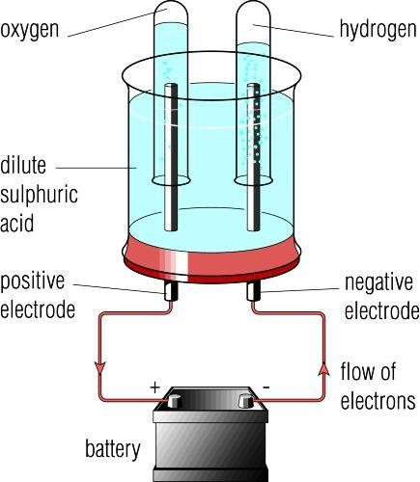

Electrolysis of copper (II) sulphate, CuSO_{4(aq)} solution using platinum electrodes
An aqueous solution of copper(II) sulphate contains four types of ions;

  - Ions from copper(II) sulphate are: Cu2+ and SO42−
  - Ions from water are: H+ and OH−
  - At the cathode: Cu2+ and H+ both move to the cathode. Cu2+ ions accept electrons more readily than H+ ions. As a result, Cu2+ ions are preferentially discharged as copper metal (atom) which appears as a brown deposit.
Cu2+(aq) + 2e Cu(s)

  - At the anode: SO42− and OH− both move to the anode. OH− ions give up electrons more readily than SO42− ions. Consequently, OH− ions are preferentially discharged to give oxygen gas.
4OH−(aq) 2H2O(l) + O2(g) + 4e
Bubbles of oxygen gas are observed at the anode.

Cu2+ ions give copper(II) sulphate solution its blue color. As they being discharged and deposited at the cathode as copper metal, the color of the solution fades and if we continue with electrolysis the solution finally turns colorless and acidic.

Electrolysis of copper (II) sulphate solution using copper electrodes
Ions present:
  - Ions from copper(II) sulphate: Cu2+ aand SO42−
  - Ions from water: H+ and OH−
  - At the cathode: Cu2+ and H+ move to the cathode. Cu2+ ions are lower in reactivity series and are preferentially discharged by gaining electrons to form a brown solid which is copper.
Cu2+(aq) + 2e Cu(s) (Copper deposited)
Copper is deposited and it increase the mass of the cathode.

  - At the anode: SO42− and OH− move to the anode. We should expect OH− ions to be oxidized, but because of the nature (type) of electrodes used i.e. copper; none of the ions is discharged. Instead copper electrode dissolves.
Cu(s) Cu2+(aq) + 2e (Copper dissolves)

Copper is an active electrode and it therefore gets dissolved. This process is called
electrode ionization and it causes a decrease in anode mass.

4. APPLICATION OF ELECTROLYSIS
- Electroplating
Electroplating is a process of coating a metallic object with a thin layer of another metal by electrolysis.

  - The object to be coated must be the cathode.
  - The object that coats must be the anode.
  - The electrolyte must contain ions of the metal that go to the cathode and plate the object. (e.g. Silver nitrate solution or copper (II) sulphate solution)

Example:

In silver (or copper) plating, articles such as cutlery (knife, spoon, fork and key) act as the Cathode. The anode is pure silver (or pure copper) and the electrolyte contains Ag+ ions (or Cu2+ions) . When the current is applied, silver (or copper) ions move to the object to be plated.
  - Cathode reaction: Ag+(aq) + e Ag(s) (silver deposits)
  - Anode reaction: Ag(s) Ag+(aq) + e (silver dissolves) Or
  - Cathode reaction: Cu2+(aq) + 2e Cu(s) (copper deposits)
  - Anode reaction: Cu(s) Cu2+(aq) + 2e (copper dissolves)

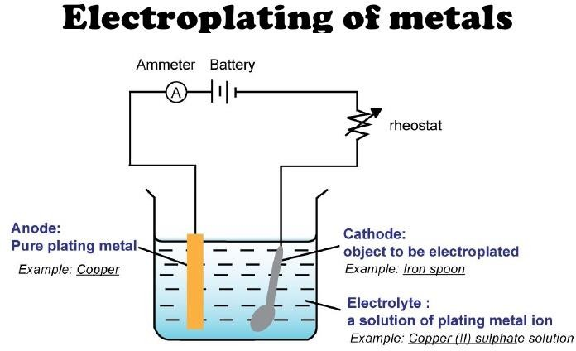

Give two reasons for electroplating materials:
  - To prevent rusting/ corrosion
  - To improve appearance (To make object look better)
  - To improve the thickness of the metal surface

Refining (purifying) of metals
Refining is removing impurity from metal by the use of electrolysis method.
Example: Copper refining

During refining of copper, the following must be done:
- The cathode is made of a strip of pure copper.
- The anode is made of impure copper.
- The electrolyte must contain ions of the metal to be refined. (Electrolyte is a
solution of copper(II)sulphate, CuSO4(aq)
During the electrolysis, only copper ions move from the anode to the cathode, leaving the impurities behind.
  - Cathode reaction: Cu2+(aq) + 2e Cu(s) (Copper is deposited)
  - Anode reaction: Cu(s) Cu2+(aq) + 2e (impure copper dissolves)
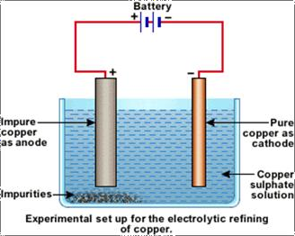
The impure block of copper at the anode dissolves and pure copper is deposited at the cathode. The impurities from the anode drop to the bottom of the cell as Sludge contains valuable metals like silver and gold.

Extraction of metals
Example: Extraction of aluminium metal
Aluminum does not exist in nature in the uncombined state.
- The most important ore from which aluminium is extracted is bauxite, Al2O3.2H2O(s).
- The alumina must be molten for electrolysis to work, since the ions are not free to move in the solid state.

- Electrodes used: Both electrodes (cathode and anode) are made of carbon in the form of graphite.
- When Al2O3 is melted, the Al3+ and O2− ions are free to move and conduct electricity.
- The purified dry ore, called alumina, is aluminium oxide, Al2O3. The following are the steps in the extraction of aluminium metal.

Dehydration of bauxite
Al2O3.2H2O(s) Al2O3(s) + 2H2O(l)

Melting and electrolysis of Al₂O_{3(s)}
2Al2O3(l) 4Al3+(l) + 6O2−(l)

Reaction at cathode (reduction)
4Al3+(l) + 12e 4Al(l)
molten aluminium

Reaction at anode (Oxidation)
6O2−(l) 3O2(g) + 12e
The overall reaction for this electrolysis is 2Al2O3(l) 4Al(l) + 3O2(g)

Aluminium is denser than the alumina (molten Al2O3) + cryolite (Na3AlF6) solution and so it falls to the bottom of the cell where it can be tapped off as pure liquid metal.
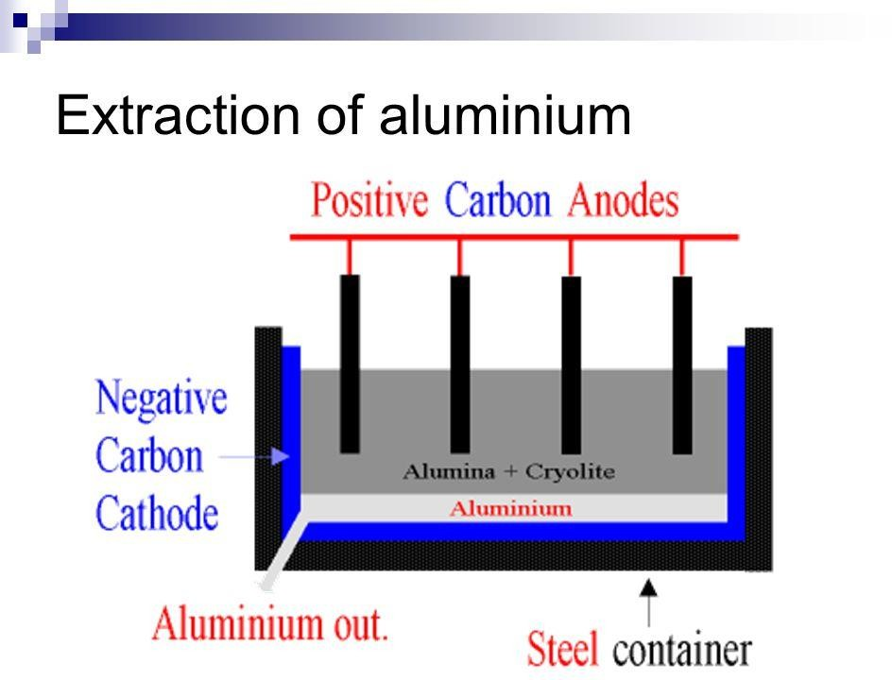
Oxygen is given off at the positive carbon anode. Because of hot oxygen reacts with the carbon anode, carbon dioxide is also given off at the carbon anode.
C(s) + O2(g) CO2(g)
The carbon anodes slowly disappear because each molecule of carbon dioxide which is given off takes a little piece of carbon away with it. The carbon anodes need to be replaced when they become too small.

The main problem with aluminium extraction is:
- High melting point of alumina (20400C). It is not practical to do electrolysis at such a high temperature. The temperature is reduced by adding cryolite (sodium aluminium fluoride, Na3AlF6) to the alumina (Al2O3).
A solution of alumina in cryolite melts at about 9000C and electrolysis is done at about 9500C.

Manufacture of sodium hydroxide, Chlorine and Hydrogen
Electrolysis of brine (concentrated aqueous sodium chloride) yields sodium hydroxide, chlorine and hydrogen.

EXERCISES
- Use words from the list to answer the questions that follow. You can use each word once, more than once or not at all.
  - Anode
  - Cathode
  - Electron
  - Electrolyte
  - Ion
  - Molecule
  - Atom
  - Electrolysis
- What is the name of the positive electrode in an electrolysis?
- What is the name of the negative electrode in an electrolysis?
- Which type of particles carries electrical charge during electrolysis?
- What name is given to the process of splitting up a substance using electricity?
- What is formed when an ion with a single positive charge gains an electron?
- You are provided with some words below. You are required to copy out the sentence (a)
to (e) and fill in the blank spaces using the words in the list. You may use the words once, more than once, or not at all.
  - A non-electrolyte
  - a non-conductor
  - an electron
  - a metal
  - a conductor
  - an ion
  - an electrolyte
  - a non-metal
- A substance that will conduct electricity when molten and/ or in aqueous solution is called……………………………

- A compound that does not conduct electricity whether in the solid, molten or aqeous state is called………………………….
- A solid substance that conducts electricity but does not contain ions is called…………………………………..
- A particle that carries electric current in a solid conductor is called……………………
- A compound that does not conduct electricity when solid, but does so when molten or in solution, is called…………………………
- Complete the table below to show the reactions and products of electrolysis. The first one is already done for you.

Substance in melt form | Electrodes used | Ions present | Cathode reaction | Anode reaction
NaCl (l) | Graphite or platinum | Na+ (l),  Cl– (l) | Na+(l) + e Na(l) | 2Cl– (l) Cl2(g) +2e
CuCl2(l) | Graphite or platinum | Cu2+ (l),  Cl– (l)
PbCl2 (l) | Graphite or platinum | Pb2+ (l),  Cl– (l)
PbI2 (l) | Graphite or platinum | Pb2+ (l),  I– (l)
MgCl2 (l) | Graphite or platinum

- Complete the table below to show the products of electrolysis for the following substances when platinum or graphite electrodes are used. The first one is done for you.

Dilute solution of substances | Electrodes used | Ions present | Cathode reaction |  | Anode reaction
NaCl (aq) | Graphite or platinum | H+, OH– Na+, Cl– | H+(aq) + e | H2(g) | 4OH– (l) | H2O(l) +O2(g) +4e
H2SO4(aq) | Graphite or platinum | H+, OH–,  SO42-
MgSO4(aq) | Graphite or platinum | H+, OH– Mg2+,SO42–
Cu(NO3)2(aq) | Graphite or platinum | H+, OH–  Cu2+,NO32– | Cu2+(aq) + 2e | Cu(s) | 4OH– (l) | H2O(l) +O2(g) +4e
Na2SO4 (aq) | Graphite or platinum | H+, OH– Na+, SO42–
NaOH (aq) | Graphite or platinum | H+, OH–  Na+

- a) What are the particles that conduct electricity in:
- graphite
- molten sodium chloride?
- State what is observed at each electrode when molten sodium chloride is electrolyzed between graphite electrodes.
- Write equations for the reactions at each electrode in part (b).
- Explain why solid sodium chloride does not conduct an electric current.
- a) Lead metal and molten lead(II) chloride are both conductors of electricity. Name the conducting particles in:
- Lead
- Molten lead(II) chloride
- list the difference between an electrolyte and a conductor.

- Molten lead (II) chloride was electrolyzed using carbon electrodes:
  - State the products that are liberated at the electrodes.
  - Write the equations for the reactions that take place at the electrodes.
- a) Draw a labelled diagram showing the electrolysis of dilute sulphuric acid (electrolysis of water)
- Write equations to show the reactions taking place at the cathode and anode in this electrolysis.
- If 5 cm3 of a gas are collected at the cathode in the above electrolysis, what volume of the gas is collected at the anode.
- One of the application of electrolysis in daily life is electroplating.
- i) Define the term electroplating.
ii) Give two advantages of electroplating.
- i) In order to silver plate an object, what type of electrodes and electrolyte should be used?
- Name three other industrial applications of electrolysis.
- Aluminium is widely used. It is extracted by electrolysis of a molten mixture of aluminium oxide and cryolite. The electrolytic cell uses graphite anodes and a graphite lining as the cathode.
- Why is cryolite used in this process.
- Write equations to show that is formed at the:
  - Cathode
  - Anode
- Why do the graphite anodes have to be replaced after a period of time?
- How might this process of extraction affect the environment?
- Give one use of aluminium, and explain one property of the metal on which the use is based.

- The following figure represents apparatus used in an electrolysis experiment on copper
(II) chloride solution using carbon rod.
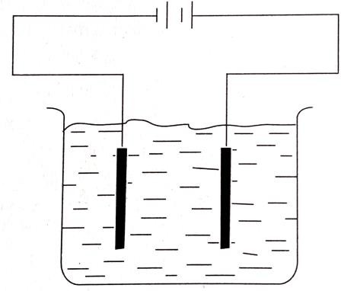
- i) List the ions present in the solution at each electrode.
  - Write an equation for the reaction taking place at the cathode.
  - What would be observed if blue litmus paper was dipped into the solution near the anode? Explain your answer.
- In another experiment on copper (II) chloride, the carbon electrodes were replaced by copper electrodes.
  - State what happens at each electrode.
  - Write equations for the reactions taking place at each electrode.
  - State what is happening in this electrolysis.
- a) The figure below shows a simple electrolysis cell used in the electrolysis of 0.01M sulphuric acid using platinum electrodes. Hydrogen and oxygen are the products at the electrodes.
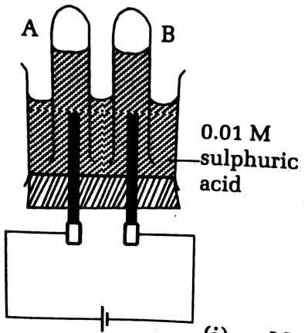
- Which ions are in solution?
- Specify the gaseous products in tubes A and B.

- Write the ionic equations for the reactions giving rise to the gaseous products.
- In a similar experiment, concentrated hydrochloric acid was electrolyzed between carbon electrodes.
  - Name the ions present in the solution.
  - Name the products formed in tubes A and B.
  - Write the ionic equations to show how the products are formed at the electrodes.
- Figure below shows the apparatus used for electrolysis of brine using carbon electrodes.
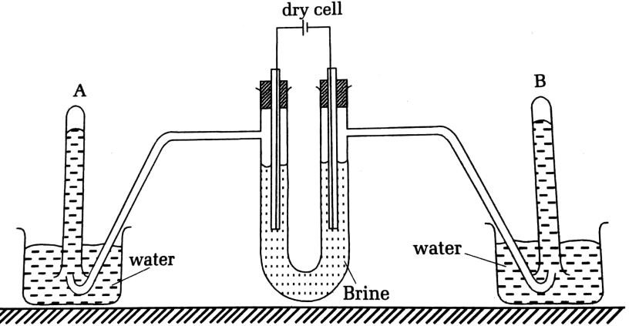
- i) What ions are in brine?
  - What gases are collected in test tubes A and B?
  - What chemical tests would you carry out to identify each gas?
- Give the ionic equations for the reaction taking place at:
  - The anode
  - The cathode
- Brine is neutral (pH=7) but, as electrolysis was continued for some time, the pH increased to12. Explain.
- In another experiment, carbon anode and iron cathode were immersed in fused (molten) sodium chloride.
  - What would you be observed at the anode?
  - What takes place at the cathode?
  - Give the equations for the reactions in d (i) and d (ii).

UNIT 9: STRUCTURE AND PROPERTIES OF ALKENES AND ALCOHOLS
- ALKENES

Definition
Alkenes are hydrocarbons which contain carbon – carbon double bond, -- C = C – and thus they are referred to as unsaturated hydrocarbons. They are represented by a general formula C_{n}H_{2n}. where n is integral number (2,3,4,5,6,7,8….)

Nomenclature
- In the IUPAC system of nomenclature, alkenes are named by replacing, “ ane ” of the corresponding alkanes with “ ene ” from alkene.
- The longest chain containing the double (C = C) bond is usually taken and the carbon atoms are then numbered in such a manner which gives the least value to the carbon atom with the double bond.
- Indicate the location of the double bond by the location of its first carbon.
- Name branched or substituted alkenes in a manner similar to alkanes.

Example1:
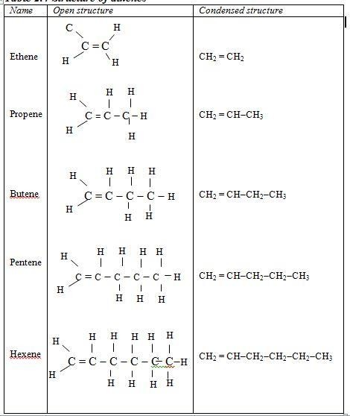

Example2: Names of branched alkenes
- CH2 = C-CH2-CH2 2-methyl but-1-ene
CH3
- CH2=CH-CH-CH2-CH2-CH-CH2-CH-CH2-CH3 3-Ethyl 6,8-dimethyl dec-1-ene

CH2CH3 CH3 CH3

Isomerism in alkenes
Isomerism is possible with alkenes having four or more carbon atoms per molecule. There are two form of structure isomerism in alkenes.
  - Position isomerism: In position isomerism, the position of the double bond changes but the length of the chain remains the same.
Examples:

Position isomers Names
CH3CH2CH = CH2 but-1-ene

CH₃CH = CH -CH₃
and
but-2-ene

CH3CH2CH2CH = CH2
CH₃CH₂CH = CH - CH₃
pent -1- ene
pent - 2 - ene

  - Chain isomerism: Chain isomerism is shown by a straight chain and a branched chain in alkenes with the same molecular formula.
NOTE: In chain Isomerism, the position of double bond does not change.

- C4H8 has
CH3CH2CH = CH2
CH3C = CH2
| CH3
1 - butene ( straight chain isomer)
2 - methyl -1 - propene (Branched chain isomer)

- C5H12 represents the following

CH3CH 2 CH 2 CH = CH 2
CH3CH 2 C = CH 2
| CH3

pent -1 - ene ( straight chain isomer)
2 - methylpbut -1 - ene (Branched chain isomer)

  - Physical properties of alkenes
- Alkenes with carbon number less than 5 are gas at ordinary temperature, the other are liquid up to 18 while others are solids as n increase
- Alkenes are insoluble in water but soluble in organic solvents.

- Boiling points and melting points of alkenes are less than those of alkanes but also increase as the molecular weight increase.
- The densities of alkenes increase with increasing number of carbon atoms.

The following table gives a summary of physical properties of some alkenes

Alkene | Molecular formula | Physical state | Density (g/cm3) | Melting point (0C) | Boiling point (0C)
Ethane | C2H4 | Gas | 0.6128 | -169 | -104
Propene | C3H6 | Gas | 0.6142 | -185 | -47
Butene | C4H8 | Gas | 0.6356 | -185 | -70
Pentene | C5H10 | Liquid | 0.64 | -165 | 30
Hexene | C6H12 | Liquid | 0.67 | -98 | 63

Chemical properties of alkenes
    - Combustion reactions
Alkenes are highly flammable and burn readily in air with a yellow sooty flame, forming carbon dioxide and water.

3n
n CO2 + n H2O

CnH2n +

2 O₂

Example: CH3CH2CH=CH2 + 6 O2 4CO2 + 4H2O

Addition reactions
Alkenes undergo addition reaction across the double bond such that the double bond is converted to a single bond.

Addition of hydrogen (Reduction or hydrogenation)
The alkenes are readily reduced by the addition of hydrogen across the double bond to form alkanes. The reaction occurs in the presence of a catalyst like Ni, Pt or Pd at 2000C.
R − CH = CH − R'+H 2 ⎯⎯^{Pt}→ R − CH2 − CH2 − R'
Examples: CH3-CH=CH-CH3 + H2 Pt CH3CH2CH2CH3 CH3CH=CH2 + H2 Pt CH3-CH2-CH3

Addition of halogens (halogenations reaction)
Alkenes react by addition reaction with halogens to produce vicinal dihalogenoalkane products.
Example: H2C=CH2 + Br2 BrH2C-CH2Br
The reaction of alkenes with bromine is used as a test for unsaturation (compound contains a double or triple bond). In this reaction decoloration of bromine indicates presence of multiple bond for example a double bond.

Addition of hydrogen halide (Hydro halogenation)
Hydrogen halides(HCl(g), HBr(g) and HI(g)) readily add across the double bond of the alkenes to form alkyl halides. The reactions take place at room temperature. The hydrogen atom from hydrogen halide adds to the carbon atom of the double bond which is already bonded to more hydrogen atoms “This is Markovnikov rule”
H2C=CH2(g) + HCl(g) H3C-CH2Cl(g) (Chloroethane)
CH3-CH=CH2(g) + HBr(g) CH3-CHBr-CH3(g) (2-Bromopropane)
CH3-CH2-CH=CH2(g) + HCl(g) CH3-CH2-CHCl-CH3(g) (2-Chlorobutane)

Addition of water (Hydration of alkenes)
Water can add across the double bond of the alkenes in presence of sulphuric acid as catalyst to form alcohols

Example:
H2C=CH2(g) + H2O(l) H3C−CH2OH(l) (Ethanol)
CH3-CH2-CH=CH2(g) + H2O(l) CH3CH2CH(OH)CH3(l) ( Butan-2-ol)
  - Methods of preparation of alkenes
Alkenes are obtained from dehydration (Removal of a molecule of water from an alcohols) and cracking of higher alkanes.

Example: Preparation of ethene

Dehydration of the corresponding alcohols
The dehydration of ethanol can also be achieved by using either hot excess concentrated sulphuric acid at 1700C – 1800C or passing vapour of alcohol over heated aluminium oxide.

Heating a mixture of ethanol and conc. H₂SO₄ at 170oC.
CH3CH2OH (l) Conc H2SO4 CH2=CH2 (g) + H2O (l)
Ethanol 1700C ethene
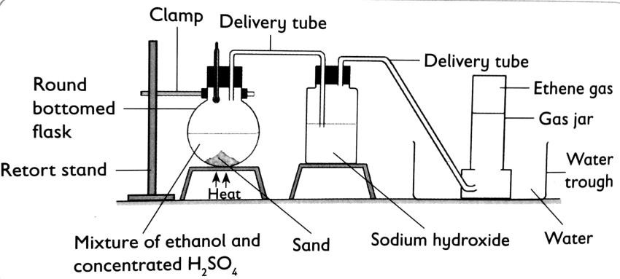
- The gas produced is passed through NaOH to remove impurities (SO2, and CO2).
2NaOH (aq) + SO2(g) Na2SO3 (aq) + H2O(l)
- Sand is added to promote uniform boiling of the mixture and to prevent the cracking of the flask.

Passing vapour of alcohol over hot aluminium oxide
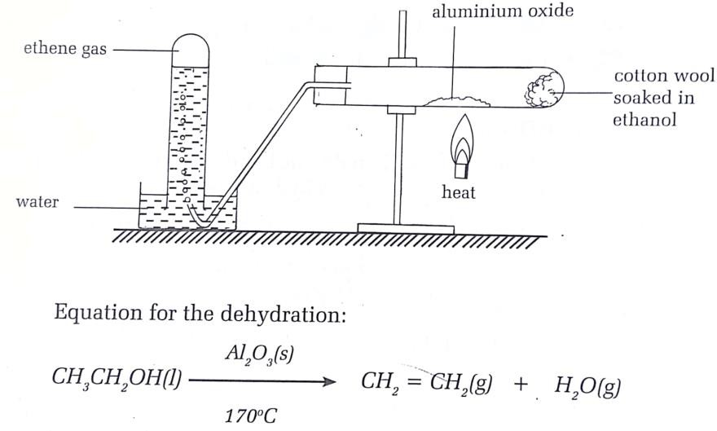
- Cracking of higher alkane
Cracking refer to breaking up of long chained hydrocarbons into shorter useful hydrocarbons alkanes and alkenes by means of heating.
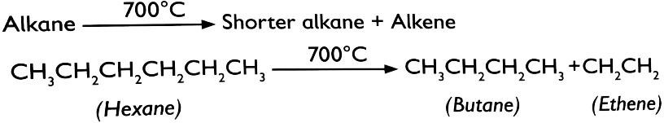

Test of alkenes
These include the following.
- Reagent: Bromine water (Orange in color)

Observation: Ethene decolourises a solution of bromine water (Br2/H2O) from
orange to colorless.
- Reagent: Acidified potassium manganate (VII) (potassium permanganate)
(KMnO4) is purple in color.
Observation: Ethane decolorise a solution of potassium permanganate from purple to
colorless.
- Reagent: Potassium dichromate solution (is orange in color)(K2Cr2O7)
- Observation: Ethane changes the orange color of potassium dichromate to green when bubbled through it.

Uses of alkenes
- Manufacture of plastics such as polyethene and polypropene.
- Manufacture of alcohols such as ethanol.
- Manufacture of detergents
- Lower alkenes are used as fuels.

EXERCISES
- Which process allows large hydrocarbons to be broken down into smaller hydrocarbons?
  - Cracking
  - Polymerisation
  - Fractional distillation
  - Saturation
- Which of these is a formula of an alkene?
  - C2H2
  - C2H4
  - C2H6
  - CH4
- Which statement about hydrocarbons is correct?
  - Alkanes are unsaturated because they have single bonds.
  - Alkenes are saturated because they have double bonds.
  - Alkenes are unsaturated because they have double bonds.
  - All above.
- When an alkene is mixed with bromine water
  - The bromine water changes from colourless to orange
  - The bromine water stays orange
  - Bromine water changes from orange to colourless
  - No change is observed.
- In the formula of an alkene, = represents:
  - Two atoms that are the same
  - shared pair of electrons
  - A double covalent bond
  - Equal bonds.
- Which of the following is an alkane?
  - Ethanol
  - Hexane
  - Propene
  - Ethyne
- Looking at the chemical formulae of these compounds, which is an alkane?
  - C3H8
  - C2H4
  - C5H10
  - CH4
- What is the name of the alkane which has theformula C5H12?
  - Ethane
  - Octane
  - Butane

  - Pentane.
- Alkanes are saturated hydrocarbons. What does this mean?
  - There are some C = C double bonds present in the molecule
  - All C atoms are bonded by single covalent bonds
  - They are very reactive
  - They contain water.
- When hydrocarbons like the alkanes burn in plenty of air, what type of reaction takes place?
  - Complete combustion
  - Incomplete combustion
  - Thermal decomposition
  - Dissociation reaction.
- How do you test for an alkene?
  - They turn universal indicator purple.
  - They turn bromine water colourless.
  - They turn limewater cloudy.
  - They do not react.
- Write the structural formulae for the following alkenes.
  - hex – 2 –ene
  - 2,3 – dimethylbut – 2 –ene
  - But – 2 –ene
  - 2 – methylprop-1-ene
  - 3,3 – dimethylbut –1 –ene
- What is the difference between saturated and unsaturated hydrocarbons?
- Name the following alkenes.
  - CH3CH2CH=CH2
  - CH2C =CHCH3
  - CH2=CH3CH3
  - CH3CH=CHCH2CH3
- a) What are isomers?
- Is there any difference between structural isomers and position isomers?
- Draw and name all structural and position isomers of hexene
- Write an equation to show how ethane reacts with hydrogen to produce ethane.
- Copy and complete the passage using the list of words in the brackets provided.
(Bromine, decolorises, double, ethane, ethene, and orange.)
Ethane can be distinguished from ethane by adding water to each compound. Bromine water has an colour. Ethene bromine water but does not. The bromine adds across the bond in and no other compound is formed.
- Ethene is unsaturated hydrocarbon whereas ethane is saturated hydrocarbon.
  - Describe how you can distinguish between ethane and ethane using a chemical test.
  - Draw a full structural formula for ethane and ethene.

  - Ethene reacts with steam to form ethanol.
    - What conditions are needed to carry out this reaction?
    - Describe another method for making ethanol.
  - Write the equation for the complete combustion of ethanol.
- Match each word on the left with its description on the right

Ethanol | The breaking down of long-chained alkanes  to alkenes and short –chained alkanes.
Saturated | Organic compounds containing only single  bonds
Unsaturated | One of the products of fermentation of  glucose.
Addition | Organic compounds containing C=C double  bond
Cracking | A reaction in which two or more  compounds combine to form only one compound

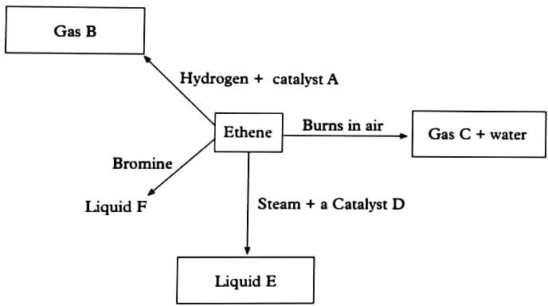
- The following question is about some of the reaction of ethene.
  - Give the name and the formula for substance A to D.
  - Write a word equation to represent the reaction in which liquid E is formed.
  - Name the homologous series that gas B belongs to.
  - Describe chemical test which would allow you to identify gas C.

ALCOHOLS

Introduction
Alcohols are organic compounds that are derivatives of hydrocarbons where one or more hydrogen atoms of hydrocarbon is or are replaced by hydroxyl (-OH) group. They are represented by the general formula: CnH2n+1–OH or R-OH where R is alkyl group. The molecule of an alcohol consists of an alkyl group CnH2n+1 and functional –OH group.

Nomenclature and isomers
According to IUPAC system, alcohols are named by replacing the final “e” of the parent hydrocarbon (alkane) with “ol”, then specify the position of -OH group before ending by
“ol”.

Examples:
The names of the first five members are given in Table below.

Alkane | Alcohol | Number of carbon atoms | Molecular formula of the alcohol | Structural formulae of the alcohol
Methane | Methanol | 1 | CH3OH | H  H C OH or CH3OH H
Ethane | Ethanol | 2 | C2H5OH | H H  H C C OH or CH3CH2OH H H

Propane | Propan-1-ol | 3 | C3H7OH | H H H  H C C C OH H H H  Or CH3CH2CH2OH

Butane | Butan-1-ol | 4 | C4H9OH | H H H H  H C C C C OH H H H H  Or CH3CH2CH2CH2OH
Pentane | Pentan-1-ol | 5 | C5H11OH | H H H H H  H C C C C C OH  H H H H H Or CH3CH2CH2CH2CH2OH

Physical properties
- Alcohols are soluble in water. This is due to the hydroxyl group in the alcohol.
- The boiling point of an alcohol is always much higher than the boiling point of the corresponding alkane and alkene with the same hydrocarbon chain.
- The boiling point also increase as the length of hydrocarbon chain increases.

- The boiling point of alcohols with branches is lower than that of unbranched alcohols with the same number of carbon atoms.

Chemical properties of alcohols

Combustion
Ethanol burns in plenty of oxygen or air with blue flame, giving out carbon dioxide and water.
CH3CH2OH(l) + 3O2(g) 2CO2(g) + 3H2O(l)

Reaction with alkali metals
Alcohol react with with alkali metals like Na, K, and Li to form metal alkoxide with hydrogen gas that produce pop soumd.
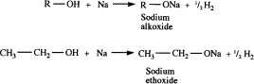

Reaction with carboxylic acid (Esterification)
Alcohols react with carboxylic acids to form sweet smelling compound called ester with elimination of a water molecule. This process of ester formation is called esterification. The reaction takes place in presence of dilute sulphuric acid (H2SO4)
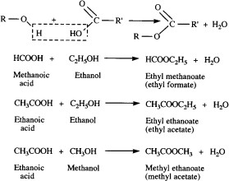

Reaction with halogen acids (HCl, HBr, HI)
Alcohols react with halogen acids to give alkyl halides.
CH3CH2CH2CH2-OH + HBr CH₃CH₂CH₂CH₂-Br + H₂ O

Dehydration
Alcohols are dehydrated by heating at a temperature of 170oC, with concentrated sulphuric acid to alkenes.

CH -CH -CH -OH H2SO4
CH3-CH=CH2 + H2O

3 2 2
170⁰C

Oxidation
Primary and secondary alcohols are oxidized to aldehydes and ketones respectively by use of acidified K2Cr2O7, KMnO4 with nitric acid once concentrated.

Cr O ²⁻/H⁺
O Cr O ²⁻/H⁺

2 7
R-CH OH
R-C
2 7
R-COOH

2
primary alcohol

R-CHOH-R
IIndalcohol

Heating

Cr2O72-/H+
R' Heating

H AALDEHYDE

R-CO-R'
Ketone
Heating

ACID

Cr2O72-/H+
R C R''
Heating

no reaction

tertiary alOcoHhols

Note
Alcohol do not react with sodium hydroxide because alcohols are not acidic ROH + NaOH No reaction

Preparation of alcohols
Ethanol can be prepared:
    - By Fermentation of sugar and
    - By hydration of ethene.

Fermentation of sugars
Fermentation is the process in which yeast break down sugar into alcohol and carbon dioxide.
Foodstuffs like maize, bananas, millet and sugar canes all contain sugars. These sugars, through fermentation, are converted to ethanol by an enzyme called zymase contained in yeast.
Through the process of fermentation, yeast converts sugars into alcohol and carbon dioxide.
Glucose + yeast Alcohol + carbon dioxide

Example:
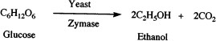
Carbon dioxide gas bubbles out of the fermenting solution into the air leaving a mixture of ethanol and water.

ii. Hydration of alkenes
Ethanol is also manufactured by hydration of ethene (addition of water in ethene) in the presence of sulphuric acid.

CH2=CH2 + H2O H2SO4 CH3CH2OH
Ethanol
CH3CH=CH2 + H2O H2SO4 CH3CH(OH)CH3
Propan-2-ol
Note: Other alcohols are prepared through hydration of alkenes.

Uses of alcohols
- Alcohols are used as fuel.
- Alcohols are also used as a solvent
- Ethanol is used as disinfectant.
- Ethanol is an alcoholic beverage.
Note: Only ethanol and not any other alcohol is used in alcoholic beverages. In fact, methanol is highly poisonous.

Misuse of alcohols (health hazards caused by drinking too much alcohol)
- Drinking too much alcohols can cause liver damage to humans (hepatitis), kidney damage which are difficult to cure.
- Drinking too much alcohols can result in anti-social behavior such as fighting, prostitution, domestic violence.
- Drinking too much alcohols can cause road accidents, brain damage (when a person becomes addicted), unplanned pregnancies, family(ies) conflicts which lead to fighting.
- When methanol is consumed it can cause blindness or death.

EXERCISES
- Give the IUPAC names of the following alcohols.
  - CH3OH
  - C3H7OH
  - C5H11OH
  - CH3CH2OH
  - C4H9OH
- Ethanol undergoes different reactions with different reactants
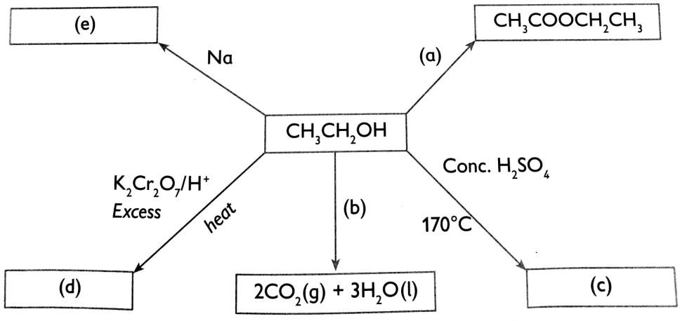
Give the names and formula of substances a, b, c, d and e
- a) State the products formed during combustion of alcohols.
b) With reference to ethanol, write a chemical equation to represent the combustion of alcohols.
- Distinguish between esterification and neutralization.
- Write chemical equations for the reaction between the following substances:
  - Potassium and ethanol
  - Propanol and propanoic acid
  - Ethanol and concentrated sulphuric acid.
- Compare and contrast the preparation of ethanol by fermentation and by hydration of ethene.
- a) Draw the structure formula of the following compounds
- Pentan-1-ol
- Propan-1-ol
- State two uses of alcohols
- Outline two social and tow medical effects of misuse of ethanol.

UNIT10 : CARBOXYLIC ACIDS

Introduction and definition
Carboxylic acids or organic acids are organic compounds represented by general
CnH2n+1COOH or R-COOH where R represent CnH2n+1. When n=0,1,2,3,…. The acid contain –CO-OH as functional group.

Nomenclature (naming)
According to IUPAC system, the acids are named after the corresponding hydrocarbons by replacing the ending “e” by “oic acid”.
The names of the first five members of the aliphatic carboxylic acids are given in table below.

IUPAC Name | Structural formulae
Methanoic acid | HCOOH
Ethanoic acid | CH3COOH
Propanoic acid | CH3CH2COOH
Butanoic acid | CH3CH2CH2COOH
Pentanoic acid | CH3CH2CH2CH2COOH

Physical properties of carboxylic acids
- They have high melting and boiling points compared to other organic compounds of the same mass or number of carbon atoms.
- The acids with one to four carbon atoms are completely miscible with water. Solubility decreases as the carbon chain length increases.
- Organic or carboxylic acids are weak acids in opposition to some mineral acids such as hydrochloric acids which are strong acids.

Chemical properties of carboxylic acids

Reaction of carboxylic acid with metals
The carboxylic acids react with reactive metals such as sodium, potassium and magnesium to form a salt and hydrogen. The metal displaces the hydrogen in the –COOH group.
2CH3COOH + 2Na 2CH3COONa + H2
Ethanoic acid Sodium ethanoate

2CH3COOH + Mg (CH3COO)2Mg + H2
Ethanoic acid Magnesium ethanoate

Reaction of carboxylic acid with a base
Carboxylic acid react with sodium hydroxide to form salt and water CH3COOH + NaOH CH3COONa + H2O
When long chain carboxylic acids are reacted with sodium hydroxide the organic salt formed is known as soap. Such a process of making soap is known as saponification.

Reaction of carboxylic acid with carbonates
Carboxylic acids react with sodium carbonate to form a salt, carbon dioxide and water. 2CH3COOH(aq) + Na2CO3(s) 2CH3COONa(aq) + CO2(g) + H2O(l)

Reaction of carboxylic acid with alcohols
Carboxylic acids react with alcohols in presence of few drops of concentrated sulphuric acid to form esters. The acid act as catalyst.

CH3COOH(aq) + CH3CH2OH(aq) H+ CH3COOCH2CH3(aq) + H2O(l)
Ethanoic acid Ethanol heat Ethylethanoate water NOTE: The process of ester formation is called esterification.

Reduction of carboxylic acid
Carboxylic acids are easily reduced by strong reducing agent such as lithium aluminium hydride (LiAlH4). The carboxylic acids are reduced to alcohol.
CH3COOH LiAlH4 CH3CH2OH + H2O
Ethanoic acid Ethanol

Preparation of carboxylic acids

Oxidation of primary alcohols
The oxidation of primary alcohols leads to the formation of aldehydes that undergo further oxidation to yield acids. The oxidizing agent used include acidified potassium manganate(VII) or acidified potassium dichromate(VI)

Stage1: Conversation of thanol to ethanal

CH3CH2OH(l) KMnO4 /H+ CH3CHO(aq) + H2O(l)
Ethanol Ethanal

Stage2: Oxidation of ethanal to ethanoic acid

CH3CHO(aq) KMnO4 /H+ CH3COOH(aq)
Ethanal Ethanoic acid

Uses of carboxylic acids
Carboxylic acids are used:
  - As solvent
  - To manufacture of drugs
  - As food preservatives
e.g. benzoic acid
  - In making artificial rubber
  - Making perfumes

EXERCISES
- Define the following terms.
  - Esterification
  - Saponification
- Methanoic acid is added to the same volume of ethanol in the presence of concentrated sulphuric acid and warmed.
- What is the name of the ester formed?
- Write an equation for the reaction in (a).
- Write equations and name the products in the following reactions.
- Propanoic acid and potassium.
- Ethanoic acid and potassium hydroxide.
- Methanoic acid and lead carbonate.
- Butanoic acid and magnesium oxide.
- Butan-1-ol and ethanoic acid heated in the presence of concentrated sulphuric acid.
- Write the molecular formula and structural formula for butanoic and pentanoic acids.
- Ethanoic acid is a weakacid. Explain.
- Explain why the boiling point of ethanoic acid (118°C) is higher than that of propan-1-ol (b.p. 97°C)and yet they have the same molecular mass.
- Which ester forms from the reaction between methanol and ethanoic acid? Write a word equation for the reaction.
- Describe with equations, the reaction between ethanoic acidand sodium metal.
- The following ester, CH3COOH was hydrolysed. Write the formula and names of the organic acid and alcohol used to form the ester.
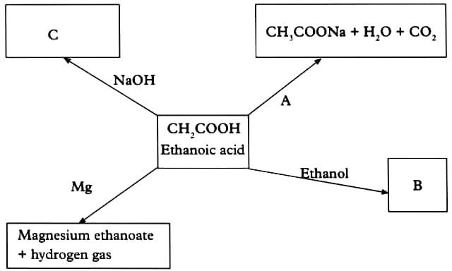
- Ethanoic acid, CH3COOH, forms a weak acid when added to water. Some reactions of ethanoic acid are shown below.
- Explain what is meant by a strong acid.

- Name the substance A that is added to ethanoic acid.
- Substance B is formed when ethanoic acid reacts with ethanol, what type of substance is B?
- Draw the structural formula of salt C.
- Write a balanced chemical equation for the reaction between Mg and ethanoic acid
- Copy and complete the reactions below?
- CH3OH + CH3COOH
- CH3CH2OH + CH3COOH
- CH3COOH + NaOH
- CH3COOH + Na2CO3
- CH3COOH + Na
- Ethanoic acid CH3COOH, is typical weak acid.
- Draw the full structural formula for ethanoic acid.
- Describe two ways in which ethanoic acid differs from a strong acid such as sulphuric acid.
- Write balanced equations for the reaction of ethanoic acid with:
  - Magnesium
  - Sodium carbonate
- Ethanoic acid can be made in the laboratory by the oxidation of ethanol with acidified potassium dichromate.
  - Name another oxidising agent that can be used to oxidize ethanol.
  - What conditions are required for this oxidation?
  - Give three uses of ethanoic acid.
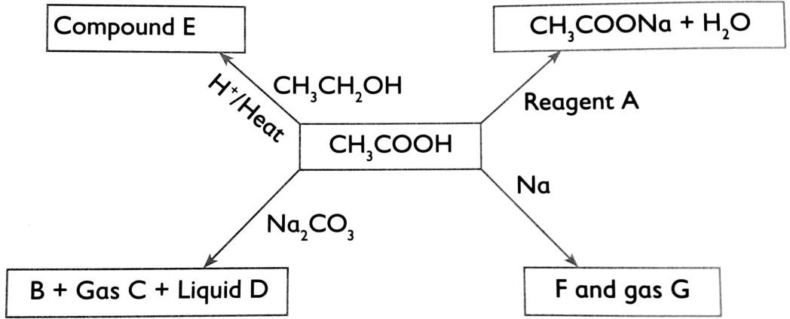
- Study the flow-chart below and answer the questions that follow.
- Give name and formula of:
  - Reagent A.
  - Compound E.
  - Liquid D.
  - Gas G
- Identify substance B, C, and F.

UNIT 11: PETROLEUM PRODUCTS AND POLYMERISATION
- ORIGIN OF CRUDE OIL AND PRODUCTION OF PETROLEUM PRODUCTS
Petroleum or crude oil was formed over millions of years by the combined effects of bacteria, heat and pressure on dead marine animals and plants, buried underground at considerable depth. Crude oil, which is a mixture of hydrocarbon compounds (Alkanes) such as petrol, kerosene, diesel, oil, waxes and bitumen containing carbon and hydrogen only, is pumped to the surface from underground using oil rigs. It is then separated into various fractions by fractional distillation. The most volatile fractions come off at the top of the distillation column and the least volatile remain as residue. Each of these fractions contains various hydrocarbons, which can further be separated by finer fractional distillation.

Crude oil or petroleum is first heated in a furnace to about 4000C and then its vapor is pumped into fractionating tall tower(column). As the vapor rises up the tower, it is cooled. The tower is divided into several compartments. Each compartment above is cooler than the one below it. So the temperature in the tower decrease as you ascend the tower. The fractions at the top of fractionating column have lower boiling points than the fractions at the bottom.
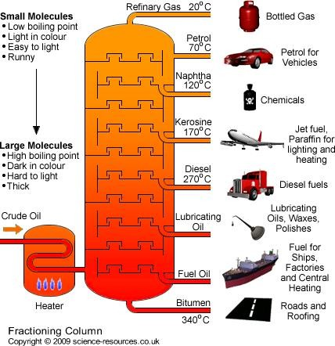

Fractions | Number of carbon atoms | Boiling point 0C | Uses
1. Natural gases or refinery gases(mixture of methane, ethane, propane and butane) | C1 – C4 | Below 25°C | Used as fuel for domestic gas cooker
2. Naphta | C5 – C15 | 30-250°C | Used to make chemicals
3. Petrol(Gasoline) | C5 – C6 | 30-60ºC | Used as fuel in cars and solvents for substances like paints
4. Kerosene | C10-C15 | 150-250°C | Used as jet fuel
5. Diesel oil | C12 – C18 | 250-400ºC | Fuel for diesel engines
- Lubricating oil  - Bitumen | C17-C40 | Above 400°C | - Fuel for chips, lubricating in machine parts  - Road construction

Polymerisation
Polymerization: is a process by which small organic molecules (called monomers)
combine to form one large organic molecule(polymer).
The individual small molecules, the reactants, are called monomers while the larger molecules, the products, are called polymers.
- A polymer is a large organic molecule formed by joining several monomers.
- A monomers are small organic molecule that joined together to form polymer.

Types of polymers
Based on their sources polymers can be classified as:
  - Natural polymers
  - Synthetic polymers

Natural polymers
These are naturally occurring polymers. All living things (Animals and Plants) contain polymers. Proteins, carbohydrates, wood and natural rubber are all polymers. These polymers occur naturally.

Examples of some natural polymers include:

  - Starch ( made from glucose monomer)
  - Cellulose (e.g. cotton, wool, paper and silk)
  - Proteins (made from amino acid monomer)
  - Glycogen (made from glucose monomer)
  - Fats
  - Rubber

Synthetic polymers
Synthetic polymers are human made polymers. They are manufactured in industries. They include:
- Polythene
- Polypropene
- Polychloroethene or Polyvinyl chloride (PVC)
- Polyester
- Nylon
- Terylene
- Nylon
- Perspex (artificial glass)

Polymerization
Synthetic polymers are made by polymerization. There are two kinds of polymerization:
- Addition polymerization
- Condensation polymerization

Addition polymerisation of some synthetic polymers
Addition polymerisation involves joining monomers of one type, which are unsaturated molecules like ethene, chloroethene and phenylethene etc. During polymerisation of ethene for example, the double bonds between the carbon atoms are broken down enabling many molecules of ethene to join to each other to form a large molecule called poly(ethene). It is commonly called polythene.

Polythene
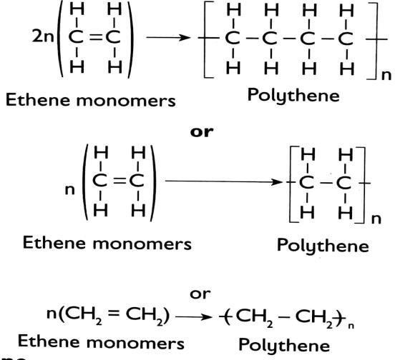
Polythene is formed when ethene molecules (monomers) join up by addition polymerisation. This can be summarized according to the following equations

Polypropene
It is formed when propene monomers join up by addition polymerization
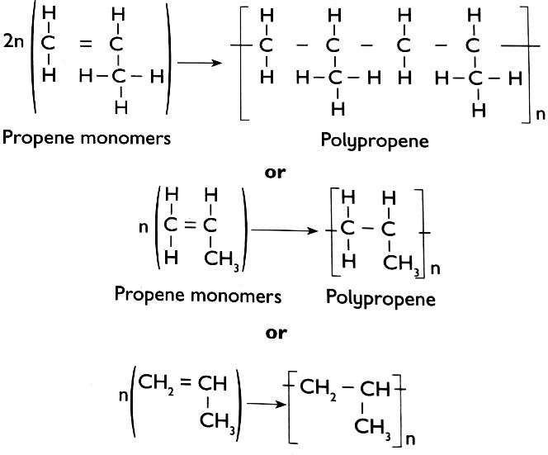

Polyvinyl chloride (PVC)
Polyvinyl chloride is a polymer of vinyl chloride monomer. Vinyl chloride is also known as chloroethene.

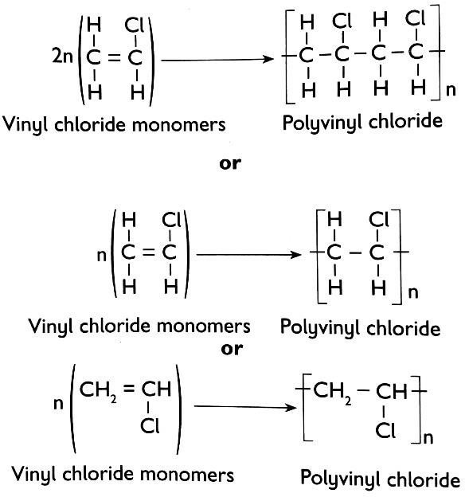

Condensation polymerization of some synthetic polymers
This is the formation of a single molecule by the combination of two or more molecules. This process where monomers join through elimination of a small molecule. e.g. water(H20)
or hydrogen chloride(HCl), ammonia(NH3). –W-R-R-W-W-R-R-W-W-R- Nylon and terylene are made by condensation polymerisation.

Polyester
It is a polymer made from reaction of a dicarboxylic acid and a diol. The polymer has ester linkages.
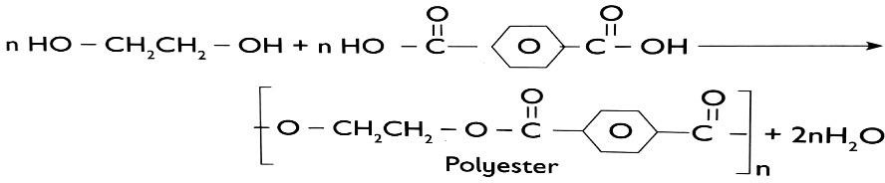

Nylon
Nylon -6,6 is produced by the condensation reaction between two monomer units adipic acid and 1,6-hexanediamine in the presence of heat. This is formed from a six-carbon diacid and a six carbon diamine as shown below.
nH2N−(CH2)6−NH2 + n HOOC−(CH2)4−COOH −NH−(CH2)6−NH−CO−(CH2)4−CO−n + 2n H2O
1,6-hexanediamine Adipic acid Nylon-6,6
Note:
  - If the monomer name is known, then the polymer name is obtained by adding the prefix poly to the monomer name.
  - During addition polymerisation, monomers are joined by breaking the double bond to open up new links where they join to each other forming polymer while during condensation polymerisation, monomers are joined through elimination of small molecules like H2O, HCl, NH3

Uses of polymers in daily life

Polymer | Used in making
Polythene | - Pipes  - Plastic bags  - Plastic bottles  - Film wrappers  - Electric wires insulators
Polypropene | - Plastic bottles  - Chairs  - Ropes
Polyvinyl chloride(PVC) | - Crates and boxes  - Plasticrope  - Artificial leather  - Water pipes  - Insulation for electrical wires
Polyester | - Clothing (fabrics)  - Ropes  - plastic wrap  - bottles  - switches  - electric sockets and fuses, appliances.
Nylon | - Brush  - Shoes  - Ropes  - Fishing nets and parachutes
Rubber(synthetic) | - Vehicle tyres  - Rubber shoes

- Dangers associated with polymers and hydrocarbons to the environment
- Synthetic polymers are non-biodegradable.
- Hydrocarbons burn in air to produce smoke and carbon dioxide which causes global warming.
- Waste synthetic fibres dumped in the soil pollutes soil.

EXERCISES
- The name of the process by which crude oil is separated into pure fractions is called fractional distillation. True / False
  - The black solid that comes out at the bottom of fractionating tower is called… (Oil, bitumen, soot)
  - The name given to the repeating unit in a polymer is called…………………
    - Isotopes
    - Isomer
    - Monomer
    - Allotropes
- a) Define the following terms:
  - Isomers
  - Monomer
  - Polymer
- i) Name two major groups of polymers
- Give two examples for each of the polymers
- Complete the equations below to show polymers formed.
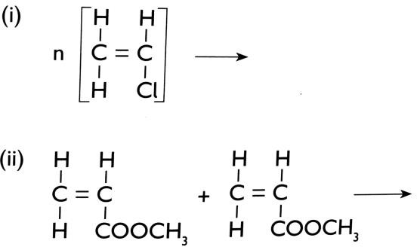
- Differentiate between a polymer and monomer.
- a) What is the name given to the smallest repeating unit of a polymer
- Draw the structure of the smallest repeating unit of polyvinyl chloride.
- The polymerization of tetrafluoroethene (C2F4) is similar to that of ethene (C2H4)
  - What is meant by the term polymerization?

  - Draw the structure formula of a portion of the polymer obtained from the monomerC2F4.
- A polymer of polyvinyl chloride is represented below:
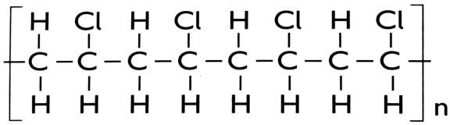
- Draw the structure of one of the monomers.
- Give the name of the monomer you have drawn in (b) above.
- How many monomers are in the sample of the polymer shown above?
- Describe briefly how crude oil is formed and deposited in underground reservoirs.
- Distinguish between additional polymers and condensation polymers.
- Give one use of each of the following polymers.
- Polyethene
- Terylene (polyester)
- Polyvinyl chloride
- Rubber
- Cellulose
- a) Outline 2 benefits of recycling polymers and plastics.
- Why are synthetic polymers difficult to dispose?
- Identify 2 disadvantages of burning plastics and polymers so as dispose them.
- Discuss the dangers associated with polymers and hydrocarbons to the environment.
- Match the names of the monomers given below to the polymers.

Monomer name | Polymer name
Glucose | Polypropene
Amino acid | Starch
Propene | Polyvinyl chloride
Vinyl chloride | Protein
Phenylethene | polyphenylethene

