GS RWAHI TSS SUBJECT:CHEMISTRY DATE:21/02/2025 MAX:100 MARKS
CLASS:S3A&B
TEACHER:ISAAC
MIDDLE TIME TEST OF CHEMISTRY
- This paper consists of three sections A, B and C
SECTION A: Attempt ALL questions. (55 marks)
SECTION B: Attempt any THREE questions. (30 marks)
SECTION C: Attempt only one question. (15 marks)
2.You do not need the periodic Table.
3.Silent non-programmable calculators may be used.
4.Use only a blue or black pen.

5. Do not open this paper until you are told to do so.

6. Write your name and the classroom you study in on the papers you answered on.
SECTION A: ATTEMPT ALL QUESTIONS (55 marks)
1) Choose a correct meaning for each of the following safety symbols as used in
laboratory. (4Marks)
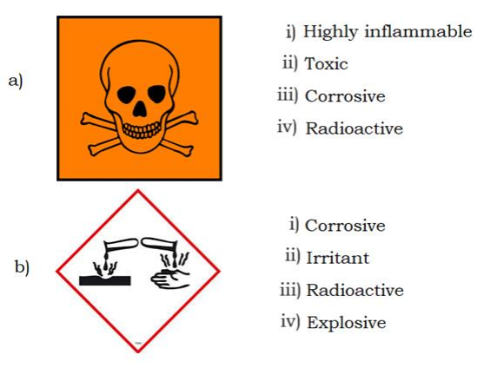
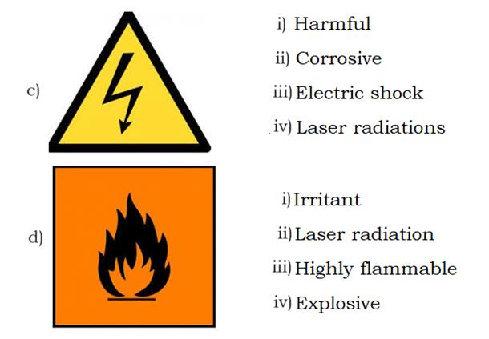

2) Choose a correct answer for each of the following questions.
a) Potassium chloride, KNO3 is a(n): (1mark)
i) acidic salt. ii) normal salt.
iii) double salt. Iv) basic salt.
b) Which among the following is an acidic salt? (1 mark)
i) KNO3 ii) NaCl
iii) K2SO4 iv) NaHCO3
c) The correct IUPAC name for NH4Cl is: (1 mark)
i)tetrahydrogenonitrogenchloride. ii) ammoniafour chloride.
iii) ammonium chloride. iv) nitogenhydrogen chloride.
d)Sodium oxide reacts with carbon dioxide to give: (1 mark)
    - Carbonic acid ii) Sodium carbonate
    - Sodium chloride iv) Sodium sulphate

3) Three atoms of elements are represented as follows: 19 9𝑋, 10 20𝑌 and 12 26𝑍.
a) Write the electronic configuration for X, Y and Z atoms. (3 marks)
b) Which of the atoms X, Y and Z:
i) reacts by losing electrons? (1 mark)
ii) reacts by gaining electrons? (1 mark)
c) Predict the chemical formula of compound formed between X and Z.
(2 marks)

4) This question concerns chemical formulae and equations.
a) Write correctly the compound formed between the provided ions:
Na+ and PO4 3- (1 mark)
b) Convert the following word equations into balanced symbolic chemical equations.
i) Hydrogen + Chlorine ⎯→ Hydrogen chloride (2 marks)
ii) Sulphur + Oxygen ⎯→ Sulphur dioxide (2 marks)
iii) Sodium hydroxide + Nitric acid ⎯→ Sodium nitrate + Water (2 marks)
5. Use the term “miscible” and “immiscible” to fill in the blank spaces of the passage below.
a)Two liquids that do not mix to form homogeneous mixture are known
as………………………..liquids. (1 mark)
b) Liquids which mix to form homogeneous mixture are ………….. (1 mark)
6.C6H14 is an organic compound which is a member of homologous series of alkanes.
a. Define the term “hydrocarbon” (2marks)
b. What is the name of C5H12. (1mark)
c. Give the formula of an alkane with 7 C atoms. (1mark)
d. Write a balanced chemical equation of the reaction for the combustion of an
alkane with 4 carbon atoms. (2marks)
e. Alkanes are examples of fossils fuels. State two environmental problems caused by the burning of alkanes. (2marks)
7. Burning magnesium was lowered into a jar of Oxygen. (5marks)
a.) Write the chemical equation showing what happened
b) Water was added to the product in (a) and the resultant mixture
tested with litmus. Is the solution acidic or alkaline?
8. State what would be observed if Ammonia has reacted with hydrogen chloride. (1mark)
a) Write the chemical equation to illustrate that reaction. (2marks)
b) State 2 other characteristic changes you can observe when performing an
experiment and confirm that a chemical reaction is taking place. (2marks)
9. Consider the following substances: glucose solution, C6H12O6(aq), sodium chloride solution, NaCl(aq), urea solution, (NH2)2CO(aq), distilled water.
  - Differentiate between electrolyte and non-electrolyte. (2 marks)
  - Classify the above substances into electrolytes and non-electrolytes. (4 marks)
10. Fill in the blank spaces with an appropriate term from the list: crystalline, metallic bond, covalent bond, noble gases.
  - The chemical bond formed with share of electrons between two atoms is known
as a ……………………………….. (1 mark)
  - When a bond is formed between two atoms, each atom acquires a stable
electron configuration similar to that of……………………………….. (1 mark)
  - Ionic compounds are usually……………………………..solids. (1 mark)
d)The force which binds various metal atoms together is called…………………(1 mark)
11. The quantity of matter is usually determined in terms of number of mole.
  - Define the term mole. (1 mark)
b)Calculate the number of moles corresponding to 5 grams of sodium chloride. (Atomic masses: Na = 23, Cl = 35.5) (3 marks)
c)At constant temperature, a gas occupies 1200 litres at 2 atm pressure. Determine the pressure to which the gas must be compressed to occupy 60 litres. (3 marks)
12. State whether each of the following statements is true or false.
  - Alkanes contain only single covalent bonds. (1 mark)
  - The boiling points of alkanes decrease with increasing molecular size. (1mark)
  - Organic compounds are soluble in water but insoluble in organic solvents.(1mark)
  - The IUPAC name of an alkane containing four carbon atoms is butane. (1mark)

SECTION B: ATTEMPT ANY THREE (30) Marks
13. The set up below (Figure ) is used to prepare oxygen gas in laboratory.
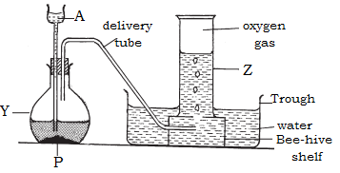
a) Name the substances which are used as liquid A and solid P. (2 marks)
b) Name the apparatuses Y and Z.(2 marks)
c) Describe how you would confirm the presence of oxygen.(1 mark)
d) State any two (2) uses of oxygen. (2 marks)
e) State one physical property of oxygen related to its method of collection.
(1 mark)
f) A student decides to use the above method to collect sulphur dioxide (SO2).
Is this decision appropriate? Justify your answer. (2 marks)

14) The following grid (Figure 3) shows a section of the Periodic Table with no true
symbols. Study it and answer the questions that follow.
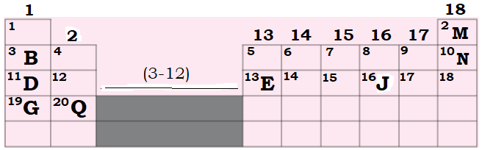

a) Give the specific names for group1 and group 17 elements. (2 marks)
b) State the specific name given to horizontal rows of the Periodic Table.
(1 mark)
c) Identify any two (2) elements which are metals.(2 marks)
d) State any one (1) element which is:
i) a noble gas? (1 mark)
ii) an alkaline earth metal? (2 mark)
e) Fill in the blank spaces. (2 marks)
Elements in the today Periodic Table are arranged in order of
i) ____________whereas in Mendeleev table, they were arranged in order
ii) of their ______________.
15. In the Habber process, hydrogen is made to react with nitrogen directly over a catalyst.
a)Give the equation for the reaction. (2Marks)
b)Name the catalyst used. (1Mark)
c)What other two conditions favour this reaction? (2Marks)
d)Give one sources of: (2Marks)
i)Nitrogen and
ii)Hydrogen
e)Give two commercial uses of ammonia. (2Marks)
f) What does the sign mean in the equation? (1Mark)
16. a) When concentrated hydrochloric acid was added to manganese(IV) oxide and heated, the gas thus evolved, bleached litmus paper. Write the equation to show what happened. (2Marks)
b)Chlorine dissolves in water to give chlorinewater.
i)Write the equation for the reaction that occurs. (2Marks)
ii)When the chlorine water is exposed to sunlight a colourless gas,which gives a positive test with a glowing splint, is given off. Explain. (2Marks)
c)Materials bleached with chlorine do not gain colour with time as opposed to those bleached using Sulphur dioxide. Explain. (1Mark)
d)Chlorine can react with a cold dilute solution of potassium hydroxide, to form water and two other products.
i)Write the equation for the reaction. (2Marks)
ii)Name the other two products. (1Marks)

SECTION C: Attempt one question from this section (15 Marks)
17. Dry chlorine can be prepared by the reaction between manganite (IV) oxide with concentrated sulphuric acid. Below is a diagram of this preparation:
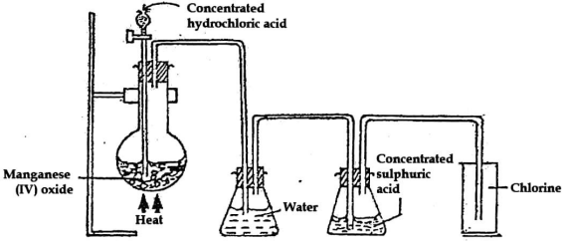
- Write the chemical equation of the reaction between manganese (IV) oxide and concentrated hydrochloric acid. (2Marks)
- What are the roles of water and concentrated sulphuric acid in this experiment? (2Marks)
- When chlorine reacts with iron: (4Marks)
    - Iron (II) chloride not formed.
    - State the compound that is instead of iron (II) chloride.
- With the aid of ionic equation, state what would be observed if chlorine was bubbled through the solution of: (4Marks)
  - Iron (II) sulphate
  - Potassium iodide
- Chlorine is a bleaching agent when in the presence of cold water. Write an equation for the reaction between chlorine and cold water. (2Marks)

18.a) The atomic mass of magnesium, oxygen and chlorine are 24, 16 and
  - respectively.
i)Calculate the number of moles in 18g of MgO. (2 marks)
ii)Calculate the mass of MgCl₂ produced when 18g of MgO react completely with excess HCl. (2 marks) Equation:
MgO + 2HCI → MgCl₂ + H₂O

b)State a reagent that can be used to distinguish between the following pairs of ions and state the observable change in each case.
i)CO₃2- and Cl - (2 marks)
ii)Cu₂₊ and Ca2+ (2 marks)
c) An organic compound contains 4.O7% hydrogen, 24.27% carbon and 7l.65% chlorine by mass. Its molar mass is 99 g/mol.
i)Determine the empirical formula of the compound. (2 marks)
ii)Determine the molecular formula of the compound. (2 marks)
(Atomic mass: C = 12, H = 1, Cl = 35.5)
d) Sulphur reacts with some metals:
i)Write a balanced equation of the reaction between sulphur and iron.
ii)State the names of 2 allotropes of sulphur. (2 marks)

